Why an Association?
Currently the CHW workforce is fragmented and misunderstood across the state.
Our Mission
Meeting the needs of the diverse Community Health Worker workforce by continuously improving training, professional development, communication and access to resources and job opportunities.
Our 4 Areas of Focus
The WSCHWA plans to achieve its BOLD mission through the goals identified for each Focus Areas:
- FOCUS 1: PROFESSIONAL DEVELOPMENT
Goal Statement: Education and skill training on topics that are important to CHWs
- FOCUS 2: NETWORKING
Goal Statement: Getting to know and learning from other CHWs across the state otherwise have met to share ideas, interests, and goals, and get support.
- FOCUS 3: ADVOCACY
Goal Statement: Identify issues that are important to CHWs and work with others to encourage local, regional and state policymakers to address the issue
- FOCUS 4: SUSTAINABILITY
Goal Statement: Developing a structure that helps the CHW Association to grow and sustain to include a transitional leadership team.

Initial Implementation Structure
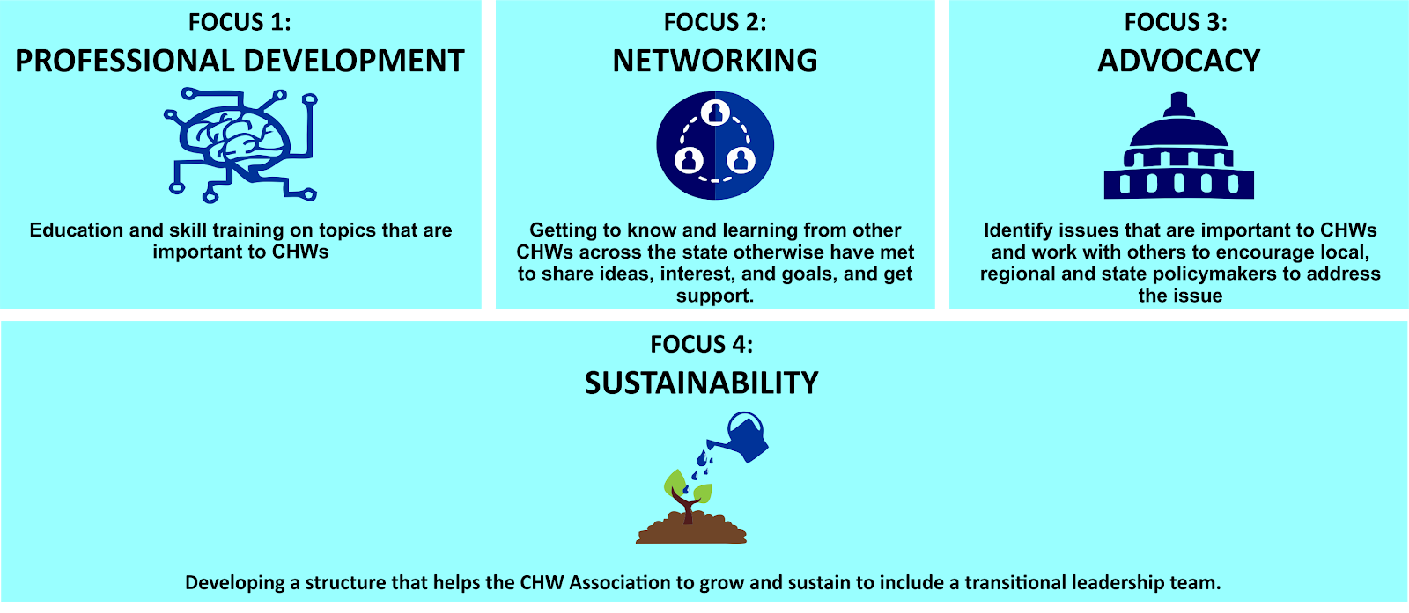

Strategic Roadmap
FOCUS 1: PROFESSIONAL DEVELOPMENT
Goal Statement: Education and skill training on topics that are important to CHWs.
Key Strategies:
- Research lessons from other states
- Develop a structure and roadmap to professional and/or workforce development
- Develop a ladder for young/new CHWs workforce development-simultaneous
- Skills and training on connecting systems and services
Success Measures:
- Index of resources for professional development by topic (regional based)
- A (council/committee/board) that reviews new and developing trainings and curricula, then makes recommendations
- Open access index for CHWs snapshot of professional development in WA
- CHW 2 CHW — Professional insights/experiences for navigating issues of diversity, need and inclusion successfully?

FOCUS 2: NETWORKING
Goal Statement: Getting to know and learning from other CHWs across the state otherwise have met to share ideas, interests, and goals, and get support.
Key Strategies:
- Develop the Structured Learning and Collaboration with Virtual Learning & Networking Vehicle(s)
- Share experiences, best practices, and resources from across the state.
- Membership recruitment and new member orientation/onboarding

Success Measures:
- Web Platform up and running
- Standard New Membership process that includes on boarding packet
- Increased membership by county, sector and type of CHW SOW, language, culture
- Topics of interest identified, inventory of members’ skills, expertise, education and experts to address
- Have a registry created to connect members
FOCUS 3: ADVOCACY
Goal Statement: Identify issues that are important to CHWs and work with others to encourage local, regional and state policymakers to address the issue
Key Strategies:
- Develop a collaborative and progressive policy agenda
- Design the advocacy roadmap through policy analysis to get certification
- Sustainable funding for CHW Workforce
- Educate organizations on
- Value of CHWs and other peers (people with lived experience)
- Sustainable funding resources for CHW Workforce
Success Measure(s):

FOCUS 4: SUSTAINABILITY
Goal Statement: Developing a structure that helps the CHW Association to grow and sustain to include a transitional leadership team.
Key Strategies:
- Design the Process and Collective agreement of the Official Name and Mission Statement of the Statewide CHW Association
- Designing the official way to join the Association. (Pathway(s) to Membership)
- Understanding and making recommendations for Association Organizational and Governance Structure
Success Measure (s):

