**Metaphors and the Rhetoric of Science**

“Metaphors are pervasive in the language of science. Scientists regularly engage in analogical reasoning to develop hypotheses and interpret results, and they rely heavily on metaphors to communicate observations and findings (1). In turn, nonexperts make sense of, and contextualize, abstract ideas and new knowledge through the use of metaphors. While indispensable heuristic tools for doing, communicating, and understanding science, metaphors can also impede scientific inquiry, reinforce public misunderstandings, and perpetuate unintended social and political messages (2). For these reasons, it is especially important for scientists, science communicators, and science educators to acknowledge the conceptual, social, and political dimensions of metaphors in science and adopt critical perspectives on their use and effects.” (Cynthia Taylor and Brian Dewsbury, 2018)

Are metaphors in science problematic? Do you use metaphors for your research? How can these metaphors help and hinder interpreting results and generating hypothesis? How could they be interpreted by a nonexpert audience?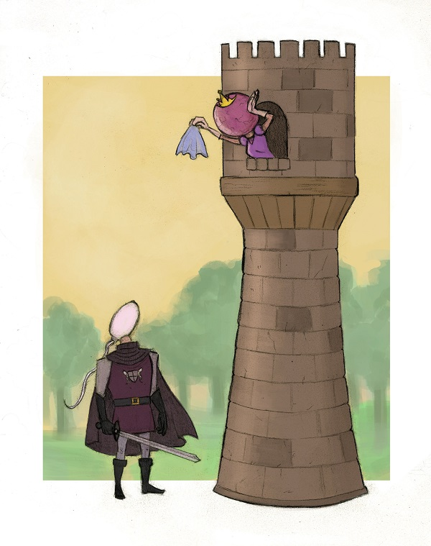

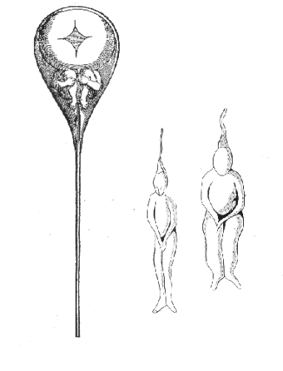

**Preformationism**

(Hartsoeker 1695), (SPACE - website)

Research surrounding fertilization can be prone to cultural bias.

**Spermism**

* Reasonable rationale?
* Biased observation and interpretation
* ovism?

**The Egg and the Sperm: How science has constructed a romance based on stereotypical male-female roles - Emily Martin 1991**

**Passive vs Active voice**

Egg - “It does not move or journey, but passively "is transported," "is swept,” or even "drifts” along the fallopian tube.”

Sperm - “They are small, "streamlined,” and invariably active. They "deliver" their genes to the egg, "activate the developmental program of the egg,” and have a "velocity" that is often remarked upon.”

**Gendered Gametogenesis Rhetoric**

Female gametogenesis - wasteful and unproductive

**Biased Metaphors**

“One popular account has it that the sperm carry out a "perilous journey" into the "warm darkness," where some fall away "exhausted." "Survivors" "assault" the egg, the successful candidates "surrounding the prize." Part of the urgency of this journey, in more scientific terms, is that "once released from the supportive environment of the ovary, an egg will die within hours unless rescued by a sperm”

**Activity 1**

*Fertilization* by Nucleus Medical Media <https://www.youtube.com/watch?v=_5OvgQW6FG4>

**Discussion questions**

What stands out to you?

Were there examples of gendered language?

Biased rhetorical devices?

How can the information presented be rephrased from different perspectives (egg, sperm, cooperative)?

**Responsible Use of Metaphors**

**Emily Martin - “gendered narrative on the molecular level”**

“One clear feminist challenge is to wake up sleeping metaphors in science, particularly those involved in descriptions of the egg and the sperm… Waking up such metaphors, by becoming aware of when we are projecting cultural imagery onto what we study, will improve our ability to investigate and understand nature. Waking up such metaphors, by becoming aware of their implications, will rob them of their power to naturalize our social conventions about gender...

At the very least, the imagery keeps alive some of the hoariest old stereotypes about weak damsels in distress and their strong male rescuers. That these stereotypes are now being written in at the level of the cell constitutes a powerful move to make them seem so natural as to be beyond alteration.”

**Fertilization metaphors**

* Hero and Damsel
* Lock and Key
* Penetration
* Victim and Femme Fatale
* Sexual Conflict

How can we responsibly use these metaphors? Or should we just get rid of them?

**Activity 2**

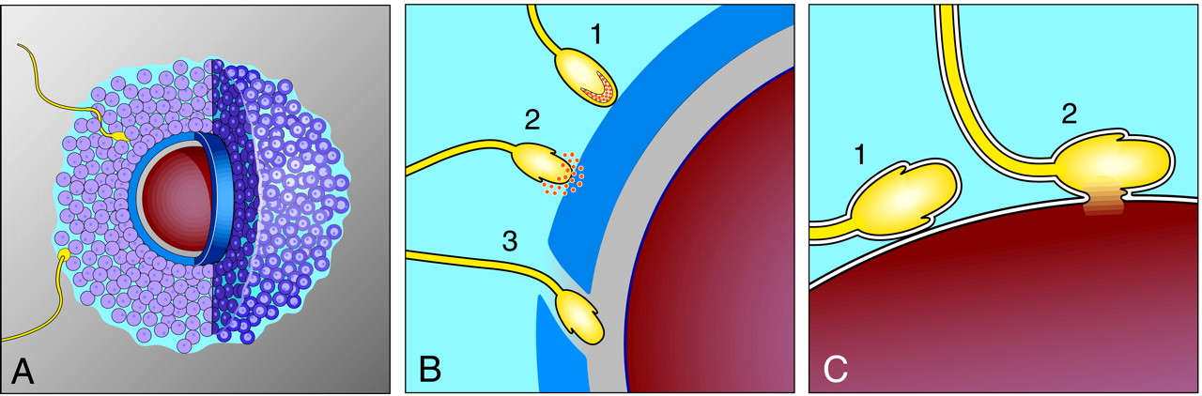

(Primakoff and Myers 2002)