**SUPPLEMENTAL MATERIALS**

**Supplemental Figure 1. Study flow**

**Supplemental Figure 2. TST conversions and reversions in post-trial observational follow-up**

**Supplemental Table 1. Baseline characteristics of trial participants with at least one measure of M. tuberculosis infection by 24 months**

**Supplemental Table 2a. Mtb infection incidence rates and hazard ratios for HIV-exposed uninfected children in Kenya between trial arms.**

**Supplemental Table 2b. Mtb infection incidence rates and hazard ratios for HIV-exposed uninfected children in Kenya between trial and observational study periods.**

**Supplemental Table 3a. TST positivity incidence rates and hazard ratios for HIV-exposed uninfected children in Kenya between trial arms.**

**Supplemental Table 3b.**  **TST positivity incidence rates ratios comparison between trial and post-trial observational follow-up.**

**Supplemental Table 4. Correlates of 24-month cumulative *M. tuberculosis* infection among HIV-exposed infants in Kenya**

**\* Reasons for ineligibility:**

22 not 6-10 weeks of age

22 birthweight <2.5 kg

4 born premature (<37 weeks)

4 mothers with TB in past year

5 infants with TB contact

10 unsure if willing to stay in area or complete follow-up

1 enrolled in another study

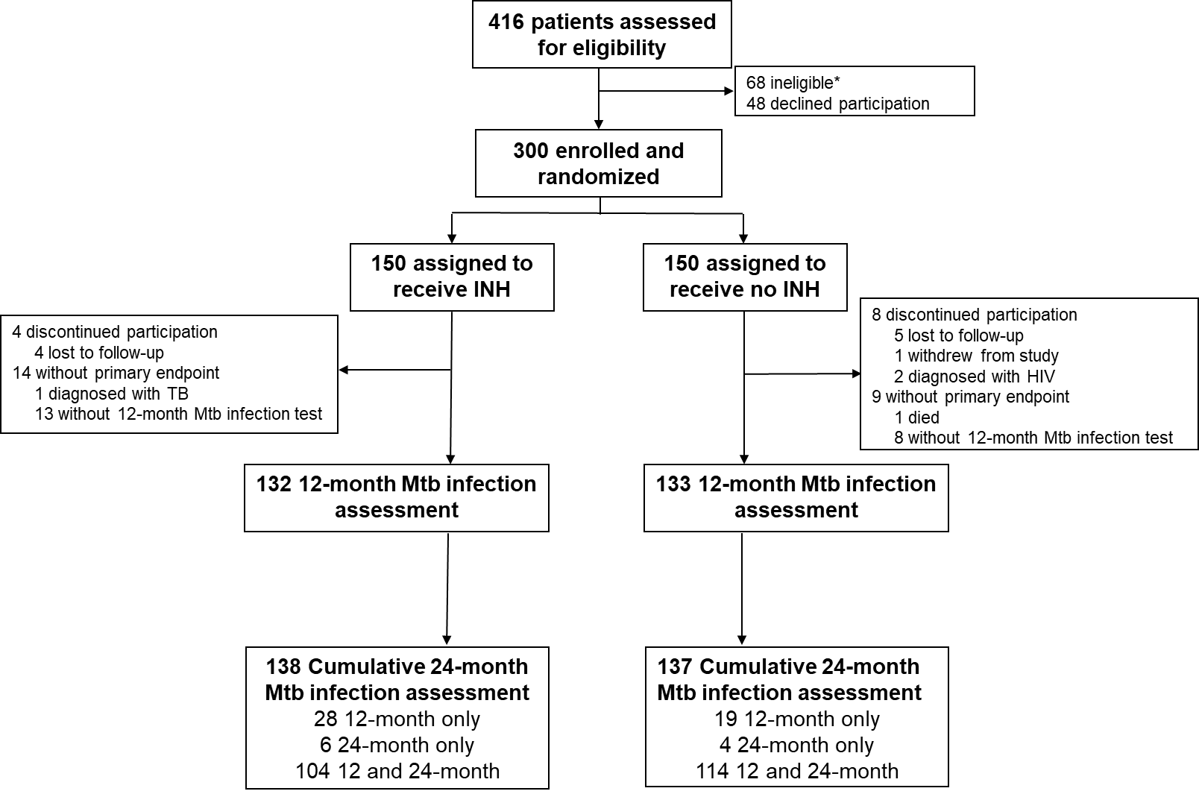

**Supplemental Figure 1. Study flow**



**Supplemental Figure 2.** **TST conversions and reversions in post-trial observational follow-up among children with TST assessment at trial end (12-months) and post-trial observational follow-up (24-months of age).** Denominators include children with persistently negative TST, not visualized in the bar chart. * p=0.04

|  |  |  |  |
| --- | --- | --- | --- |
| Supplemental Table 1. Baseline characteristics of trial participants with at least one measure of *M. tuberculosis* infection by 24 months | | | |
|  |  | **Trial arm** | |
|  | **Total**  **N=275** | **INH**  **N=138** | **No INH**  **N=137** |
| **Baseline** | **Median (IQR)**  **or n (%)** | **Median (IQR)**  **or n (%)** | **Median (IQR)**  **or n (%)** |
| **Infant Characteristics** |  |  |  |
| Infant age (weeks) | 6.3 (6.0-6.6) | 6.3 (6.0-6.6) | 6.3 (6.0-6.4) |
| WAZ score | 0.2 (-0.4-1.0) | 0.3 (-0.5-0.9) | 0.2 (-0.4-1.0) |
| Female | 131 (47.6) | 65 (47.1) | 66 (48.2) |
| Breastfed on enrollment | 270 (98.2) | 134 (97.1) | 136 (99.3) |
| Received ARVs for PMTCT | 272 (98.9) | 136 (98.6) | 136 (99.3) |
| BCG vaccination | 257 (93.5) | 129 (93.5) | 128 (93.4) |
| **Maternal Characteristics** |  |  |  |
| Maternal age | 27 (24-31) | 27 (23-31) | 28 (24-31) |
| Secondary education started | 126 (45.8) | 68 (49.3) | 58 (42.3) |
| ARVs before pregnancy | 208 (75.6) | 108 (78.3) | 100 (73.0) |
| CD4 (cells/mm3)* | 473 (336-655) | 473 (327-655) | 472 (348-655) |
| HIV viral load undetectable† | 211 (79.6) | 97 (74.1) | 114 (85.1) |
| History of TB | 28 (10.2) | 14 (10.1) | 14 (10.2) |
| History of IPT | 205 (74.6) | 99 (71.7) | 106 (77.4) |
| Current IPT | 54 (26.3) | 25 (25.3) | 29 (27.4) |
| **Residential Characteristics** |  |  |  |
| Persons in household | 5 (4-6) | 4 (4-6) | 5 (4-6) |
| Rooms in household | 2 (1-3) | 2 (1-3) | 2 (1-3) |
| Lack of flush toilet | 245 (89.1) | 123 (89.1) | 122 (89.1) |
| Lack of electricity | 67 (24.4) | 37 (26.8) | 30 (21.9) |
| Lack of running water | 207 (75.3) | 103 (74.6) | 104 (75.9) |
| Abbreviations: INH isoniazid, IQR interquartile range, WAZ weight-for-age Z score, PMTCT prevention of maternal to child transmission, BCG Bacille Calmette-Guerin, ARV antiretrovirals, HIV human immunodeficiency virus, TB tuberculosis, IPT isoniazid preventive therapy  * N=247 (125 INH, 118 no INH). CD4 data collected from routine programmatic data, 28 missing due to changing guidelines regarding CD4 monitoring in Kenya.  † N=265 (131 INH, 134 no INH). HIV VL data collected from routine programmatic data, 10 missing. HIV viral load lower level of detection by routine Ministry of Health testing in Kenya is 20 copies/ml. | | | |

.

|  |  |  |  |  |  |
| --- | --- | --- | --- | --- | --- |
| **Supplemental Table 2a. Mtb infection incidence rates and hazard ratios for HIV-exposed uninfected children in Kenya between trial arms.** | | | | | |
|  |  | **Mtb infection risk by trial arm** | | | |
| **Study periods** | **N** | **n (%)\*** | **Rate (per 100 PY)**  **(95%CI)** | **HR**†  **(95%CI)** | **p** |
| **iTIPS trial (12-month incidence)**‡ | 265 | 28 (10.6) | 11.1 (7.7-16.1) |  |  |
| No INH | 133 | 18 (13.5) | 14.5 (9.1-23.0) | ref | -- |
| INH | 132 | 10 (7.6) | 7.9 (4.2-14.6) | 0.55 (0.25-1.20) | 0.132 |
| **Post-trial observational follow-up**  **(12-24 month incidence)**§ | 190 | 10 (5.3) | 6.0 (3.2-11.1) |  |  |
| No INH | 96 | 3 (3.1) | 3.5 (1.1-10.8) | ref | -- |
| INH | 94 | 7 (7.5) | 8.6 (4.1-18.1) | 2.44 (0.63-9.46) | 0.196 |
| **Trial and post-trial observational follow-up (cumulative 24-months incidence)**|| | 275 | 39 (14.2)# | 8.7 (6.3-11.9) |  |  |
| No INH | 137 | 22 (16.1) | 9.8 (6.5-14.9) | ref | -- |
| INH | 138 | 17 (12.3) | 7.5 (4.7-12.1) | 0.75 (0.40-1.42) | 0.382 |
| * n/N  † Hazard ratio (HR) estimated using Cox proportional hazards regression  ‡By QFT-Plus and/or TST. At trial end 3 participants were QFT-Plus positive and 25 were TST positive. Estimate varies slightly from published trial result (12-month incidence 10.1 per 100 PY [95%CI 7.0-14.6]; INH 7.0 vs. No INH 13.4 per 100PY, HR 0.53 [95%CI 0.24-1.14], p=0.11) which included person-time for participants who completed trial follow-up but were missing Mtb infection endpoint.  § By TST only. Includes 190 (94 INH, 96 No INH) children with negative 12-month Mtb infection results  || Incidence of first Mtb infection test (either QFT-Plus or TST) considered positive within 24 months, includes 1 child with a missing Mtb infection assessment  # Includes one child missing Mtb infection assessment at trial end with positive Mtb infection test at 24 months | | | | | |

|  |  |  |  |  |  |
| --- | --- | --- | --- | --- | --- |
| **Supplemental Table 2b.**  **Mtb infection incidence rates and hazard ratios for HIV-exposed uninfected children in Kenya between trial and observational study periods.** | | | | | |
|  |  | **Mtb infection risk by study period** | | | |
| **Trial arms** | **N** | **n (%)\*** | **Rate (per 100 PY)**  **(95%CI)** | **HR**†  **(95%CI)** | **p** |
| **Overall** |  |  |  |  |  |
| iTIPS trial (12-month incidence)‡ | 265 | 28 (10.6) | 11.1 (7.7-16.1) | 2.00 (0.97-4.12) | 0.060 |
| Post-trial observational follow-up  (12-24 month incidence)§ | 190 | 10 (5.3) | 6.0 (3.2-11.1) | ref | -- |
| **No INH** |  |  |  |  |  |
| Trial | 133 | 18 (13.5) | 14.5 (9.1-23.0) | 4.45 (1.31-15.12) | **0.017** |
| Post-trial observational follow-up | 96 | 3 (3.1) | 3.5 (1.1-10.8) | ref | -- |
| **INH** |  |  |  |  |  |
| Trial | 132 | 10 (7.6) | 7.9 (4.2-14.6) | 0.97 (0.37-2.55) | 0.950 |
| Post-trial observational follow-up | 94 | 7 (7.5) | 8.6 (4.1-18.1) | ref | -- |
| * n/N  † Hazard ratio (HR) estimated using Cox proportional hazards regression  ‡By QFT-Plus and/or TST. At trial end 3 participants were QFT-Plus positive and 25 were TST positive. Estimate varies slightly from published trial result (12-month incidence 10.1 per 100 PY [95%CI 7.0-14.6]; INH 7.0 vs. No INH 13.4 per 100PY, HR 0.53 [95%CI 0.24-1.14], p=0.11) which included person-time for individuals who completed trial follow-up but were missing Mtb infection endpoint.  § By TST only. Includes 190 (94 INH, 96 No INH) children with negative 12-month Mtb infection results | | | | | |

|  |  |  |  |  |  |
| --- | --- | --- | --- | --- | --- |
| **Supplemental Table 3a. TST positivity incidence rates and hazard ratios for HIV-exposed uninfected children in Kenya between trial arms.** | | | | | |
|  |  | **TST positive risk by trial arm** | | | |
| **Study periods** | **N** | **n (%)\*** | **Rate (per 100 PY)**  **(95%CI)** | **HR**†  **(95%CI)** | **p** |
| **iTIPS trial (12-month incidence)** | 187 | 25 (13.4) | 14.3 (9.6-21.1) |  |  |
| No INH | 94 | 17 (18.1) | 19.8 (12.3-31.8) | ref | -- |
| INH | 93 | 8 (8.6) | 9.0 (4.5-18.0) | 0.47 (0.20-1.08) | 0.075 |
| **Post-trial observational follow-up**  **(12-24 month incidence)**§ | 137 | 7 (5.1) | 6.0 (2.9-12.6) |  |  |
| No INH | 66 | 2 (3.0) | 3.5 (0.9-14.0) | ref | -- |
| INH | 71 | 5 (7.0) | 8.4 (3.5-20.2) | 2.30 (0.45-11.85) | 0.320 |
| **Trial and post-trial observational follow-up (cumulative 24-months incidence)**|| | 253 | 36 (14.2)# | 8.0 (5.8-11.1) |  |  |
| No INH | 129 | 21 (16.3) | 9.2 (6.0-14.1) | ref | -- |
| INH | 124 | 15 (12.1) | 6.8 (4.1-11.3) | 0.73 (0.38-1.42) | 0.361 |
| * n/N  † Hazard ratio (HR) estimated using Cox proportional hazards regression  § Includes 190 (94 INH, 96 No INH) children with negative 12-month TST results  || Incidence of first TST considered positive within 24 months  # Includes 4 children missing TST assessment at trial end with positive TST at 24 months | | | | | |

|  |  |  |  |  |  |
| --- | --- | --- | --- | --- | --- |
| **Supplemental Table 3b. TST positivity incidence rates ratios comparison between trial and post-trial observational follow-up.** | | | | | |
|  |  | **TST positive** **risk by study period** | | | |
| **Trial arms** | **N** | **n (%)\*** | **Rate (per 100 PY)**  **(95%CI)** | **HR**†  **(95%CI)** | **p** |
| **Overall** |  |  |  |  |  |
| iTIPS trial (12-month incidence) | 187 | 25 (13.4) | 14.3 (9.6-21.1) | 2.64 (1.14-6.11) | **0.023** |
| Post-trial observational follow-up  (12-24 month incidence)§ | 137 | 7 (5.1) | 6.0 (2.9-12.6) | ref | -- |
| **No INH** |  |  |  |  |  |
| Trial | 94 | 17 (18.1) | 19.8 (12.3-31.8) | 6.29 (1.45-27.22) | **0.014** |
| Post-trial observational follow-up | 66 | 2 (3.0) | 3.5 (0.9-14.0) | ref | -- |
| **INH** |  |  |  |  |  |
| Trial | 93 | 8 (8.6) | 9.0 (4.5-18.0) | 1.19 (0.39-3.65) | 0.756 |
| Post-trial observational follow-up | 71 | 5 (7.0) | 8.4 (3.5-20.2) | ref | -- |
| * n/N  † Hazard ratio (HR) estimated using Cox proportional hazards regression  § Includes 190 (94 INH, 96 No INH) children with negative 12-month TST results | | | | | |

|  |  |  |  |  |
| --- | --- | --- | --- | --- |
| Supplemental Table 4. Correlates of 24-month cumulative M. tuberculosis infection among HIV-exposed infants in Kenya | | | | |
|  | **Cumulative 24-month Mtb infection assessment** | | | |
|  | **Mtb infection**  **N=39** | **No Mtb infection N=236** | **HR* (95%CI)** | **p** |
|  | **Median (IQR) or n (%)** | |  |  |
| **Infant Characteristics** |  |  |  |  |
| Study arm (INH vs. No INH) | 17 (43.6) | 121 (51.3) | 0.75 (0.40-1.42) | 0.382 |
| Female | 15 (38.5) | 116 (49.2) | 0.65 (0.34-1.25) | 0.197 |
| WAZ score† | 0.32 (-0.40-0.71) | 0.20 (-0.48-0.97) | 0.96 (0.70-1.32) | 0.824 |
| Known TB exposure‡ | 4 (10.3) | 5 (2.1) | 3.94 (1.40-11.11) | **0.009** |
| **Maternal Characteristics** |  |  |  |  |
| ARVs before pregnancy | 32 (82.1) | 176 (74.6) | 1.45 (0.64-3.29) | 0.373 |
| CD4 (cells/mm3)§ | 478 (252-731) | 472 (347-651) | 1.00 (1.00-1.00) | 0.653 |
| HIV viral load >1000 (copies/ml)|| | 3 (7.9) | 11 (4.9) | 1.61 (0.49-5.23) | 0.430 |
| History of TB | 4 (10.3) | 24 (10.2) | 0.87 (0.31-2.45) | 0.796 |
| History of IPT | 28 (71.2) | 177 (75.0) | 0.84 (0.42-1.69) | 0.631 |
| Current IPT | 4 (14.3) | 50 (28.3) | 0.46 (0.16-1.33) | 0.151 |
| **Residential Characteristics** |  |  |  |  |
| Persons in household | 5 (3-6) | 4.5 (4-6) | 1.03 (0.86-1.24) | 0.741 |
| Rooms in household | 2 (1-3) | 2 (1-3) | 0.86 (0.65-1.14) | 0.288 |
| Lack of flush toilet | 39 (100.0) | 206 (87.3) | -- | **0.012**# |
| Lack of electricity | 6 (15.4) | 61 (25.9) | 0.52 (0.22-1.24) | 0.142 |
| Lack of running water | 36 (92.3) | 171 (72.5) | 4.22 (1.30-13.70) | **0.017** |
| Abbreviations: INH isoniazid, IQR interquartile range, WAZ weight-for-age Z score, ARV antiretrovirals, HIV human immunodeficiency virus, TB tuberculosis, IPT isoniazid preventive therapy  * Hazard ratio (HR) estimated using univariable Cox proportional hazards regression  †At enrollment  ‡ Report of TB exposure during study period  § N=243 (35 Mtb infection, 208 no Mtb infection). CD4 data collected from routine programmatic data, 22 missing due to changing guidelines regarding CD4 monitoring in Kenya.  || N=265 (38 Mtb infection, 227 no Mtb infection. HIV VL data collected from routine programmatic data, 10 missing. HIV viral load lower level of detection by routine Ministry of Health testing in Kenya is 20 copies/ml  # Fisher’s exact p-value | | | | |