The CDC Growth Charts for Children with Special Health Care Needs

Introduction
It has been estimated that 15% of the pediatric population have special needs and that 40-60% of those children are at risk for nutritional problems. The growth of some infants, children, and youth with special health care problems differs from that of other children because of reasons not related to nutrition. However, they are included among the children in all regular school and health care facilities and their growth will also be evaluated utilizing the CDC growth charts. The purpose of this module is to describe some of the effects that special health care needs can have on growth and to illustrate how the CDC Growth Charts can be used with children with special health care needs.

Objectives

Upon completion of this module, you will be able to:

- recognize conditions of children with special health care needs that influence growth
- recognize that children with special health care needs are at high risk for nutrition problems that can influence growth
- use the CDC growth charts to assess the growth of children with special health care needs

Table of Contents

1. Who are the children with special health care needs?

2. Growth patterns of children with special health care needs

3. Measurement considerations for children with special needs

4. Using corrected age to plot measures for low birthweight and premature infants

5. Body mass index-for-age

6. Issues regarding the use of condition-specific growth charts

7. Application of principles

8. References and resources

1. Who are the children with special health care needs?

"Children with special health care needs are those who have or are at increased risk for a chronic physical, developmental, behavioral, or emotional condition and who also require health and related services of a type or amount beyond that required by children generally." (McPherson, et al, 1998).

For all children, growth potential is determined by genetics, and influenced by biological and environmental factors. These factors can include disease, nutrient intake, poverty, and other environmental circumstances. A child with special health care needs is at higher risk for other factors that can influence growth, such as impaired motor skills, the need for long-term use of medications, and other, secondary medical conditions.

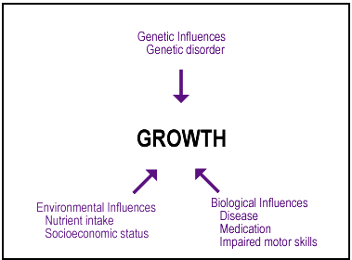
Figure 1. Influences on growth

Growth interpretation is a key part of the design of medical and nutrition interventions. As with all children, accurate weighing and measuring are critical. For more information about technique for measuring and interpreting growth, see the modules about Accurately Weighing and Measuring Infants, Children, and Adolescents: Equipment; Technique; and Developing and Rating Your Technique.

2. Growth patterns of children with special health care needs

We can examine the growth patterns of children with special health care needs by looking at two distinct categories of conditions:

- conditions that alter growth
- conditions that have the potential to alter growth

Conditions that alter growth

Chromosomal disorders
Some conditions, which involve abnormalities at the chromosomal level, are associated with growth patterns that differ from those of children without chromosomal abnormalities. It is assumed that these differing growth patterns represent altered growth potential related to the underlying chromosomal abnormality. Examples of conditions related to chromosomal aberrations include Prader-Willi syndrome, Cornelia deLange syndrome, Turner syndrome, and trisomy 21 (also called Down syndrome).

Trisomy 21 will be used to illustrate the challenges in assessing the growth of a child with any chromosomal disorder:

Children with trisomy 21 have an extra chromosome 21 in their cells. They also typically have shorter stature, smaller head circumference and a different pattern of growth, particularly during the first five years of life, than other children (Feucht and Lucas, 2000). Because of these differences, the growth of children with trisomy 21 is not the same as that of the reference children used to develop the CDC growth charts.

Recognition of the differing growth pattern in the child with trisomy 21, and the problem posed by comparing that child's growth to that of average children, led investigators to develop and publish alternative growth charts used with this population (Cronk, et al, 1988). These charts have been used by nutritionists and other clinicians. However, it must be emphasized that there are reasons for which these charts should not be used or not used by themselves. The use of "condition-specific growth charts" is covered in Section 6.

Genetic disorders
For children with genetic disorders, such as a metabolic disorder, there is the potential for altered growth because the affected metabolic pathways are involved in producing energy or building body tissue.

Conditions that have the potential to alter growth

While some conditions alter growth potential, other conditions have the potential to alter growth. These conditions may have associated biological or environmental factors that can influence a child's growth.

For these conditions, there is no clear rationale for the development of reference data for growth because there is no identifiable alteration in the genetic potential for growth in these conditions.

Three conditions that have the potential to alter growth are:
- neurologic disorders that impair ambulation
- low birth weight
- feeding problems

Neurologic disorders that impair ambulation
Children who are non-ambulatory due to neurological conditions such as severe cerebral palsy or neural tube defects such as spina bifida (myelomeningocele), do not grow normally. This is thought to be due to a lack of weight-bearing which normally provides the physical stress on the long bones of the leg required to stimulate bone growth (Stevenson, Roberts, Vogtle, 1995).

Some children with neurologic conditions affecting ambulation also have problems with feeding, which can be an additional factor influencing growth (Stevenson, 1995). This is discussed later in this section.

Low birth weight
Babies born weighing 1500-2500 grams have a low birth weight. Babies born weighing less than 1500 grams have a very low birth weight. They may or may not have intrauterine growth retardation (IUGR), depending on their gestational age.

- If an infant is born prematurely, the low weight may be appropriate for gestational age (AGA) and the infant may not have IUGR.

- On the other hand, an infant may be born at term weighing less than 2500 grams; that infant is small for gestational age (SGA) and has IUGR.

Depending on the timing, duration and severity of the nutritional insult, as well as the success of postnatal nutrition intervention, the growth potential of children born SGA and who have IUGR may be permanently adversely affected (Anderson, 1999).
Low birth weight infants (infants weighing 1500-2500 grams at birth) are included in the CDC reference population, so it is appropriate to use CDC growth charts with these infants.

The CDC growth charts do not include growth data from very low birth weight (VLBW) infants (infants weighing less than 1500 grams at birth). For this reason, it may not be appropriate to use the CDC growth charts to assess the growth of VLBW infants. Alternate charts are available, based on data from two major studies:

- National Institute of Child Health and Human Development Neonatal Research Network centers (Ehrenkranz, 1999) extend to 3 or 4 months of age

- Infant Health and Development Program (IHDP) (Guo et al., 1997; Guo, et al. 1996; Roche, et al., 1997) extend to age 36 months

More information about the use of the CDC growth charts with VLBW infants can be found in the module, Overview of the CDC Growth Charts.

TERMS USED TO DESCRIBE PREMATURITY AND BIRTHWEIGHT
Term | Used to describe
Premature | Infants born before 37 weeks gestation
Low birth weight (LBW) | Infants weighing fewer than 2500 g at birth
Very low birth weight (VLBW) | Infants weighing fewer than 1500 g at birth
Extremely low birth weight (ELBW) | Infants weighing fewer than 1000 g at birth
Intrauterine growth retardation (IUGR) | Growth of the fetus that is delayed related to gestational age
Small for gestational age (SGA) | Infants whose birthweights are less than expected for their gestational age; <10th percentile is often used
Gestational age | The age of a fetus or newborn, usually stated in weeks from the first day of the mother's last menstrual period
Chronologic age | The age of an infant stated as the amount of time since birth
Corrected age | The age of an infant from birth, minus the number of weeks premature
Appropriate for gestational age (AGA) | Infants whose birthweights are as expected for their gestational age; 10th - 90th percentile is often used
Large for gestational age (LGA) | Infants whose birthweights are greater expected for their gestational age; above the 90th percentile is often used
(Anderson, 1999; Scott, Artman, Hill, 1997; Alexander, 1996)

Feeding problems
Problems with feeding that interfere with an adequate nutrient intake have obvious effects on a child's growth.

Children with neurodevelopmental problems, such as cerebral palsy, often have feeding problems due to structural abnormalities of the oral area (teeth, gums, jaw) or oral-motor dysfunction due to abnormal tone or reflexes affecting their ability to close their lips, suck, swallow or chew (Cloud, 1997; Stevenson, 1995).

Children with neural tube defects such as spina bifida often have the Arnold Chiari malformation of the brain, which makes swallowing difficult (Ekvall, 1993).

Problems with gastroesophageal reflux (GER) can contribute to problems with feeding as well. Many children with neurodevelopmental problems have GER (Cloud, 1997; Stevenson, 1995).

Tactile sensitivity or sensory defensiveness, common among children with cerebral palsy, autism, and spina bifida may cause a child to avoid putting things in his/her mouth (Cloud, 1997; Stevenson, 1995).

Without intervention, these difficulties can lead to inadequate food intake and slowed growth.

Children may also have feeding problems as a result of behavioral or emotional issues, many of which result from relational difficulties early in life. Other feeding problems may be the result of complex perinatal medical interventions that center around feeding or around the mouth, making subsequent oral experiences, including feeding, unpleasant (Cloud, 1997).

Risk of under or overweight among children with special needs

Overweight
Conditions which predispose to overweight frequently occur in the child with trisomy 21, Prader-Willi syndrome and spina bifida. Reasons for an overweight condition in these children include hypotonia, lower metabolic rates, lack of ambulation and exercise, and excessive food intake relative to expenditure of energy (Cloud, 1997; Ekvall, 1993).

Underweight
Underweight is a common occurrence among children with feeding problems, whether the problems are physical or emotional/behavioral. For example, underweight may result from a situation where the child has high energy needs that are difficult to meet because of other physiologic reasons such as bronchopulmonary dysplasia or cardiac problems (Cloud, 1997; Anderson, 1999). (For more information about underweight, see the module about Identifying Poor Growth in Infants and Toddlers.)

3. Measurement considerations for children with special needs

The reference data used to develop the CDC growth charts were drawn from a nationally representative sample. These reference data are not specific for children with special health care needs. Thus, the clinician who uses the CDC growth charts to interpret the growth of a child with special health care needs must understand the potential influence of the specific condition on growth and identify reasons the child's growth might be different than that of other children.

Most important in growth assessment are consistency, using accurate measurement techniques, repeating the measurements, checking for accuracy, and, above all, plotting a series of measurements over time. (For more information, see the modules about Accurately Weighing and Measuring Infants, Children, and Adolescents: Equipment; Technique; and Developing and Rating Your Technique.

Because of their conditions, some children with special needs may be difficult to measure. Problems may include an inability to stand, contractures, scoliosis, lack of head and trunk control, and the need to wear braces. Generally, equipment in primary care clinics may not be adaptable for children with special needs. Conditions that may present problems in measurement are those associated with physical disabilities like cerebral palsy (where contractures interfere with accuracy), and spina bifida (where the child may not be able to stand erect or has scoliosis, which makes measuring stature very difficult).

Children with some conditions, such as Rett syndrome or Prader-Willi syndrome, may present no measurement problems with the available anthropometric equipment, but the resulting data may be difficult to interpret because of altered growth potential.
In the remainder of this section, some potential measurement problems of children with special health care needs are discussed and alternative measurements are reviewed.

Measures of Stature and Length

Children unable to stand should be measured on a recumbent board. Scoliosis and leg contractures decrease the accuracy of the length measurement. Alternative measurements can be used to assess linear growth, including:

- crown-rump length and sitting height
- arm span
- upper arm length
- lower leg length

Crown-rump length and sitting height
Sitting height and crown-rump length are sometimes used in place of stature and length when a child is unable to stand, but can sit erect.

Crown-rump length
Crown-rump length is measured using a recumbent length board.

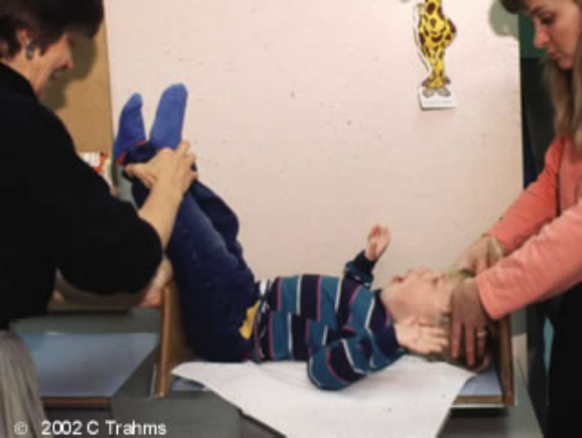 | Equipment:  recumbent length board
Technique:
The head is positioned as with a length measurement. The legs are raised so that the thighs are at a 90-degree angle to the board and held in that position during the measurement. The sliding footboard is brought up against the buttocks with firm pressure and the reading is taken.

Plotting and Interpretation:
The measurement can be plotted on the CDC charts for stature-for-age or length-for-age. Even if measurements fall below the 5th percentile, they establish a growth pattern over time (Lohman, 1988; McCammon, 1970).

Reference data exist, however the data set is small and does not include children with special health care needs (McCammon, 1970).

Sitting height (Lohman, 1988; Hamill, et al, 1973)
 | Equipment:  sitting base of a known height (e.g., 50 cm x 40 cm x 30 cm) and a wall-mounted stadiometer
Technique:
The child is placed as erect as possible with buttocks, shoulders, and head in contact with backboard of the stadiometer. Total height is measured. The height of the sitting surface is then subtracted from the total height.

Plotting and Interpretation:
The measurement can be plotted on the CDC charts for stature-for-age. Even if measurements fall below the 5th percentile, they establish a growth pattern over time.
There are reference data for sitting height, however the data are old and do not include children with special health care needs (Hamill, et al, 1973).

Sitting height – example

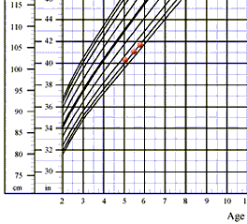 | YE is a 5 year, 7 month old boy with developmental delay. He had a stroke in infancy, and the right side of his body is affected. He is not able to stand or extend his right arm.  Sitting height measurements (along with weight) are used to monitor YE's growth. He is consistently measured sitting on a 40 cm box.  YE's sitting height measurements parallel those on the stature-for-age charts. Together, with regular weight measurements, his sitting height-for-age measurements indicate that he is growing well.

Arm span
The arm span, when accurately measured, should equal stature 1:1 if growth is normal.

Arm span measurement requires two people to complete measurements. The child extends both arms, while the anthropometer or measuring rod is held across the back, extended from the tip of one middle finger to the other (Trahms, 1997).
Arm span measurements can be plotted on the CDC charts for stature-for-age or length-for-age.

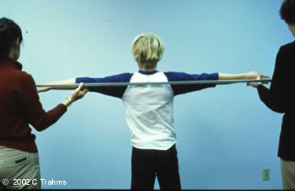 | This is a photo of correct technique for arm span measurement. Note that the child's arms are perpendicular to his body and the anthropometer is touching the extended middle fingers of the right and left hands.

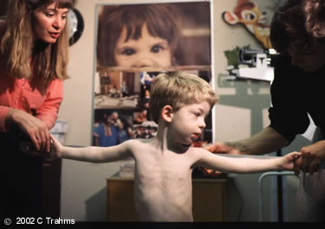 | This is a photo of incorrect technique for arm span measurement. This child is not able to extend his arms fully, so an inaccurate measure would be taken. Therefore, arm span is not an appropriate measurement for this child.
Segmental lengths: Upper arm length and lower leg length
For some children for whom stature measurements are impossible, segmental lengths (for example, upper arm length and lower leg length) can be used to monitor growth.

Upper arm length is not as affected by a high spinal lesion as stature. It is recommended for children with spina bifida who are bedridden or wheelchair bound (or for other children unable to stand or stretch out on the length board) (Cloud, 1997; Scott, 1997).

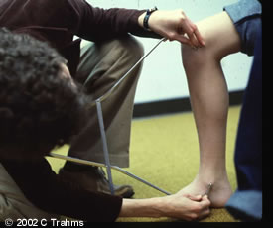

For children with cerebral palsy or other conditions that cause or result in contractures, lower leg length can be measured using either a steel or plastic tape measure or an anthropometer. This is a difficult measurement to take and, when taken, should be used with children ages 6-18 years (Cloud, 1997; Scott, 1997; Chumlea, Guo, Steimbaugh, 1994).

These measurements may be plotted on the CDC charts for stature-for-age or length-for-age. Even if measurements fall below the 5th percentile, they establish a growth pattern over time. Reference data exist for some segmental lengths (e.g., knee height), however they are old and do not include children with special health care needs or children who are non-ambulatory (and therefore may have different growth patterns) (Chumlea, et al, 1994)

Weight measures

Weight should be measured on beam-balance or digital scales. For children and adolescents with special needs who are unable to stand, chair scales, bucket scales and wheelchair scales should be used. In some facilities, bed scales may be available.

In clinical situations where equipment is limited to standing scales, it may be necessary to weigh someone (for example, a parent or caregiver) holding the child, weigh the parent or caregiver alone, and then subtract the weight of that person from the weight of the two together.

Sequential weights are important, and the child should always be wearing the same amount of clothing. Braces and special shoes should be removed in order to obtain an accurate weight. If the child wears braces, the braces may be weighed once, separately, and then subtracted from subsequent weight measurements.

Information about equipment, including sources for special scales is found in the module, Accurately Weighing & Measuring Infants, Children and Adolescents: Equipment.
4. Using corrected age to plot measures for low birthweight and premature infants

Low birthweight infants form a heterogeneous group that includes premature infants and those born at term. Therefore, it is important to classify low birth weight infants according to their weight for their gestational age.

Growth charts based on a large longitudinal cohort of premature infants from the Infant Health and Development Program (IHDP) are available for two ranges of birthweights: 1500 grams or less and 1501-2500 grams. (Guo 1997, Guo 1996) When these charts are used for premature infants, the measures should be plotted according to the corrected age. This is also true when the CDC infant (0-36 months) charts are used.

Corrected (or gestation-adjusted) age is determined by subtracting the number of weeks of prematurity from the infant's chronological age. Guidelines for calculating an infant's corrected (or gestation-adjusted) age are provided in the module, Overview of the CDC Growth Charts.

For most premature infants, the corrected age should be used until he or she reaches 2 years when plotting length, weight, and head circumference. For the premature infant weighing less than 1000 grams at birth, the corrected age is often used until age 3 years. If the child's growth "catches up" before 24-36 months of age, chronologic age is used instead of corrected age.

In many clinical settings, corrected age is used until the transition from the birth to 36 month charts to the charts for 2 to 20 year olds.

Infants born small for gestational age may fall below the 5th percentile on the CDC charts, even when corrected for gestational age. However, the CDC charts can be used to assess an infant's rate of growth; growth rate should parallel that of the reference infants.

5. Body Mass Index-for-age

A recent report by the Surgeon General cited obesity as a major concern among adults with mental retardation and underscored the need to prevent obesity and increase physical activity. (Satcher, 2001.)

Body mass index-for-age is the recommended method of screening for overweight, as well as for risk of overweight in children 2-20 years.

Conditions, such as trisomy 21, spina bifida, and cerebral palsy are commonly associated with reduced growth in length and/or stature compared to that of typically-developing children (Cloud, 1997; Scott, 1997; Ekvall, 1993). Weight gain of children with reduced linear growth may be similar to typically-growing children; this increases the potential for problems with overweight. Prevention and management of overweight in children with special health care needs is often a large component of the medical plan. Thus, detection of risk for overweight is critical, and the use of BMI-for-age can be very helpful.

Differences in bone size and fat and muscle distribution make the use of the reference data for many estimators of body composition inappropriate for many children with special health care needs. For example, BMI-for-age may not identify overweight in some children who are "overfat" because of decreased muscle mass.

Since the body composition of a child with special health care needs may differ from that of the reference population, skinfold measurements, along with BMI-for-age, may provide additional critical information about a child's body composition. This information can be useful for monitoring changes in an individual's body composition and growth pattern.

Example: Body Mass Index-for-age

JS is a 10 year old girl with trisomy 21. Her growth charts indicate the following:

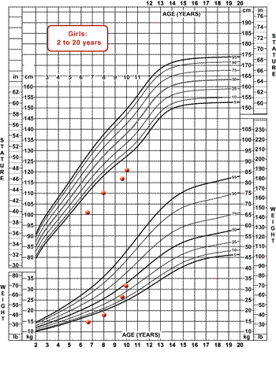 | - Stature-for-age has been consistently below the 5th percentile.  - Weight-for-age has increased from below the 5th percentile at ages 6 1/2 years and 8 years to between the 25th and 50th percentiles at age 10 years.

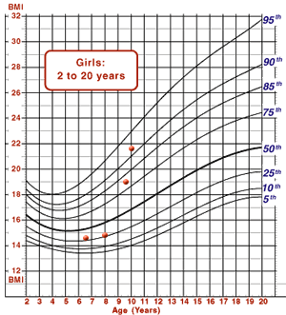 | - BMI-for-age has increased from close to the 25th percentile at ages 6 1/2 years and 8 years to between the 90th and 95th percentiles at age 10 years.

This information is shared with JS's parents, along with concerns that JS is at risk for overweight. A referral is made to a registered dietitian who has experience working with children with trisomy 21. JS's food pattern is modified slightly, and after six months, her rate of weight gain has slowed, and his BMI-for-age is more appropriate.
Read more about skinfold measures

Skinfold measures can provide information about an individual's body composition. One of the most commonly used skinfold measurements is triceps skinfold. Along with mid-upper arm circumference, this measurement can used to estimate arm fat and arm muscle area. Subscapular skinfold measurements are also useful for estimating fat stores.

The measurements should be taken with an accurate, calibrated skinfold caliper and a flexible, nonstretchable tape measure. Accurate measurement requires training and regular practice and validation.

Reference data exist for children over 1 year of age, but it should be noted that the children in the data set did not have special health care needs. Differences in bone size and fat and muscle distribution make the use of the reference data inappropriate for many children. Skinfold measurements are best used for monitoring changes over time.

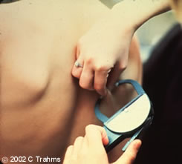 | 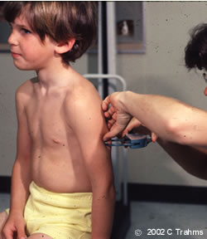
Subscapular skinfold measurmenet | Triceps skinfold measurement

References for skinfold measurement and interpretation

Technique

- Lohman TG, Roche AF, Martorell R. Anthropometric Standardization Reference Manual. Illinois: Human Kinetics; 1988.

- Nardella M, et al. Nutrition Interventions for Children with Special Health Care Needs. Washington State Department of Health. 2001.

Reference data
- Frisancho AR. New norms of upper limb fat and muscle areas for assessment of nutritional status. Am J Clin Nutr. 1981; 34:2540-2545.

- Gurney JM, Jelliffe DB. Arm anthropometry in nutritional assessment: a nomogram for rapid calculation of muscle circumference and cross-sectional muscle and fat areas. Am J Clin Nutr. 1973; 26:912-915.

- Tanner JM, Whitehouse RH. Revised standards for triceps and subscapular skinfolds in British children. Arch Dis Child 1975; 50:142-145.
6. Issues regarding the use of condition-specific growth charts

In the case of chromosomal or genetic disorders, there may be a clear rationale for the development of reference growth data based on altered growth potential. However, other conditions exist which are also associated with altered growth patterns but where there is not a clear rationale for the development of such reference data. The most important reason for this is that there is no identifiable alteration in the genetic potential for growth in these conditions; rather, there is some other factor, either biological or environmental, which may influence the child's ability to achieve that potential.

Growth charts have been developed for a number of conditions for which growth patterns are altered. These include:

- Trisomy 21 (Down syndrome) (Cronk, 1988)
- Prader-Willi syndrome (Holm, 1995)
- Williams syndrome (Morris, 1988)
- Cornelia deLange syndrome (Kline, 1993)
- Turner syndrome (Ranke, 1983; Lyon, 1985)
- Rubinstein-Taybi syndrome (Reference)
- Marfan syndrome (Pyeritz, 1983; Pyertiz, 1985)
- Achondroplasia (Horton, 1978)

The current CDC recommendation is to use the CDC growth charts in all cases. However, recognizing the limitations of these special charts, which are discussed below, some clinicians may elect to use them, for example to illustrate to families how a specific condition can alter a child's growth potential.

Use of the special charts developed to assess growth of children who have conditions with no genetic or chromosomal basis for an altered growth pattern, such as cerebral palsy, is not recommended.

Limitations of specialized growth charts

The usefulness of specialized growth charts is limited by a number of factors:

- Developed from very small samples

- Data do not reflect racial, ethnic, or geographical diversity

- Old data used to construct the charts

- Difficult to be sure that the data are representative of the population as a whole or come from a well-nourished group of children within that population

- Inconsistent measuring techniques used (in some cases, chart reviews were used to collect data; for other cases, the measurement techniques were not clearly defined)

- Secondary medical conditions which influence growth potential (and which often accompany a primary chromosomal disorder) not considered

The charts based on the growth of children with trisomy 21 provide some examples of these limitations. (Because trisomy 21 is a chromosomal anomaly, growth potential is altered, and the development of reference data based on this alteration is reasonable.) The clinician using the special charts should be aware of limitations:

- The children in the sample were of limited diversity with respect to race, ethnicity and the geographic location of their residence.

- The nutritional status of the children in the sample was not assessed, so it is difficult to ascertain whether or not the data represent a well-nourished group of children or reflect problems with nutritional status.

- The existence of secondary medical conditions affecting growth (congenital heart disease, which affects about 40% of children with trisomy 21, and feeding problems, which are present in up to 80% of children with trisomy 21) was not considered in developing the reference data.
7. Application of principles

Example 1: Child with trisomy 21

AB was followed in an early intervention program from 3 weeks until 41 months of age. Feeding was never a problem, but she was at risk for overweight. At 35 months of age, hypothyroidism was diagnosed, and medication was started.

Her growth was plotted on the CDC charts (head circumference-for-age, weight-for-age, length-for-age, weight-for-length, stature-for-age, and BMI-for-age). Because she was followed past the age of 3 years, both the 0-36 month and the 2-20 years charts were used.

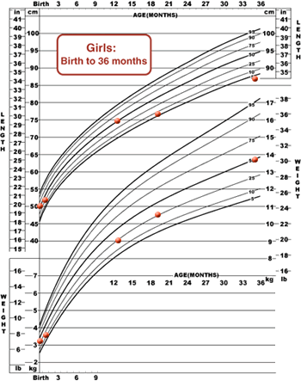 | 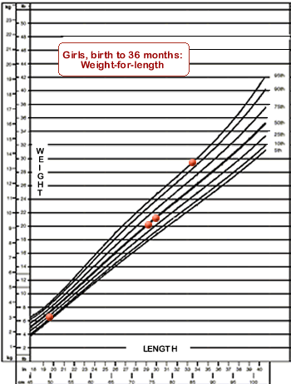
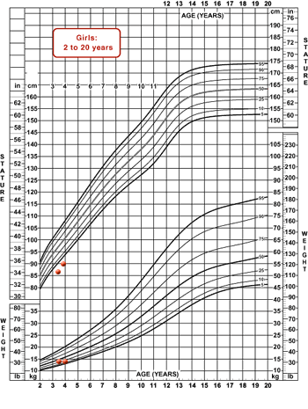 | 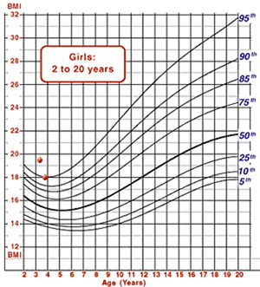

Year 1
- Her length-for-age started at about the 25th percentile, and increased to about the 50th percentile at age 13 months.
- Weight-for-age was about the 25th percentile.
- Weight-for-length increased from about the 25th percentile to about the 50th percentile.

Year 2
- Length-for-age decreased from about the 50th percentile at age 13 months to between the 5th and 10th percentiles at age 20 months.
- Weight-for-age continued along the 25th percentile.
- Weight-for-length continued along the 50th percentile.

Year 3
- Although the recommendation is to use the 2-20 year old charts for children over the age of 2 years, the 0-36 month charts were used for AB.
- AB was not able to stand unassisted, so length was measured, and length-for-age and weight-for-age were plotted on the appropriate charts.
- Length-for-age continued to decrease to slightly below the 5th percentile.
- Weight-for-age increased to about the 50th percentile.
- Weight-for-length increased to the 95th percentile.

AB's family was interested in how her growth compared to the growth of other children with trisomy 21. The limitations of the condition-specific growth charts were explained:

- Small sample size with limited diversity

- Reflect growth of children with and without cardiac problems and feeding problems; not necessarily "ideal" growth pattern

The condition-specific growth chart was used to make the following points:
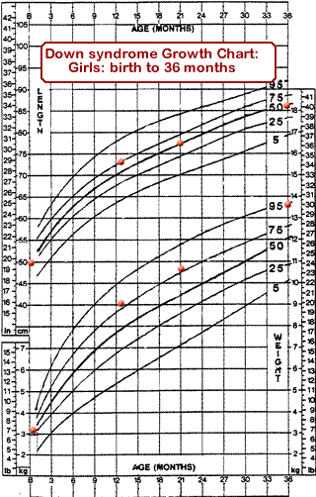 | - AB seems "short for her age" when compared to typically-developing children; when compared to other children with trisomy 21, she is not "short."
 | - At the age of 35 months, even among children with trisomy 21, AB's weight is at the 95th percentile for age.

Example 2: Child with low birthweight

LH is a 3-year-old twin girl born at 27 weeks gestation with a birthweight of 1030 gm, appropriate for gestational age. All weight and length measurements were plotted using corrected age.

Corrected age is determined by subtracting the number of weeks premature from the infant's chronological age.

Corrected age = Chronological age - number of weeks premature

LH was born at 27 weeks gestation and is now 3 years (or 36 months or 156 weeks) past her date of birth:

Step 1:
40 weeks - 27 weeks = 13 weeks, or 3 months, 1 week premature.

Step 2:
corrected age = 156 weeks - 13 weeks = 143 weeks corrected age (33 months or 2 years, 9 months)

or

Step 2:
corrected age = 36 months - 3 months = 33 months corrected age

LH was walking with assistance at age 3 years. The length measure was used due to her lack of stability when standing.

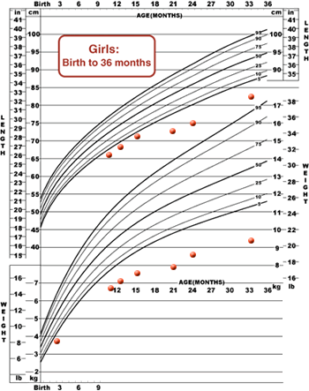 | 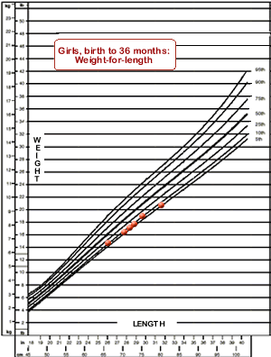
- Weight-for-age, length-for-age, and head circumference-for-age (not shown) are all consistently below the 5th percentile. | - Weight to length relationship at age three was at the 10th percentile.

Because LH was born with a very low birthweight (VLBW <1500 grams), IHDP charts were also used to assess her growth.

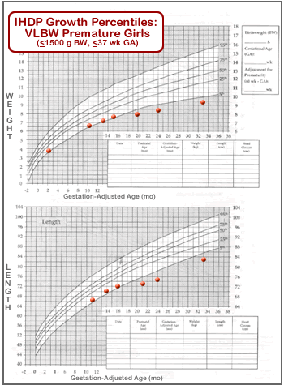 | 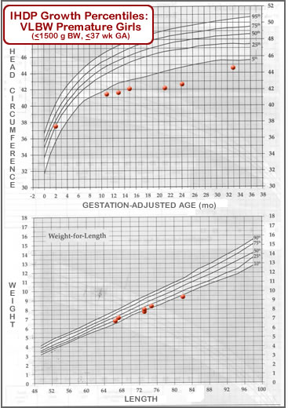
- Weight-for-age decreased from between the 5th and 25th percentiles at age 2 months (corrected age) to below the 5th percentile by age 21 months (corrected age). | - Head circumference-for-age decreased from the 5-25th percentile at age 2 months (corrected age) to below the 5th percentile.
- Length-for-age decreased from between the 5th and 25th percentiles at age 11 months (corrected age) to below the 5th percentile by age 21 months (corrected age). | - Weight-for-length remained relatively constant, between the 10th and 25th percentiles.

Self-test: Child with spina bifida

MW is a 7 year, 10 month old male with spina bifida (myelomeningocele) in the high lumbar area. Physical activity is limited, but MW is able to use his arms and shoulders. He is unable to stand, so a stature measurement cannot be taken.
Which alternative to stature is most appropriate?

- crown-rump length
- arm span
- upper arm length
- lower leg length

Because MW is able to sit upright and extend his arms, arm span is the best answer. Crown-rump length is more appropriate for a child who cannot extend his arms and who cannot sit upright. Upper arm length is used for a child who is unable to extend his arms and/or sit upright. Lower leg length is used for a child with contractures of the upper or lower body.
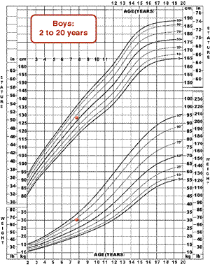 | MW's stature was approximated using arm span. His measures were:  - Arm span: 127 cm (50 in)  50-75th percentile  - Weight 30 kg (64.25 lb)  75-90th percentile  Because arm span was used to approximate stature and there are no data to support the use of arm span with BMI, BMI was not calculated.  Triceps skinfold measurements, along with mid-arm circumference measurements were used to monitor MW's growth and assess his body composition.

Self-test: Child with Prader-Willi syndrome

EM is a 6 year, 10 month old girl with Prader-Willi syndrome. Her weight- and stature-for age are shown in the following CDC growth chart: | 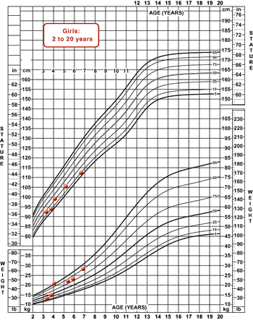

Which of the following methods is most appropriate to assess EM's weight gain pattern?

- weight-for-length
- BMI-for-age
- sitting height
- triceps skinfold

BMI-for-age is recommended to identify risk of overweight. Because EM is older than 3 years, the weight-for-length charts are inappropriate. It is possible to measure EM’s stature, so an estimator of stature (e.g., sitting height) is not necessary. Triceps skinfold may provide information about changes in EM’s body composition over time, but BMI-for-age is more useful at this time.

EM weighs 29.5 kg and is 110.5 cm tall. What is Em's BMI?

- 26.7
- 26.3
- 24.2
- 21.9

The correct response is c. 24.2.
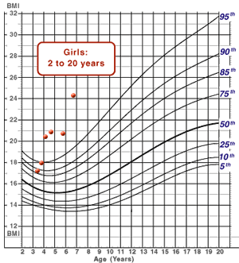 | When plotted on the BMI-for-age chart, BMI-for-age is greater than the 95th percentile, indicating that EM is overweight.

8. References and resources

References

Anderson DM. Nutrition for premature infants. In: Samour PQ, Helm KK, Lang C, Eds, Handbook of Pediatric Nutrition, 2nd edition. 1999. Gaithersburg, MD: Aspen Publishers.

Chumlea WC, Guo SS, Steinbaugh ML. Prediction of stature from knee height for black and white adults and children with application to mobility-impaired or handicapped persons. J Am Diet Assoc 1994; 94(12): 1385-1388.

Cloud HH, Update on nutrition for children with special needs. Top Clin Nutr 1997; 13(1): 21-32.

Cronk C, Crocker AC, Pueschel SM, et al. Growth charts for children with Down syndrome: 1 month to 18 years of age. Pediatrics 1988; 81(1): 102-110.

Ekvall SW. Myelomeningocele. In: Ekvall SW, Ed. Pediatric Nutrition in Chronic Disease and Developmental Disorders, Prevention, Assessment and Treatment. 1993. New York: Oxford University Press.

Ehrenkranz RA, Younes N, Lemons JA, et al. Longitudinal growth of hospitalized very low birth weight infants. Pediatrics 104:280-9. 1999.

Feucht S, Lucas B. Nutrition issues for children with Down syndrome. Nutrition Focus 2000, 15(5).

Frisancho AR. New norms of upper limb fat and muscle areas for assessment of nutritional status. Am J Clin Nutr 1981; 34:2540-2545.

Guo SS, Roche AF, Chumlea WC, et al. Growth in weight, recumbent length, and head circumference for preterm low-birthweight infants during the first three years of life using gestation-adjusted ages. Early Hum Dev 1997; 47: 305-325.

Guo SS, Wholihan K, Roche AF, et al. Weight-for-length reference data for preterm, low-birth-weight ifnats. Arch Pediatr Adolesc Med 1996; 150: 964-970.

Gurney JM, Jelliffe DB. Arm anthropometry in nutritional assessment: a nomogram for rapid calculation of muscle circumference and cross-sectional muscle and fat areas. Am J Clin Nutr 1973; 26:912-915.

Hamill PV, et al. Body weight, stature, and sitting height. US Vital and Health Statistics, Series 11, #126; Publication No. HSM 73-1606. Washington CD: US Government Printing Office, 1973.

Holm V. in Greenswag LR, Alexander RC. Management of Prader-Willi Syndrome, 2nd ed. 1995. New York: Springer-Verlag.

Horton WA, Rotter JI, Rimoin DL, et al. Standard growth curves for achondroplasia. J Pediatr 1978; 93(3):435-438.

Kline AD, Barr M, Jackson LG. Growth manifestations in the Brachmann-deLange syndrome. Am J Med Genet 1993; 47(7): 1042-1049.

Lohman TG, Roche AF, Martorell R. Anthropometric Standardization Reference Manual. 1988. Illinois: Human Kinetics.

Lyon AF, Preece MA, Grant DB. Growth curves for girls with Turner syndrome. Archives of Disease in Childhood 1985; 60(10):932-935.

McCammon RW, Ed. Human Growth and Development. 1970. Springfield, IL: Charles C Thomas.

McPherson M, Arango P, Fox H, et al. A new definition of children with special health care needs. Pediatrics 1998; 102:137-140.

Morris CA, Demsey SA, Leonard CO, et al. Natural history of Williams syndrome: physical characteristics. J Pediat. 1988; 113(2):318-326.

Pyeritz RE. in: Emery AH, Rimoirn DL, Eds. Principles and Practice of Medical Genetics. 1983. New York: Churchill Livingstone.

Pyeritz RE. in: Papadatas CJ, Bartsocas CS, Eds. In: Endocrine Genetics and Genetics of Growth. 1985. Alan R. Liss, Inc.

Ranke MB, Pfluger H, Rosendahl W, et al. Turner syndrome: spontaneous growth in 150 cases and review of the literature. Eur J Pediatr 1983; 141(2):81-88.

Roche AF, Guo SS, Wholihan K, Casey PH. Reference data for head circumference-for-length in preterm low-birth-weight infants. Arch Pediatr Adolesc Med 151:50-7. 1997.

Satcher D. Statement of the Surgeon General on the Special Hearing on Promoting Health for People with Mental Retardation before the US Senate Committee on Appropriations, Anchorage AK. March 5, 2001.

Scott BJ, Artman H, Hill LA. Monitoring growth in children with special health care needs. Top Clin Nutr 1997; 13(1): 33-52.

Stevenson RD, Nutrition and feeding of children with developmental disabilities. Ped Annals 1995; 24 (5) 255-260.

Stevenson RD, Roberts CD, Vogtle L. The effects of non-nutritional factors on growth in cerebral palsy. Developmental Medicine and Child Neurology 1995; 37:124-130.

Tanner JM, Whitehouse RH. Revised standards for triceps and subscapular skinfolds in British children. Arch Dis Child 1975; 50: 142-145.

Trahms C, Pipes P. Nutrition in Infancy and Childhood. 6th ed. 1997. Washington: McGraw-Hill.

Resources

Akefeldt A, Gilberg C. Behavior and personality characteristics of children and young adults with Prader-Willi syndrome: a controlled study. Journal of the American Academy of Child and Adolescent Psychiatry 1999; 38(6):761-769.

Bandini LG, Schneller DA, Fukagana NK,Wykes L, Dietz WH. Body composition and energy expenditure in adolescents with cerebral palsy or myelodysplasia. Pediatr Res 1991; 29:70-72.

Cassidy SB. Prader-Willi syndrome. J Med Genetics 1997; 34(11):917-923.

Cloud HH. Impact of legislation on nutrition services for individuals with developmental disabilities. Top Clin Nutr 1993; 8(4):1-4.

Corwin DS, Isaacs JS, Georgeson KE, et al. Weight and length increases in children after gastrostomy placement. J Am Diet Assoc 1996; 96(9): 874-879.

Eiholzer U, Weber R, Stutz K, et al. Effect of 6 months of growth hormone treatment in young children with Prader-Willi syndrome. Acta Paediatrica Supplement 1997; 423:66-68.

Harris AB, Blyler EM, Baer MT. Nutrition Strategies for Children with Special Needs. 1999. University of Southern California, University Affiliated Program. Center for Child Development and Developmental Disabilities, Childrens Hospital Los Angeles.

Nardella M, et al. Nutrition Interventions for Children with Special Health Care Needs 2001. Washington State Department of Health.

Pueschel SM. General health care and therapeutic approaches. In: Pueschel SM, Pueschel JK, Eds. Biomedical concerns in persons with Down Syndrome. 1992. Baltimore:Paul H. Brooks Publishing Co.

Roe DA. Drug and Nutrient Interactions. 1989. Chicago, IL: American Dietetic Association.

Stallings VA, Cronk CE, Zemme BS, et al. Body composition in children with spastic quadriplegic cerebral palsy. J Pediatr 1995; 126(5 pt 1):833-839.

Story M, Holt K, Sofka D, Eds. Bright Futures in Practice: Nutrition. 2000. Arlington, VA. National Center for Education in Maternal and Child Health.

Unonu JN, Johnson AA. Feeding patterns, food energy, nutrient intakes and anthropometric measures of selected black preschool children with Down syndrome. J Am Diet Assoc 1992; 92(7):856-858.

Glossary

Appropriate for gestational age (AGA):Infants whose birthweights are as expected for their gestational age; 10th - 90th percentile is often used.

Arnold Chiari malformation: a malformation that can accompany myelomeningocele and other neural tube disorders where the cerebellum and medulla oblongata protrude into the spinal canal.

Asymmetric IUGR: IUGR that has resulted in weight and length measurements that are less than expected for gestational age, but a "normal" head circumference.

Bronchopulmonary dysplasia (BPD): a chronic lung disorder that is most common among children who were born prematurely, with low birthweights, and who received prolonged mechanical ventilation.

Catch-up growth: a term used to describe a rate of growth that is faster than expected. For infants born with low birthweights or small for gestational age, catch-up growth can describe gains in weight or length where the measurement reaches the 5th percentile for age (when it had previously been below the 5th percentile). In other instances, catch-up growth refers to weight and/or height gains when a child who has experienced stunted growth receives adequate energy and protein.

Cerebral palsy: a motor nerve disorder caused by injury to the central nervous system; symptoms depend on the area of the brain involved and the severity of the damage.

Contractures: static muscle shortening resulting from tonic spasm or fibrosis; frequently seen in individuals with cerebral palsy.

Cornelia deLange syndrome: a congenital syndrome characterized by short stature, microcephaly, delayed development and mental retardation, a number of distinct facial features, and upper limb anomalies; also referred to as deLange syndrome and Brachmann-deLange syndrome.

Corrected age: the age of an infant from birth, less the number of weeks premature.

Early intervention services: established by Part H of P.L. 97-457 of 1986 (now Part C of the IDEA of 1997); community-based therapeutic and educational services for infants and children under 3 years of age with developmental delays.

Encephalopathy: any degenerative disease of the brain.

Gastroesophageal reflux (GER): regurgitation of the contents of the stomach into the esophagus, where they can be aspirated; often results from a failure of the esophageal sphincter to close.

Gestational age: the age of a fetus or newborn, usually stated in weeks from the first day of the mother's last menstrual period.

Hypotonia: diminished muscle tone.

Infant Health and Development Program (IHDP): a national collaborative clinical study of low birthweight preterm infants.

Intrauterine growth retardation (IUGR): development of the fetus that is delayed related to gestational age.

Intraventricular hemorrhage: bleeding into or near the ventricles within the brain; severity ranges from Grade I to Grade IV.

Low birth weight: infants weighing between 1500 and 2500 g at birth.

Myelomeningocele: a congenital defect that results in a hernia (containing the spinal cord, the meninges and cerebral spinal fluid) along the spinal column, also called spina bifida.

Neural tube defects: any defect of the brain and spinal cord that is caused by failure of the neural tube to close during growth during pregnancy.

Prader-Willi syndrome: a genetic disorder marked by hypotonia, short stature, hyperphagia and cognitive impairment.

Rett syndrome: an X-linked disorder marked by progressive neurological deterioration, seizures, and microcephaly.

Scoliosis: a sideways curve of the spine resulting in an S shape of the back.

Small for gestational age: infants whose birthweights are less than expected for their gestational age; <10th percentile is often used.

Symmetric IUGR: IUGR that has resulted in weight, length, and head circumference measurements that are less than expected for gestational age.

Triceps skinfold measures: measurement of the skin and subcutaneous fat layer around the triceps muscle, used with arm circumference measurement to estimate fat and muscle stores.

Turner syndrome: a disorder in females marked by the absence of one X chromosome, typically characterized by ovarian failure, genital tissue defects, cardiac problems, and short stature.

Trisomy 21: a genetic disorder in which an individual has an extra 21st chromosome, typically characterized by low muscle tone, cardiac problems, GI malformations, and a distinct facial appearance; also called Down syndrome.

Very low birth weight: infants weighing less than 1500 g at birth.

[END OF MODULE]

