Accurately Weighing and Measuring: Technique

INTRODUCTION

With the availability of the WHO Growth Standards, it is an opportune time for all pediatric health care providers to re-evaluate the tools they use and the approach they have in their clinical setting for measurement, plotting and interpretation of growth charts.

This module reviews equipment for measuring and recording length, weight, and head circumference for infants, children and adolescents.

The information in this module is intended for the measurement of typically developing children. Another module provides information on the measurement techniques to be used when children have special physical considerations.

In this module ‘length’ refers to the measurement technique for infants. Length is measured in the recumbent position. ‘Stature’ refers to the child and adolescent ‘height’ measure. Stature is measured standing.

OBJECTIVES

- To present accurate techniques for measuring weight, length and head circumference for infants
- To present accurate techniques for measuring weight and stature for children and adolescents

TABLE OF CONTENTS

1. Importance of Reliable and Accurate Measurements

2. Three Components of Accurate Measuring

3. Weighing Infants

4. Measuring Infant Length

5. Measuring Head Circumference

6. Weighing Children and Adolescents

7. Measuring Child and Adolescent Stature

8. Which Units to Use?

9. Plotting Measurement Data

10. References

- WHY IS IT IMPORTANT TO WEIGH AND MEASURE INFANTS, CHILDREN AND ADOLESCENTS ACCURATELY?

Accuracy is important in obtaining all pediatric size measurements because these measurements will be used as the basis of clinical assessment and to calculate Body Mass Index (BMI).

If growth is not proceeding as expected for an individual of a given age based on the size measures, then referral for additional evaluation may be necessary to address the concern.

The measurement process has two steps:

1. measure

2. record

If measures are in error, then the foundation of the growth assessment is also in error. It is important to have the date, age, and actual measurements recorded so the data may be used by others or at a later point in time.

- Many clinical decisions and clinical interventions are based on physical measurements

- Accurate and reliable physical measures are used to:
- monitor the growth of an individual
- detect growth abnormalities
- monitor nutritional status
- track the effects of medical or nutritional intervention

Parameters of Measurement Accuracy

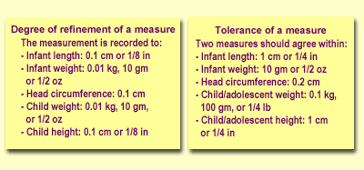

To address quality assurance issues, there are two sets of numbers of interest.

The first set is the degree of refinement of a measure. That is, the degree to which a measure is recorded. For example, infant weight is recorded to 0.01 kg, 10 grams, or 1/2 ounce. If a newborn infant was weighed only to 0.1 kg, 100 grams, or 3 ounces, a rate of weight gain of less than 100 grams would not be reflected in the measure.

The tolerance of a measure is the difference between two measures that is accepted as reasonable accuracy. The tolerance of a measure is generally larger than the degree of refinement of a measure. For example, the weight of an infant is recorded as 3.12 kg and on re-measuring it is recorded as 3.13 kg. These measures are within an acceptable tolerance. If, however, the infant was weighed at 3.12 kg and a second measure was 3.2 kg, the infant should be re-weighed. If the third measure was recorded as 3.11 kg, the average of the two closest measures would be recorded.

The tolerance of a measure is generally larger for measures of older children and adolescents because small changes are less critical for the interpretation of growth.

2. THREE COMPONENTS OF ACCURATE MEASURING

Accurate weighing and measuring have three critical components. These are: technique, equipment, and trained measurers.

Technique: Standardized

Equipment: Calibrated, accurate

Trained measurers: Reliable, accurate

Appropriate technique for each measure must be utilized. The techniques should be very similar to those used to obtain data to develop the growth charts. These measures should be performed by a trained measurer so they are both accurate and reliable.

Accurate, calibrated equipment appropriate to the measurements being obtained is required. (Appropriate equipment is addressed in the Accurately Weighing and Measuring: Equipment module.)

There is a deceptive simplicity about the measurement of length or stature and weight. Many measurers believe the procedures to be so straightforward and obvious that they do not require any training to accurately perform the measures. However, standardization exercises have demonstrated that even experienced measurers can be inaccurate or even careless in performing weight and length or stature measurements.

The individual obtaining the measurements must understand the importance of reliable equipment, standardized technique, and the need for reproducible and accurate physical growth data.

Much of pediatric clinical assessment is based on the physical measurement data obtained and plotted on a growth chart. If this information is not reliable because of inadequate equipment, unacceptable technique or recording error, the data may lead to a clinical impression that is in error.

3. WEIGHING INFANTS: EQUIPMENT AND PREPARATION

The specific recommendations for equipment necessary for accurate and reliable weighing are presented in the companion Accurately Weighing and Measuring: Equipment module. It is assumed that the scale has appropriate precision of 0.01 kg or 1/2 oz. for weighing an infant and is calibrated.

It is important that the infant be weighed using procedures similar to those used to collect the data for constructing the charts. It is also important to use consistent procedures.

The NHANES weight data were collected from infants who were wearing clean disposable diapers. Infants in the WHO Multicentre Growth Reference Study were weighed nude. Weighing infants with too much clothing is one of the most frequent sources of error in infant weight measurements. This causes infants to be ‘weighed heavy’; an infant will appear to weigh more than he actually does.

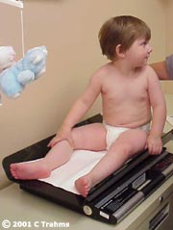 | - Infant is weighed nude or in a clean diaper on  a calibrated beam or electronic scale

Weighing Infants: Procedures

It is desirable that two people be involved with infant weight measures. One measurer will weigh the infant (and protect the infant from harm ... falling, etc.) and read the weight as it is obtained. The other measurer will immediately note the measurement in the infant’s chart.

The infant’s clothing is removed and the infant is nude or wearing a clean, dry diaper.

Regardless of the type of infant scale used, the infant should be positioned in the center of the scale tray. Infants should be weighed to the nearest 0.01 kg or 1/2 oz.

The use of metric measures is encouraged when weighing infants, children, and adolescents in a clinical setting.

- Remove infant’s clothing and be sure the  diaper is clean and dry  - Center the infant on the scale tray  - Weigh infant to nearest 0.01 kg or 1/2 oz | 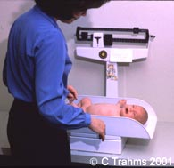

Weighing Infants: Quality of Measurements

Record the weight as soon as it is completed. Then the infant should be re-positioned and the weight measurement repeated and noted in writing.

After the infant is removed from the scale tray, the weights should be compared and they should agree within 0.1 kg or 1/4 lb.

If the difference between the weights exceeds the tolerance limit of 0.1 kg or 1/4 lb, the infant should be re-positioned and reweighed a third time. Then record the average of the two weights in closest agreement.

Experienced measurers will be adept at handling infants and sensitive to their response to physical manipulation. Confidence and a sure manner will be reassuring to parents.

- Write the weight on the infant’s chart

- Reposition and repeat weighing the infant

- Compare weights

- Weight should agree within 0.1 kg or 1/4 lb. This is the tolerance of the measure.

Weighing Infants: Alternative Approach

Occasionally, an infant is too active or too distressed for an accurate weight measurement. If the infant is too active, the measurement may be postponed until later in the clinic visit when the infant may be more comfortable with the setting.

An alternative measurement technique may be used if an electronic scale is available. Have the parent stand on the scale, reset (tare) the scale to zero, then have the parent hold the infant and read the infant’s weight. Remember that many adult scales generally only weigh to the nearest 100 gm.

- If infant is too active, postpone the measure until later

- Have parent stand on scale, tare, then read infant weight

4. MEASURING INFANT LENGTH: EQUIPMENT AND PREPARATION

Length, measured in the recumbent position, is the correct linear measurement for infants younger than 24 months of age or children aged 24 to 36 months who cannot stand unassisted.

Accurate length measurement requires a calibrated length board with certain features for measuring length in the recumbent position.

The critical components of a length board are 1) a fixed headpiece and 2) a moveable footpiece which is perpendicular to the surface of the table that the length board is on. Length boards are described in detail in the Accurately Weighing and Measuring: Equipment module.

It is important that infants be measured using procedures similar to those used in developing the charts. The NHANES length data were collected on infants wearing clean disposable diapers or diapers and undershirts.

Length measurements for infants and young children should be obtained while the child is dressed in light underclothing or a diaper. The child's shoes must be removed. Hair ornaments should be removed from the top of the head.

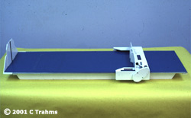 | - Length is measured with a suitable  measuring board  - Use a calibrated length board with  a fixed headpiece and movable  footpiece which is perpendicular to  the surface of the table  - Measure infant without shoes and  wearing light underclothing or diaper

Measuring Infant Length: Procedures

The child should be placed on his back in the  center of the length board so that the child is  lying straight and his shoulders and buttocks  are flat against the measuring surface. The  child's eyes should be looking straight up.  Both legs should be fully extended and the  toes should be pointing upward with feet flat  against the footpiece. | 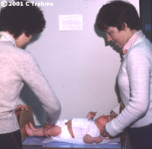

Accurate length measurements require two measurers. One measurer holds the infant’s head, with the infant looking vertically upward and the crown of the head in contact with the headpiece in the Frankfort Horizontal Plane. The head of the infant is firmly but gently held in position. The measurer gently cups the infant’s ears while holding the head. Make sure the infant's chin is not tucked in against his chest or stretched too far back.

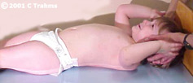 | While the second measurer holds the infant's  head in the proper position, the measurer  aligns the infant’s trunk and legs, extends  both legs, and brings the footpiece firmly  against the heels. The measurer places one  hand on the infant’s knees to maintain full  extension of the legs. The infant’s toes are  pointing upward.

It is imperative that both legs be fully extended  for an accurate and reproducible length  measurement. If only one of the infant’s legs  is extended during the length measurement,  the measurement may be unreliable and  inaccurate. Correctly positioning the infant for  a length measurement generally cannot be  accomplished without two measurers. | 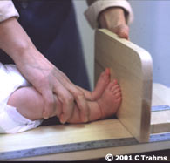

Parents may participate in the length measurement [between the two trained measurers] to provide reassurance and security to the infant.

Should length or stature be measured for a child aged 24 to 36 months? The best guideline is to think about the physical abilities of the child. Generally, if the child can stand unassisted and follow directions for proper positioning, a stature measure should be taken. However, if there are concerns about the child's growth and the previous measure was length, then length should be measured again. (See the CDC training materials: Case Example 5 for more information about transitions between charts.)

Maintaining a record of the child’s length on the "Birth to 36 months" chart may be helpful in circumstances where it is necessary to monitor small increments of growth.

What is the Frankfort horizontal plane?

The formal definition of the Frankfort horizontal plane is a line extending from the most inferior point of the orbital margin to the left tragion. The tragion is the deepest point in the notch superior to the tragus of the auricle.

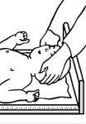  Illustration © Nardella, M, Campo, L, Ogata, B, eds. Nutrition Interventions  for Children with Special Health Care Needs, Olympia, WA, State Department of Health, 2001. | When the head is positioned correctly, the Frankfort horizontal plane is parallel to the fixed headpiece.  For length measures, the Frankfort plane is aligned perpendicular to the plane of the measuring table and parallel to the headpiece.

Measuring Infant Length: Quality of Measurements

The measurer at the feet should read aloud to the recorder the length measurement to the nearest 0.1 cm or 1/8 inch.

The length should be recorded on the data form as soon as it is completed.

Then the infant should be repositioned and the length measurement repeated and noted in writing.

After the infant is removed from the lengthboard, the length measurements should be compared and they should agree within 1 cm or 1/4 inch. This is the tolerance limit of this measure.

If the difference between the length measures exceeds the tolerance limit, the infant should be repositioned and remeasured a third time. The average of the two measures in closest agreement is recorded.

- Measure length to 0.1 cm or 1/8 inch  - Record measurement on chart  - Reposition and remeasure infant  - Measurements should agree to 1 cm  or 1/4 inch -- the tolerance of  the measure | 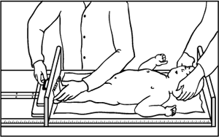  Illustration © Nardella, M, Campo, L, Ogata, B,  eds. Nutrition Interventions for Children with  Special Health Care Needs, Olympia, WA,  State Department of Health, 2001.

5. MEASURING HEAD CIRCUMFERENCE: EQUIPMENT AND PREPARATION

The specifications for equipment are presented in the Accurately Weighing and Measuring: Equipment module. It is assumed that the tape is appropriate for measuring an infant’s head circumference, that is, non-stretchable.

An accurate head circumference measure is obtained with a flexible non-stretchable measuring tape. A plastic tape such that one end inserts into the other is recommended.

Head circumference is generally measured on infants and children until age three years.

Head circumference or OFC [occipital frontal circumference] is measured over the most prominent part on the back of the head (occiput) and just above the eyebrows (supraorbital ridges). This can be translated to mean the largest circumference of the head.

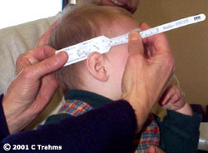 | - Head circumference is measured over  the most prominent part of the occiput  and just above the supraorbital ridges  - Use a flexible, non-stretchable tape

Measuring Head Circumference: Procedures

Any braids, barrettes, or other hair decorations that will interfere with the measurement should be removed.

The infant or child may be more comfortable in the arms or on the lap of a parent.

The tape is positioned just above the eyebrows, above the ears, and around the biggest part of the back of the head. The goal is to locate the maximum circumference of the head.

The tape is pulled snugly to compress the hair and underlying soft tissues.

The measurement is read to the nearest 0.1 cm or 1/8 inch and recorded on the chart.

- Position the tape just above the
eyebrows, above the ears, and
around the biggest part on the
back of the head

- Pull tape snugly to compress the hair

- Read the measurement to the
nearest 0.1 cm or 1/8 inch

- Write measurement on the chart

Measuring Head Circumference: Quality of Measurements

The tape should be repositioned and the head circumference remeasured.

The measures should agree within 0.2 cm or 1/4 inch.

If the difference between the measures exceeds the tolerance limit, the infant should be repositioned and remeasured a third time. The average of the two measures in closest agreement is recorded.

- Reposition tape and remeasure the head circumference

- Measures should agree within 0.2 cm or 1/4 inch

6. WEIGHING CHILDREN AND ADOLESCENTS: EQUIPMENT AND CALIBRATION

The specifics of equipment are presented in the Accurate Weighing and Measuring: Equipment module. It is assumed that the scale is appropriate for weighing a child or adolescent and is calibrated with a set of standard weights. It is important that the child or adolescent be weighed using procedures similar to those used to collect data for constructing the chart.

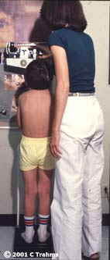 | - A child older than 36 months is weighed standing  on a scale  - Use a calibrated beam balance or electronic scale  - Child must be able to stand without assistance

Weighing Children and Adolescents: Procedures

For all children, there is a need to respect privacy. Privacy includes where the measurements are taken, clothing removal, provision of gowns, describing the measuring process, and interpreting the numbers.

The child or adolescent is weighed wearing only lightweight undergarments, or gown. The child or adolescent stands on the center of the platform of the scale.

The weight of the individual is recorded to the nearest 0.01 kg or 1/2 oz.

- Child or adolescent wears lightweight undergarments, gown, or lightweight outer clothing

- Child or adolescent stands on center of scale platform

Weighing Children and Adolescents: Quality of Measurements

The weight is recorded on the chart. The individual is repositioned and the weight measure is repeated.

The measures are compared; they should agree within 0.1 kg or 1/4 lb.

If the difference between the measures exceeds the tolerance limit, the infant should be repositioned and remeasured a third time. The average of the two measures in closest agreement is recorded.

- Reposition and repeat measure

- Measures should agree within 0.1 kg or 1/4 lb

7. MEASURING CHILD AND ADOLESCENT STATURE: EQUIPMENT AND PREPARATION

Stature or height is measured for children over the age of 24 months who can stand unassisted. Young children from 24 to 36 months may have either length or stature measured. The appropriate chart should be used for recording and plotting results. If length is measured, use the chart for birth-36 months; if stature is measured, use the chart for 2-18 years.

Accurate measurement of stature requires the use of a calibrated, vertical stadiometer with a movable headpiece, perpendicular to the vertical backboard.

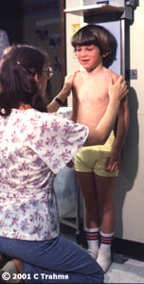 | - Measure stature for children over 24 months of age  - Use a calibrated vertical stadiometer with a  right-angle headpiece  - The child is measured standing with heels,  buttocks, shoulders and head touching a flat  upright surface

Measuring Child and Adolescent Stature: Procedures

The child or adolescent should stand on the footplate of the stadiometer without shoes. The person is positioned with heels close together, legs straight, arms at sides, shoulders relaxed. Ask the child to inhale deeply and to stand fully erect without altering the position of the heels. Make sure that the heels do not rise off the foot plate.

Lower the perpendicular headpiece snugly to the crown of the head with sufficient pressure to compress the hair. Hair ornaments, buns, braids, etc. must be removed to obtain an accurate measurement.

To ensure an accurate reading, the measurer’s eyes should be parallel with the headpiece.

- Child or adolescent stands against stadiometer without shoes, with heels together, legs straight, arms at sides, shoulders relaxed
- Child looks straight ahead
- Bring the perpendicular headpiece down to touch the crown of the head
- Measurer’s eyes are parallel with the headpiece

Measuring Child and Adolescent Stature

The measure is read to the nearest 0.1 cm or 1/8 inch and recorded on the chart.

The person is repositioned and remeasured.

The measures should agree within 1 cm or 1/4 inch.

The measure is recorded on the growth chart appropriate for age and gender.

What if Measures Exceed the Established Tolerance?

What if the two measures obtained in the clinical setting exceed the established tolerance for the measure?

For measures of weight for infants and children, the intra- and inter- observer reliability is generally very good. This assumes that the equipment is calibrated. If there is a measure that is an outlier, it is generally due to recording error or incorrectly reading the output on the scale.

Length, stature, and OFC measures are considered to be technically more difficult measures because of the importance of correct positioning on the measure. If two measures for these parameters are not within the established tolerance for the measure, then measure a third time. If two of the measures are within the tolerance, then take the average of these two measures.

In general, the guidelines are:
- If two measures are within the tolerance limits, use the mean of the two readings.
- If two measures are not within the tolerance limits, measure the child again.
- If two of the measures are then within the tolerance limits, use the mean of these measures.
- If none of the measures are within tolerance limits check your technique and plan a training session.

8. WHICH UNITS TO USE?

The choice of whether to use English or metric units for measurements and plotting can depend on a variety of circumstances.

If the available equipment is accurately calibrated and the measurers follow standard procedures, then data can be recorded in either English or metric units.

Many community clinics use English units, while most secondary and tertiary clinics and research projects prefer to use metric units.

The most important factors are to develop reliable techniques, to use calibrated equipment, and to perform accurate measurements.

Metric or English units?

Depends on user preference

Either unit is OK

Accuracy is most important

9. PLOTTING MEASUREMENTS

This section reviews techniques for plotting infant length, weight, and head circumference and will review the technique for plotting weight and stature measures for children and adolescents.

Appropriate use of the charts requires that all measures follow procedures similar to those used for the reference data. The Centers for Disease Control and Prevention (CDC) and the American Academy of Pediatrics (AAP) recommend using the WHO growth standard charts for children aged <24 months and the 2000 CDC growth reference charts for children aged 2 up to 2 years to monitor growth in the US.
It is essential to select the appropriate chart for the age and sex of the person measured.

The CDC and WHO Growth Charts are presented as:

Gender and age | Charts
Boys, birth to 24 mos. | Weight-for-length (WHO)
Boys, birth to 24 mos. | Weight-for-age (WHO)
Boys, birth to 24 mos. | Length-for-age (WHO)
Boys, birth to 24 mos. | Head circumference-for-age (WHO)
Girls, birth to 24 mos. | Weight-for-length (WHO)
Girls, birth to 24 mos. | Weight-for-age (WHO)
Girls, birth to 24 mos. | Length-for-age (WHO)
Girls, birth to 24 mos. | Head circumference-for-age (WHO)
Boys, 2 to 20 yrs. | BMI-for-age (CDC)
Boys, 2 to 20 yrs. | Weight-for-age (CDC)
Boys, 2 to 20 yrs. | Stature-for-age (CDC)
Girls, 2 to 20 yrs. | BMI-for-age (CDC)
Girls, 2 to 20 yrs. | Weight-for-age (CDC)
Girls, 2 to 20 yrs. | Stature-for-age (CDC)
Boys 2 to 5 yrs. | Weight-for-stature (CDC) (optional)
Girls 2 to 5 yrs. | Weight-for-stature (CDC) (optional)

In addition, the measurement obtained must match the chart (e.g. if length is measured, then length should be plotted, not stature).

- Select the appropriate chart for the age, sex, and measurements of the person measured

Carefully calculate the child's age

Incorrect calculation of the age of the infant or child can be a significant source of error in plotting, and thus assessment of the growth of the child.

Example  Jesse is an 8-month old female who  weighs 7 kg (5th-10th percentile) and  whose length is 65 cm (5th-10th percentile).  If she was plotted incorrectly as a  6-month old infant, both her weight  and length would lie between the  25th and 50th percentiles. | 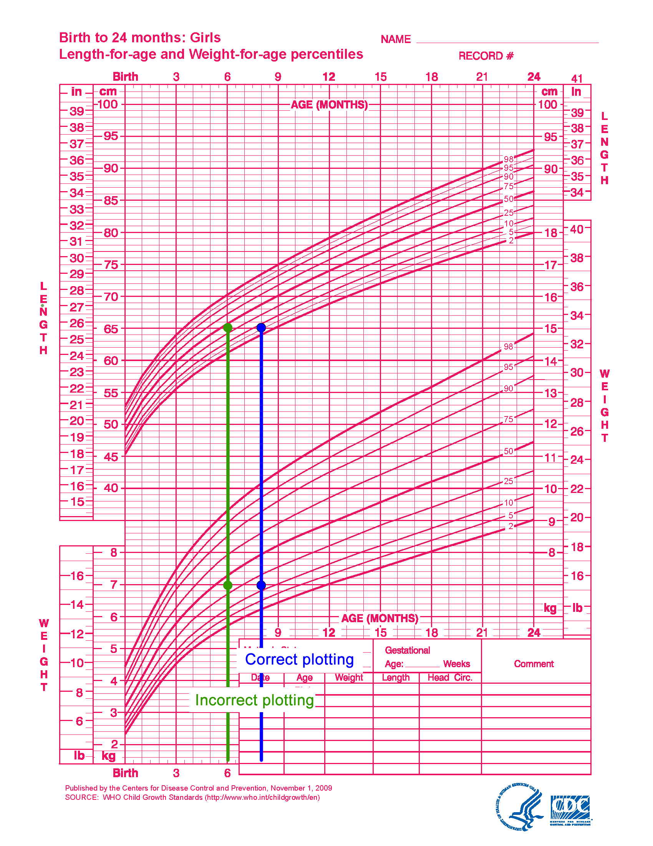

Would this error affect your clinical impression? If this was the only measure of this infant available, the clinical impression that both weight and length were between the 25th and 50th percentiles would be interpreted as appropriate growth for age. However, her actual growth between the 5th and 10th percentiles may be appropriate if this has been her growth pattern -- or it may warrant further investigation if it is a significant change from previous parameters.

Chronological age is the most influential variable in rapidly growing children, so it is essential to know the exact age of the child for plotting all measurements. Age calculated from the birthdate and the date of each set of measurements or the stated age should be recorded.

Example 1:

Today’s date is March 2, 2001.

You are measuring an infant who was born on October 15, 2000.

Set up the calculation. Subtract the birthdate from the date of the measurement. It may be necessary to convert months to days and years to months.

 | Year | Month | Day
Date of Measurement | 2001 | 03 | 02
 | 3. Convert year to  months by subtracting 1  from the years. | 1. Convert months to  days by subtracting 1  from the number of  months in the date  of measure.  4. Add 12 to the number  of months. | 2. Add 30 days to the  number of days in the  date of the measure.
Date of Birth | 2000 | 10 | 15
 | 2001 - 1 = 2000 | 03 - 1 = 2 + 12 = 14 | 02 + 30 = 32
 | 7. Subtract the birth  year from the number  of years. | 6. Subtract the birth  month from the number  of months. | 5. Subtract the day of  the birth from the  number of days.
 | 2000 - 2000 = 0 | 14 -10 = 4 | 32 - 15 = 17
Current Age | 0 years | 4 months | 17 days

The child’s age is 4 months, 17 days and is plotted as 4 1/2 months.

Example 2:

Today’s date is: June 12, 2001.

Your are measuring a child whose birthdate is August 20, 1998.

Set up the calculation. Subtract the birthdate from the date of the measurement. It may be necessary to convert months to days and years to months.

 | Year | Month | Day
Date of Measurement | 2001 | 06 | 12
 | 3. Convert year to  months by subtracting 1  from the years. | 1. Convert months to  days by subtracting 1  from the number of  months in the date  of measure.  4. Add 12 to the number  of months. | 2. Add 30 days to the  number of days in the  date of the measure.
Date of Birth | 1998 | 08 | 20
 | 2001 - 1 = 2000 | 06 - 1 = 5 + 12 = 17 | 12 + 30 = 42
 | 7. Subtract the birth  year from the number  of years. | 6. Subtract the birth  month from the number  of months. | 5. Subtract the day of  the birth from the  number of days.
 | 2000 - 1998 = 2 | 17 - 08 = 9 | 42 - 20 = 22
Current Age | 2 years | 7 months | 22 days

The child’ age is: 2 years, 9 months, 22 days and is plotted as 2 years, 9 1/2 months.

Plotting Measurements

A straight edge, right angle triangle or commercially available plotting aid is recommended to locate the intersecting point of the axis values.

- Plot the weight measurement on  the growth chart appropriate for  age and sex  - For accurate plotting of  measurements use a plotting aid  such as a straightedge | 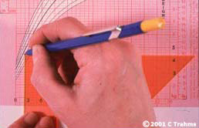

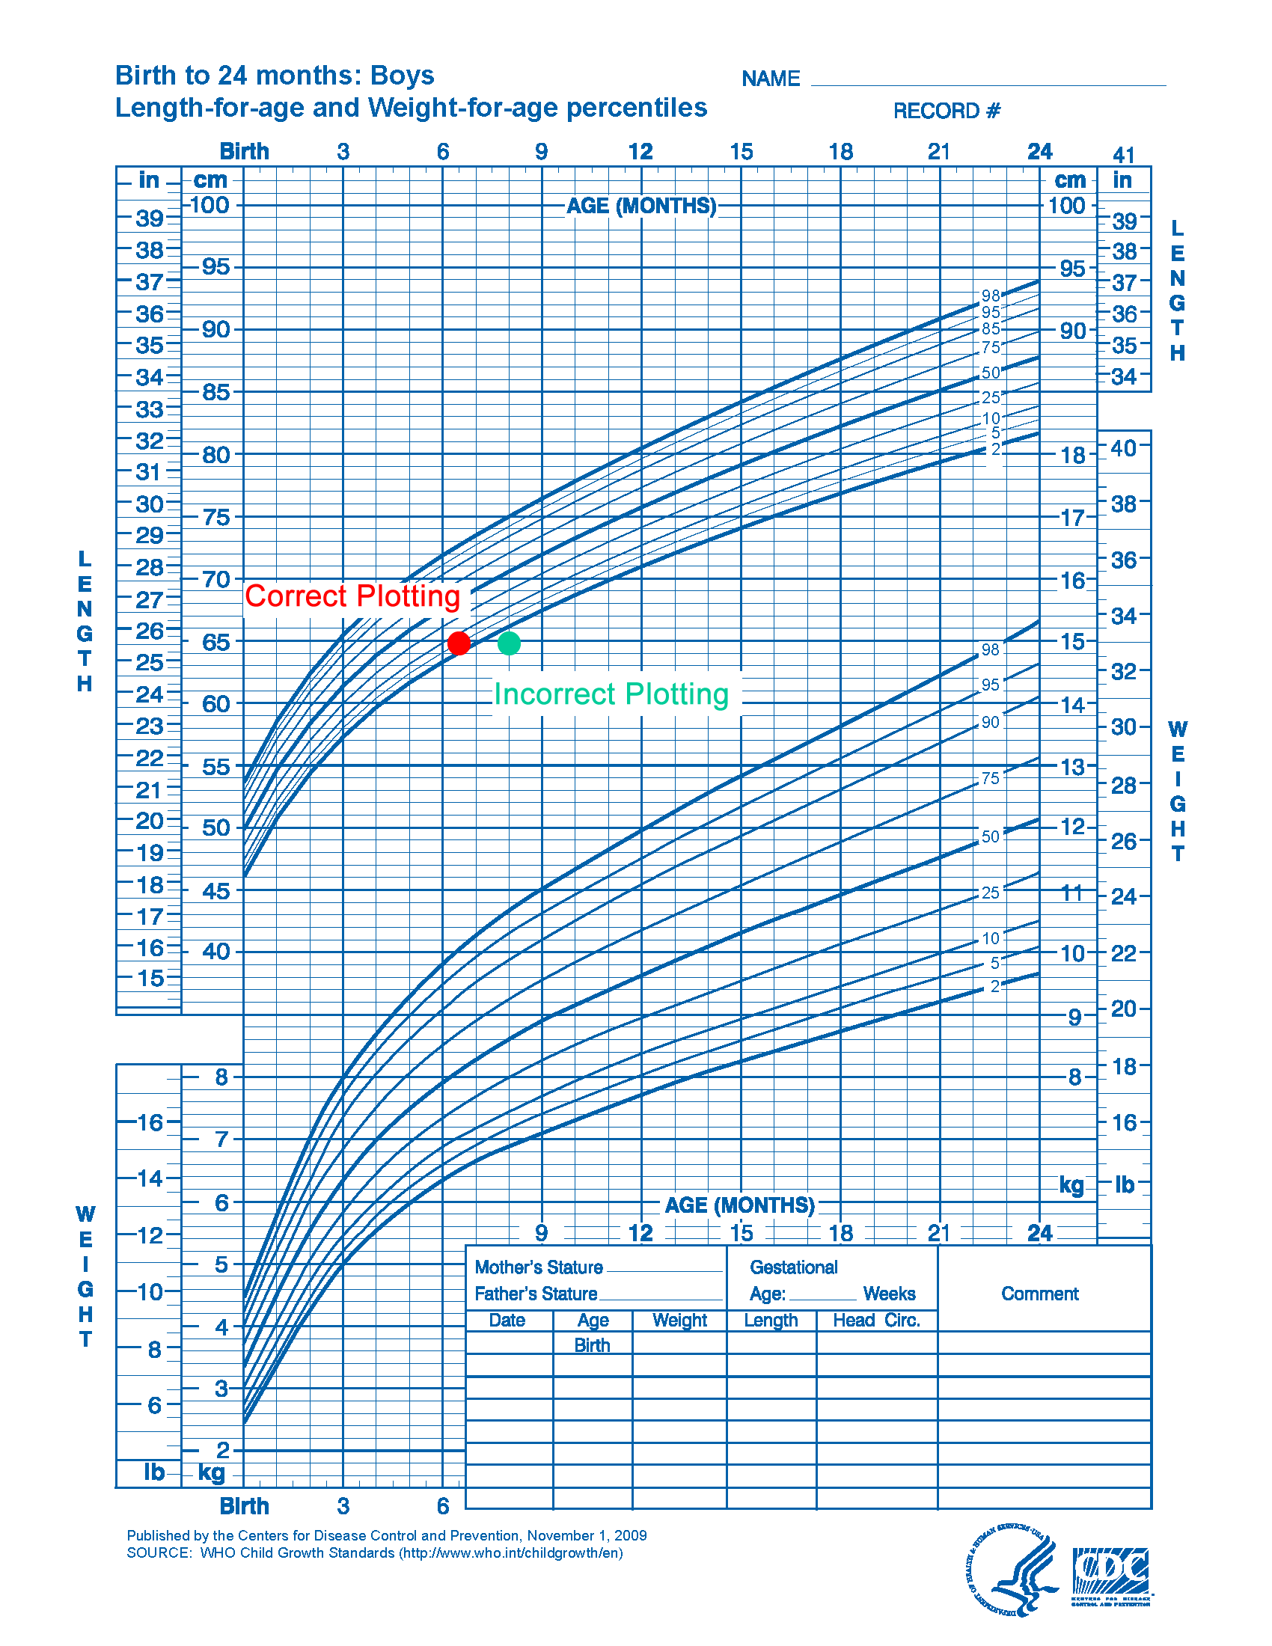 | Example:  A male infant is measured as 65 cm  in length. The 6-month, 17-day old  infant is plotted as an 8-month old infant  for length. The infant’s length is  actually at the 5th percentile.  The error has placed him below the 2nd  percentile for length.  How would this affect your clinical  impression?

Example:  A male toddler is weighed at 13 kg.  The 2-year, 10-month (34-month)  old child is plotted as a 24-month old  child for weight. When age is calculated  and plotted correctly the child's weight  is at the 25th percentile. The incorrect  plotting places him at the 50th-75th  percentile.  How would this affect your clinical  impression? | 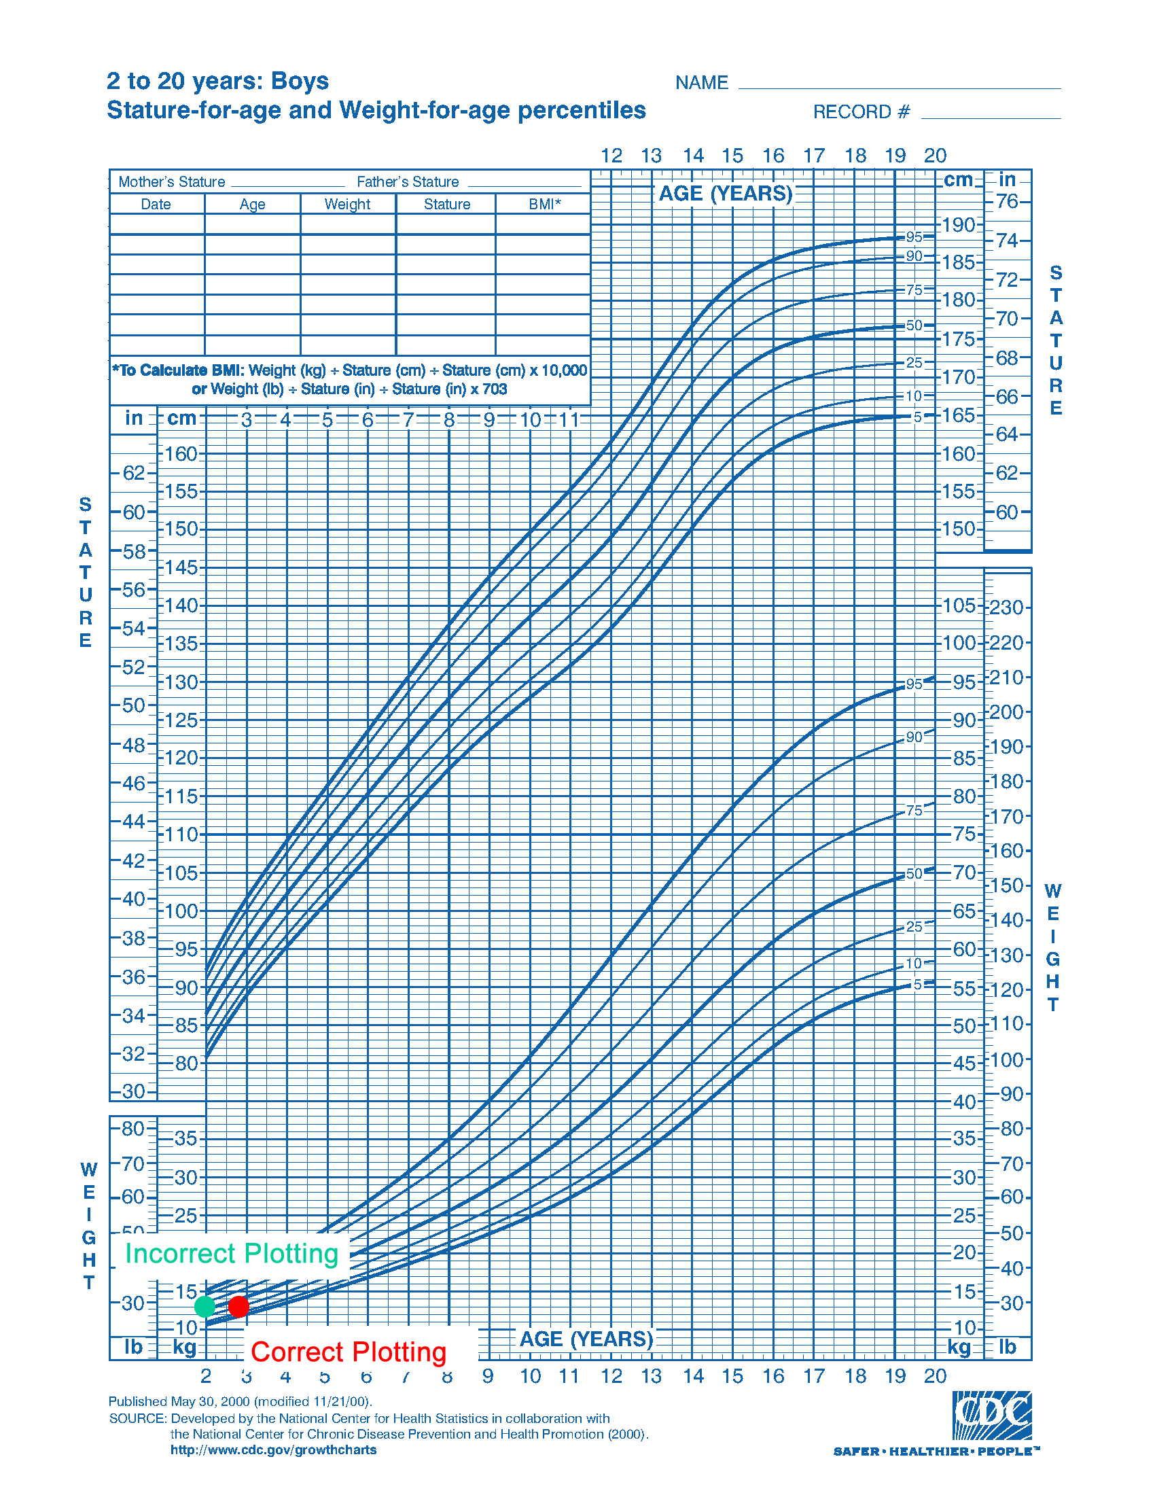

What is the Next Step?

After graphing a set of measurements, check to see if they are consistent with those from previous visits (i.e., the child is on roughly the same percentile lines as before). If not, check the measurements, graphing, or both.

When you have made accurate measurements, calculated age correctly, and plotted them on the appropriate growth chart.

- Use the information in the clinical assessment process
- Share the information with the family (i.e., translate into a form that is useful to them)

To help you to accurately weigh, measure, plot and interpret, downloadable checklists are available from this module's Contents page.

Family-centered Technique

If parents request a conversion, the infant or child’s measurements can easily be converted from kilograms to pounds and noted for their personal records of the child’s growth.

10. REFERENCES

Grummer-Strawn LM, Reinold C, Krebs NF. Use of the World Health Organization and CDC growth charts for children aged 0-59 months in the United States. Recommendations and Reports. Morbidity and Mortality Weekly Report. September 10, 2010; 59(rr09):1-15.

Identification and Quantification of Sources of Error in Weighing and Measuring Children, CDC, PHS, DHEW, 1976.

Lohman, TG, Roche, AF, and Martorell, R. Anthropometric Standardization Reference Manual, Human Kinetics Books, Champaign, IL, 1988.

NHANES III Anthropometric Procedures, a video from the National Center for Health Statistics, Centers for Disease Control and Prevention.

Pediatric Anthropometry, from Ross Laboratories, 2000.

Weighing and Measuring Children: A Training Manual for Supervisory Personnel, Nutrition Division, CDC, PHS, DHHS, and Bureau of Community Health Services, HHS, 1980.

GLOSSARY

Accurate: the nearness of the measure to the ‘true’ value.

Length: the measure from crown of the head [the superior point] to the bottom of the feet with the subject lying horizontally in a supine position. Length is always measured recumbent.

NHANES: the National Health and Examination Survey. The Surveys [NHANES I, II, and III] were conducted by the National Center for Health Statistics [NCHS] from 1963 to 1994.

Reliable: how close repeated measures are to each other.

Stature: the maximum height of an individual. The CDC Growth Charts use the term stature. Stature or height is defined as the measure from crown of the head [the superior point] to bottom of feet. It is always measured standing.

Tare: to set the weight of the scale at ‘zero’ when a weight (person) is on the scale. Another person, in this case, the infant, can then be added and the weight of the infant read directly from the scale.

Tolerance of measures: numerical difference between measures that is still accurate.

Trained measurer: one who has received instruction or certification from another measurer experienced in the proper procedures for body measurements.

[END OF MODULE]

