Interpreting Growth in Head Circumference

INTRODUCTION
When children's heads grow too rapidly or too slowly, the children are more likely to have neurologic disorders and mental retardation, especially if their head size is far from the mean. That is because growth of the head reflects growth of the brain. In well-child care, head circumference should be measured and plotted regularly. This module will help you to identify children needing evaluation of head growth.

Objective

Upon completion of this module, you will be able to:

- identify children needing evaluation because of deviations in the growth of their heads

TABLE OF CONTENTS

1. Measuring and Plotting Head Circumference

2. Small Head Size

3. Large Head Size

4. References
1. MEASURING AND PLOTTING HEAD CIRCUMFERENCE

To measure head size, we measure the circumference, using a tape measure.

Details of measurement technique are given in the module, Accurately Weighing and Measuring Infants, Children and Adolescents: Technique.

Note the following points:

- There will be some differences in clinical classifications between the WHO charts and the 2000 CDC curves. For example, a head circumference of 45 cm for a 15-month old boy is between the 25th and 50th percentiles on the CDC chart; on the WHO curve, this is between the 5th and 10th percentile.

- Measurements may be influenced by abnormal head shape.

- Measuring the parents' heads may be helpful in interpretation.

- Growth patterns over time are more informative than measurements done once.

- The head of a premature infant grows more rapidly than that of a term infant, so it is important to correct for gestational age and to consider using the Infant Health and Development Program (IHDP) special growth charts for low-birth-weight infants. For more information about correcting for gestational age, see the module, Overview of Growth Charts. For information about the use of the IHDP growth charts, see the module, The CDC Growth Charts for Children with Special Health Care Needs.

- The CDC growth charts show head circumference up to 36 months.

- For children up to 18 years, charts based on a composite, international sample have been standard for many years (Nellhaus, 1968).
2. Small Head Size

Small head size (microcephaly) is most often defined as more than two standard deviations below the mean, which corresponds to the 2.3 percentile. Some authors prefer the cutoff of 3 standard deviations below the mean. WIC uses the risk criterion of the 5th percentile. The growth chart most commonly used for children over age 3 years (see Nellhaus) shows standard deviations rather than percentiles.

In some circumstances, microcephaly may be expected, especially with very short children; it can also be due to many familial, prenatal, and postnatal causes, including prenatal and postnatal severe malnutrition. Depending on head size at birth, microcephaly may be classified as congenital or acquired, the two types tending to have different causes.

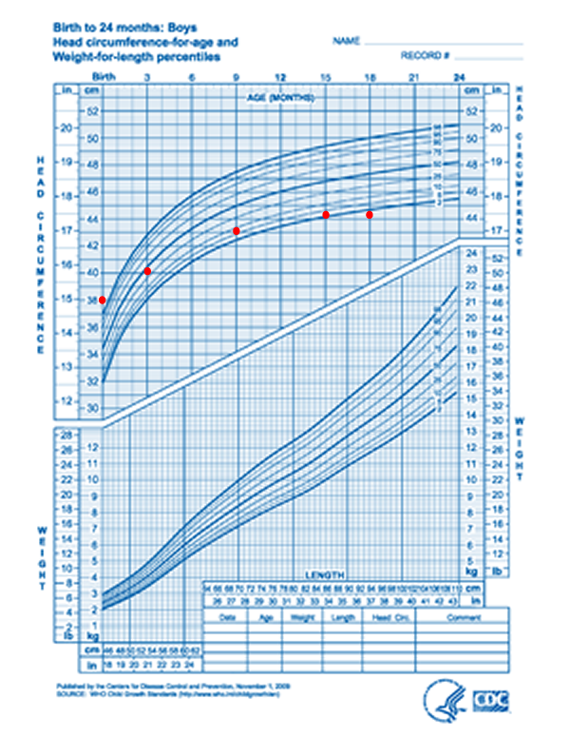
Figure 1. This chart shows small head size. Over time the child's head has grown too slowly and its circumference is now below the 2.3 percentile (2 standard deviations below the mean). This child deserves evaluation.

3. Large Head Size

Large head size (macrocephaly) is commonly defined as more than two standard deviations above the mean.

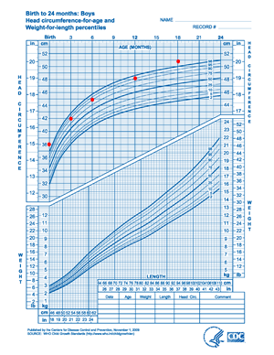
Figure 2. This child's head is large and becoming larger. The head circumference is rising across percentile lines and exceeds 2 standard deviations (the 98th percentile). This child should be evaluated.

4. References

Baer MT, Poulsen MK, Howard-Teplansky RB, and Harris AB. Effects of nutrition on development and behavior. In Levine MD, Carey WB, and Crocker AC (eds.). Developmental-Behavioral Pediatrics. 1999. Philadelphia: W.B. Saunders Company.

Casey PH, Kraemer HC, Bernbaum J, et al. Growth status and growth rates of a varied sample of low birthweight, preterm infants: A longitudinal cohort from birth to three years of age. Journal of Pediatrics 1991; 119:599-605.

DeMyer W. Microcephaly, micrencephaly, megalocephaly, and megalencephaly. In Swaiman KE and Ashwal S. (eds.). Pediatric Neurology: Principles and Practice, 3rd ed. 1999. St. Louis: Mosby.

Disorders of cranial volume and shape. In Fenichel GM. Clinical Pediatric Neurology: A Signs and Symptoms Approach. 2001. Philadelphia: W.B. Saunders.

Institute of Medicine. WIC Nutrition Risk Criteria: A Scientific Assessment. Washington, DC: National Academy Press, 1996.

Kessel A, Tal Y, Jaffe M, Even L. Reversible brain atrophy and reversible developmental retardation in a malnourished infant. Israel Journal of Medical Sciences 1996; 32:306-308.

Kessler DB, Dawson, P. (eds.). Failure to Thrive and Pediatric Undernutrition: A Transdisciplinary Approach. 1999. Baltimore: Paul H. Brookes Publishing Company. Available through www.brookespublishing.com.

Nellhaus G. Head circumference from birth to eighteen years: Practical composite international and interracial graphs. Pediatrics 1968; 41:106-114.

Moe PG, Seay AR. Neurologic and muscular disorders. In Hay WW, Hayward AR, Levin MJ, Sondheim JM (eds.), Current Pediatric Diagnosis and Treatment. 1999. Stamford, CT: Appleton and Lange.

Rios A. Microcephaly. Pediatrics in Review 1996; 17:386-87.

Skull SA, Ruben AR, Walker AC. Malnutrition and microcephaly in Australian Aboriginal children. Medical Journal of Australia 1997; 166:412-414.
GLOSSARY

Acquired: not present at birth, but developing later

Congenital: present at birth

Macrocephaly: excessive size of the head, most often more than two standard deviations above the mean

Microcephaly: excessively small head size, most often more than two standard deviations below the mean

Standard deviation: a measure of the width of the amount of variation among the values of a variable in a population

[END OF MODULE]

