***Meal Planning on Campus***

**Cafés, Markets, and Dining Halls on Campus**

* Restaurants:
  + The 8 – McMahon Hall
  + By George – Odegaard Library
  + Cultivate – Elm Hall
  + Freshens – IMA and Odegaard Library
  + Husky Den – HUB
  + Local Point – Lander Hall
  + Orin’s Place – Paccar Hall
  + Pagliacci Pizza – HUB, Lander Hall, and McMahon Hall
  + The Rotunda – Health Sciences Center
  + Subway – HUB
  + Vista Café – William H. Foege Building
* Cafés & Espresso
  + Burke Café – Burke Museum
  + Dawg Bites – IMA
  + Husky Grind at District Market – Alder Hall
  + H-Bar – Physics/Astronomy Building
  + Husky Grind Café – Mercer Court
  + Joe Haus – McMahon Hall
  + Mary Gates Espresso – Mary Gates Hall
  + Overpass Espresso – Health Sciences Center
  + Parnassus – Art Building
  + Public Grounds – Parrington Hall
  + Reboot – Paul G Allen Center for Computer Science & Engineering
  + Starbucks – HUB and Suzzallo Library
  + The Supreme Cup – Willian H. Gates Hall
  + Tower Café – UW Tower
* Markets
  + District Market – Alder Hall
  + HUB, Health Sciences Center, and Odegaard Library
  + The Nook – McMahon Hall
* UW Street Food
  + Motosurf – Red Square
  + Hot Dawgs – Red Square
  + Red Square BBQ – Red Square

**Cooking Supplies You’ll Need for Recipes Below**

***For most of the recipes you’ll find below, you’ll need the following cooking supplies:***

* Microwave
* Measuring spoons
* Measuring cup
* Plastic wrap (any brand will do)
* [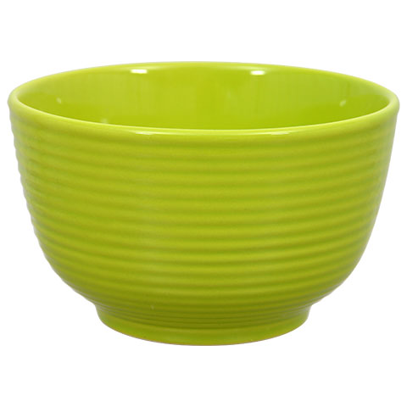](https://www.google.com/url?sa=i&rct=j&q=&esrc=s&source=images&cd=&cad=rja&uact=8&ved=0ahUKEwjavMPFntfVAhUK0WMKHRjgCqoQjRwIBw&url=https://www.dollartree.com/shop/dishwasher-safe-bowl&psig=AFQjCNEo5PTufrHcK2H2hZUrt2yCUQV0lA&ust=1502817744811835)Microwave safe mug
* Microwave safe bowl

*Check the bottom of the bowl and mug – most will say if they’re microwave safe here*

[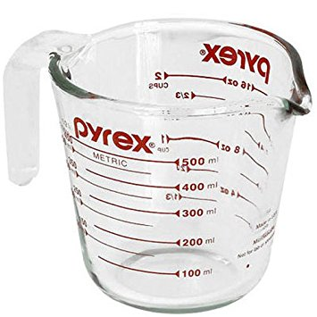](https://www.google.com/url?sa=i&rct=j&q=&esrc=s&source=images&cd=&cad=rja&uact=8&ved=0ahUKEwiX4dn7ndfVAhVUHGMKHUo9B6QQjRwIBw&url=https://www.amazon.com/Pyrex-Prepware-2-Cup-Glass-Measuring/dp/B0002ITQHS&psig=AFQjCNHbtMUccxkFEW660BDE9kY7e2UIVg&ust=1502817572353016)

[](https://www.google.com/url?sa=i&rct=j&q=&esrc=s&source=images&cd=&cad=rja&uact=8&ved=0ahUKEwjKw-OtntfVAhVR0mMKHZmfDakQjRwIBw&url=https://www.bedbathandbeyond.com/1/3/microwave-safe-coffee-mugs&psig=AFQjCNF388HrhCNVcX4s5vOnupo9zG0A8Q&ust=1502817691039437)

[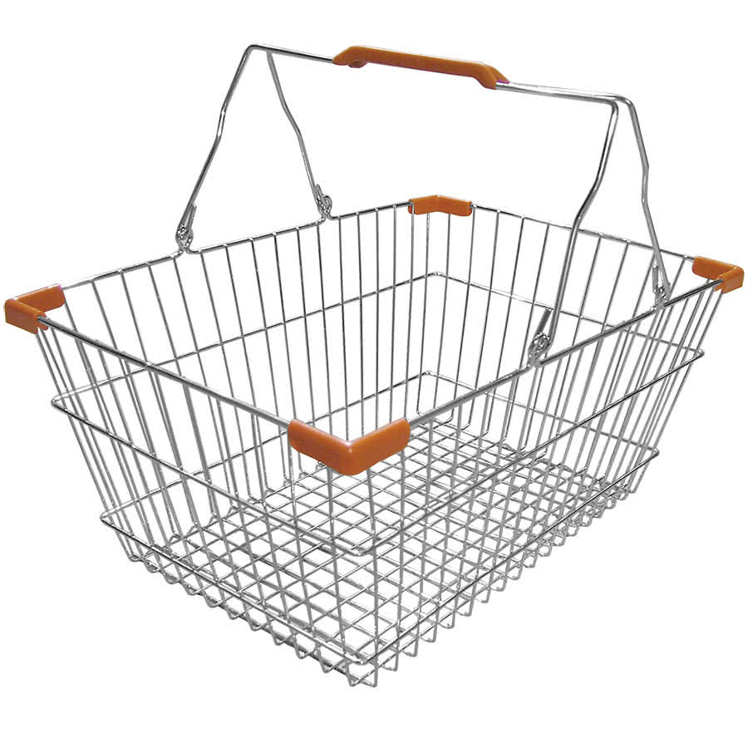](https://www.google.com/url?sa=i&rct=j&q=&esrc=s&source=images&cd=&cad=rja&uact=8&ved=0ahUKEwi_u8nJndfVAhUY22MKHZg9BawQjRwIBw&url=https://www.webstaurantstore.com/3531/shopping-baskets-grocery-carts-and-reusable-shopping-bags.html&psig=AFQjCNGDZt_DBlRJ7zybX9HkwlFtoSDudg&ust=1502817492775263)

[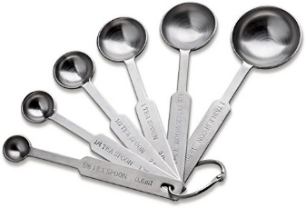](https://www.google.com/url?sa=i&rct=j&q=&esrc=s&source=images&cd=&cad=rja&uact=8&ved=0ahUKEwiJj8DhndfVAhUHxGMKHe6AC0EQjRwIBw&url=https://www.amazon.com/Natizo-Stainless-Steel-Measuring-Spoons/dp/B014HPNKY6&psig=AFQjCNFY3H2_I3sTUoKCI5s0vrHtovkxRw&ust=1502817537682368)

[](https://www.google.com/url?sa=i&rct=j&q=&esrc=s&source=images&cd=&cad=rja&uact=8&ved=0ahUKEwjxmveLntfVAhVL4GMKHQ6eBnIQjRwIBw&url=https://www.walgreens.com/store/c/glad-clingwrap-clear-plastic-wrap/ID%3Dprod16248-product&psig=AFQjCNGxGEmifPUhOm3OFDGCvHPI_Mo7vw&ust=1502817625862964)

**Breakfast Ideas for Home/Dorm**

Recipe 1: Microwaved scrambled eggs

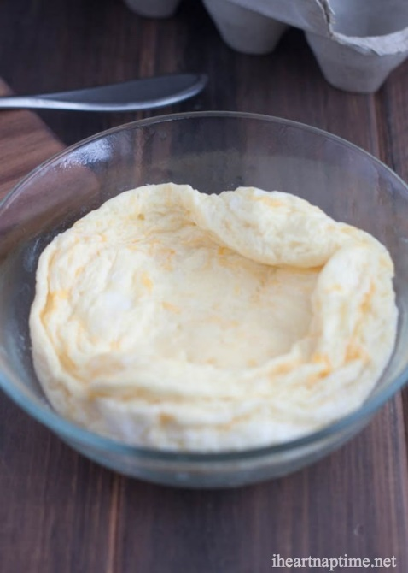  
You’ll need…

* *Eggs (1-2)*
* *Cheese*
* *Salt and pepper*
* *Optional toppings (ex: avocado, salsa, green onion)*
* *Butter or pan spray*

1. Spray or butter microwave safe bowl
2. Crack egg(s) into bowl
3. Add a dash of salt, pepper, and cheese. Stir until combined
4. Microwave on high for 45 seconds -- 1 minute
5. Remove and stir
6. Microwave on high for about 30 seconds
7. Top with any additional toppings

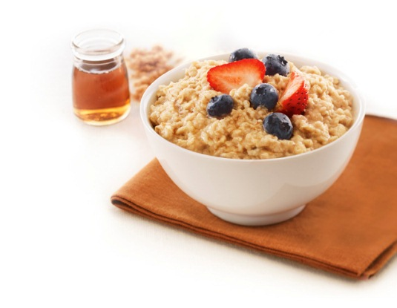Recipe 2: Microwave oatmeal

You’ll need…

* *Store bought microwave oatmeal. Quaker is a good go-to brand, but any brand will do*
* *Optional toppings (ex: berries, honey, peanut butter)*

1. Open packet of microwave oats and pour into a bowl
2. Look at the back of the packet you just opened or on the box for how much water to add in. Pour water so that all the oats get watered (no dry spots)
3. Put the oats and water mixture into the microwave and set the heat and time according to the directions on the packet or box
4. Stir in optional toppings

Recipe 3: Overnight Oatmeal

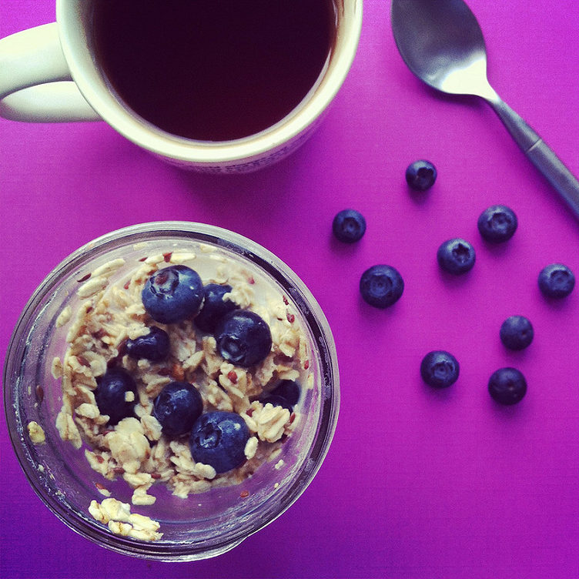

You’ll need…

* *½ cup old-fashioned oats*
* *½ cup milk (or yogurt for a thicker texture)*
* *Optional toppings (ex: berries, fruits, spices, seeds, nuts)*

1. Add all the ingredients into a jar or bowl and stir until combined
2. Cover the jar or bowl and refrigerate overnight
3. In the morning, add a splash of milk and stir again

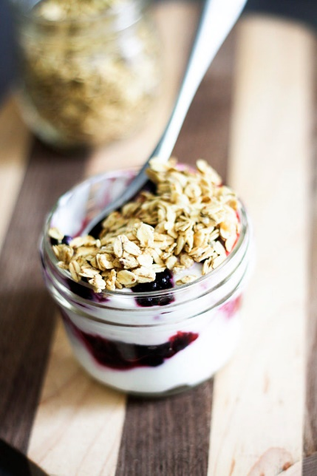

Recipe 4: Yogurt and berries

You’ll need…

* *Individual cup of yogurt*
* *Berries (fresh or frozen)*
* *Optional toppings (ex: granola or cereal)*

Add berries and other toppings to individual cups of yogurt to make a more complete meal!

Recipe 5: French toast in a mug

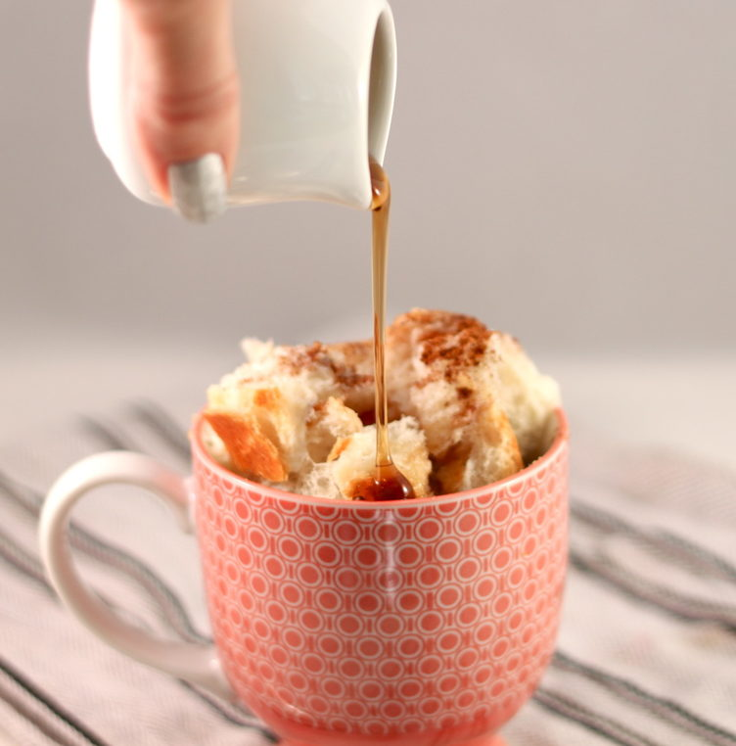 You’ll need…

* + *1-2 pieces of bread*
  + *Butter*
  + *1 egg*
  + *3 tbsp. milk*
  + *Cinnamon*
  + *Vanilla (optional)*

1. Take your bread and cut it into cubes
2. Butter a large mug or bowl and place cubed bread inside
3. In a separate bowl, mix egg, milk, a dash of cinnamon, and a drop of vanilla extract (optional)
4. Pour the mixture over bread and smoosh the bread down to absorb all the liquid
5. Place mug or bowl in microwave and cook for 1 minute
6. Check if it is fully cooked (no runny egg). If the egg is still runny, keep cooking for 10 seconds at a time until fully cooked

**Lunch and Dinner Ideas for Home/Dorm**

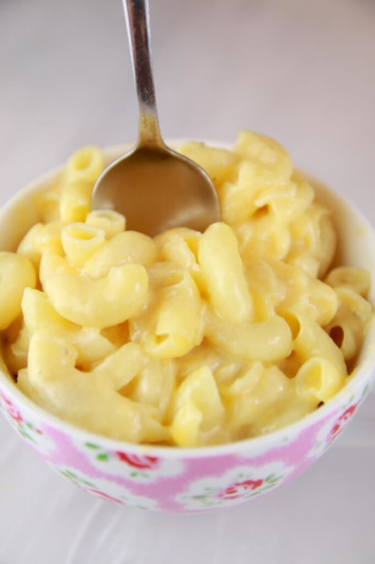Recipe 1: Microwave Mac and Cheese

You’ll need…

* + *1/3 cup pasta*
  + *¾ cup water*
  + *4 tbsp. milk*
  + *¼ teaspoon flour*
  + *4 tbsp. cheddar cheese (grated)*
  + *Salt and pepper*

1. In a large mug or bowl, add pasta and water
2. Microwave for about 3 ½ minutes, until pasta is fully cooked
3. Pour out the remaining water and add milk, flour, and shredded cheese
4. Microwave for about 1 minute
5. Stir and season with salt and pepper

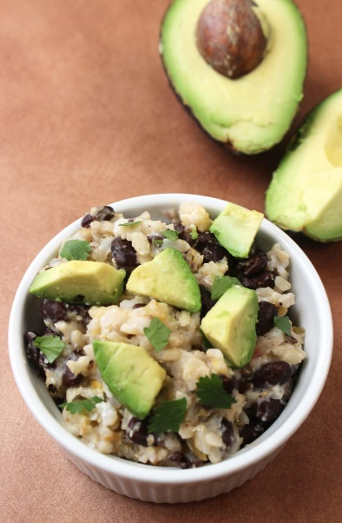Recipe 2: Quick Burrito Bowl

You’ll need…

* *1 cup cooked minute rice*
* *½ cup black beans*
* *2-3 tbsp. salsa*
* *1 tbsp. plain yogurt*
* *1 tbsp. cheese*
* *Optional toppings (ex: avocado, chicken, beef, tomato, lettuce)*

1. Combine rice, beans, salsa, yogurt, and cheese in a large mug
2. Microwave for 30 -- 60 seconds, until heated through
3. Stir and add with optional toppings

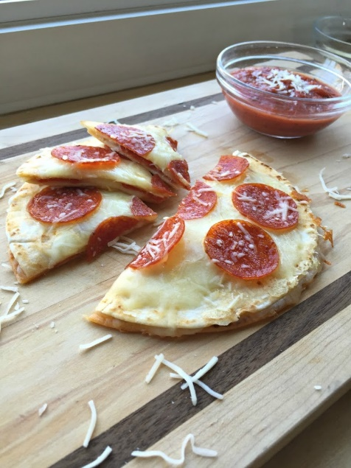

Recipe 3: Pizzadilla (Pizza Quesadilla)

You’ll need…

* + *2 flour tortillas*
  + *Handful of favorite pizza toppings*
  + *1 cup shredded Italian blend cheese*
  + *½ cup shredded Parmesan cheese*
  + *½ cup pizza or spaghetti sauce*

1. Assemble quesadilla – tortilla, ½ of the cheese, toppings, tortilla on top
2. Microwave for 30-45 seconds or until cheese is melty
3. Add remaining cheese and toppings to the top of the quesadilla and microwave again for 30 seconds or until cheese on top is melted

Recipe 4: Spinach Ricotta Lasagna in a Mug

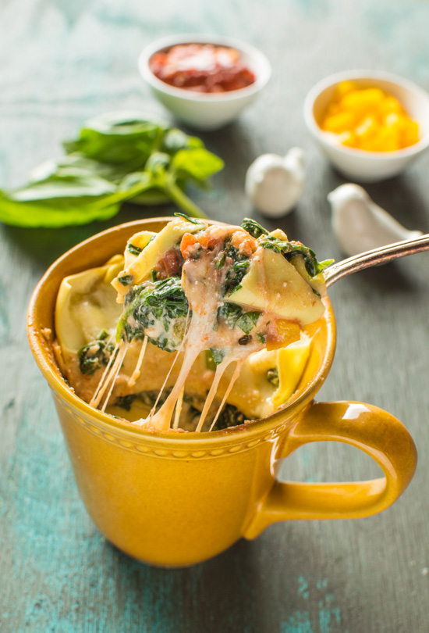You’ll need…

* *½ fresh lasagna sheet*
* *2 ½ cups baby spinach, chopped*
* *¼ yellow bell pepper, diced (optional)*
* *¼ cup ricotta cheese*
* *Salt*
* *6 tbsp. of spaghetti/tomato sauce*
* *1/3 cup shredded mozzarella cheese*

1. Cut the lasagna sheet in half and then halve it again
2. Place your pasta sheet, broken into 4 parts, in a bowl and cover with very hot water
3. Chop spinach and place into a microwave safe bowl, cover with plastic wrap and poke some holes in it. Microwave spinach for 1 minute
4. Mix the spinach with the ricotta, pepper, and salt

*Continue on next page*

*Spinach Ricotta Lasagna in a Mug cntd.*

1. Pour 2 tablespoons of spaghetti sauce into the bottom of a microwave safe mug and top with a piece of softened pasta sheet
2. Add some of the spinach mixture, 2 tablespoons of mozzarella, and another pasta sheet. Continue in this order until there is one last pasta sheet on top
3. Cover that with a little spaghetti sauce and mozzarella cheese
4. Microwave everything for 1 minute and 30 seconds.
5. Check if mozzarella is melted on top. If it isn’t, keep microwaving for 15 seconds at a time until mozzarella is melted

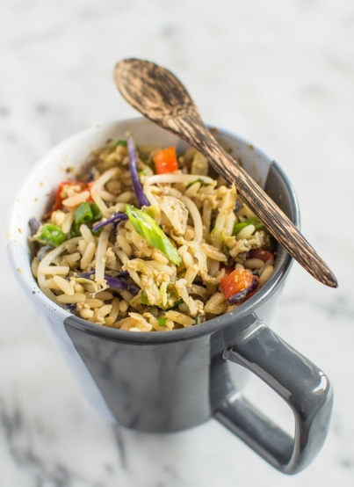Recipe 5: Egg Fried Rice in a Mug

You'll need...

* *1 cup cooked rice*
  + *Veggies (ex: peas, chopped carrots,*

*chopped green onion, cabbage)*

* *1 large egg*
* *1 tbsp. soy sauce*
* *½ teaspoon sesame oil (optional)*
* *½ teaspoon onion powder (optional)*
* *Salt and pepper*

1. Place cooked rice into a large mug
2. Add veggies on top of the rice and cover the mug with plastic wrap. Poke holes in plastic wrap
3. Microwave rice and veggies for 1 minute and 15 seconds
4. Beat egg in a separate bowl with soy sauce, sesame oil, onion powder, and a dash of salt and pepper
5. Pour egg mixture into mug and stir with veggies and rice
6. Cover the mug with plastic wrap again and poke holes in it
7. Microwave entire mixture for 1 minute and 15 seconds or until hot