Medical Student Documentation Policy
Vivian Yang, Ryan Kiser, David Tirschwell, Eric Kraus, Arielle Davis, Natalie Weathered
UPDATED 6/17/2026
Goals:
- Facilitate medical student learning and participation in patient care through note-writing.
- Optimize patient safety, team workflow efficiency, and adherence to CMS E/M requirements.
Scope:
- Applies to medical students, not PA or NP students.
- Applies only to inpatient services.
- Does not apply to procedures or encounters billed by time.

2 basic requirements for medical student documentation of billable encounters:
PRESENCE: The teaching physician or resident must be present with the medical student during the documented elements of the encounter.
- This requirement can be fulfilled by the teaching physician or resident.
  - Presence means physical presence in the exam room with the medical student and patient.
  - This implies supervision of the medical student.
VERIFICATION: Teaching physicians must verify that all medical student documentation is true and accurate.
  - This requirement can only be fulfilled by the teaching physician.
  - Verification can look different depending on the documented element:
History (CC, HPI, past medical/surgical history, social history, family history, ROS): Teaching physicians must verify the history with the patient and/or through chart review. They are not required to personally perform the history-taking.
Physical exam: Teaching physicians must both perform and verify the documented exam.
*For certain maneuvers (e.g. confrontational strength testing, reflexes, heart auscultation, etc.), the teaching physician needs to physically do the maneuver to verify findings. For other maneuvers (e.g. eye movements, pronator drift, finger-to-nose, etc.), observing the medical student doing the maneuver may be equivalent to personal performance. The teaching physician should still step in if they are concerned about the medical student’s technique and accuracy of findings.
Medical Decision Making: Teaching physicians must both perform and verify the documented medical decision making.
*Performing the medical decision making refers to the mental act of medical decision making; i.e. it does not require the teaching physician to personally counsel the patient. However, teaching physicians (or capable residents) must supervise all patient counseling done by students, and they are encouraged to discuss medical decision making with trainees for teaching purposes.
See the “Quick Guide” at the end of this document for a summary of presence, verification, and performance requirements for different elements of a patient encounter documented by a medical student.

Attestations:
See sample workflows below for how these should be used.
.ATTMSCOMPLETE
Teaching physician attests to both presence with the medical student and verification of their documentation.
“I was present with the medical student. I personally performed the physical examination and medical decision making. I have verified all of the medical student’s documentation for this encounter.”
.RESMSPRESENCE
Resident attests to presence with the medical student. This is rarely necessary with our typical workflows.
“I was present with the medical student.”
.ATTMSVERIFY
Teaching physician only attests to verification of medical student documentation in situations where they were not ever present with the medical student. This means the resident has fulfilled the presence requirement, so this should be used with .RESMSPRESENCE above. Again, this is rarely necessary with our typical workflows.
“I personally performed the physical examination and medical decision making. I have verified all of the medical student’s documentation for this encounter.”

Billing:
If all the above requirements are fulfilled – which means that all that is documented in the medical student note represents the teaching physician’s own work – and the appropriate attestations are used, teaching physicians can use the medical student note to bill just as they normally would based on medical decision making.
Teaching physicians are not required to use the medical student note for billing. They can always bill off of their own standalone note. However, they would still need to attest to or co-sign the medical student note, and they are thereby responsible for the information that note conveys in the patient chart.

Non-billable notes:
In some situations, medical students may write notes that are not billed. This is common on the consult service, for example, when following up imaging or EEG findings without seeing the patient. The teaching physician must still verify the accuracy of the note, and use the following attestation:
“I did not see the patient but have reviewed the medical student(s)’s documentation.”

Best Practices:
- Any patient assigned to a medical student MUST also be assigned to a resident.
- Residents are expected to supervise medical students following their patients. This includes seeing patients with medical students, supervising patient counseling, and reviewing medical student notes for accuracy, providing feedback and editing as appropriate. This does not replace the requirement for teaching physician verification of medical student documentation.
- Medical students should always share their notes in Epic to allow their resident to review. They should never sign a note without the explicit approval of their resident.
- Only approved Epic note templates should be used. Medical students should not be using click-through Notewriter templates.
- Teaching physicians can and should edit medical student notes for accuracy. This may include deleting content that the teaching physician did not personally verify or perform. This can be an opportunity to gather feedback for students on their note-writing.
- Medical students always have the option of seeing patients independently (as shown in preferred workflows below), as long as they return with the resident or the teaching physician to be supervised for the documented elements of the encounter.

Sample workflows:

Quick Guide: Medical Student Participation in E/M Services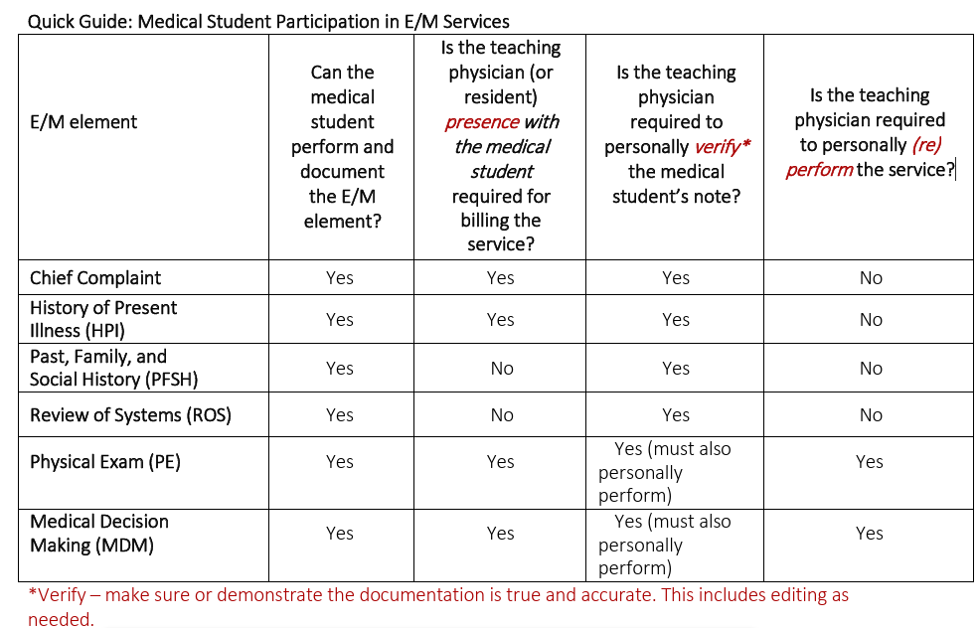
This Quick Guide and further details on the UW policy concerning medical student documentation and E/M services can be found here.

