NBME Clinical Neurology practice exams

- Access via: https://www.mynbme.org/s/login/
- Hit “Purchase” at the top
- Choose
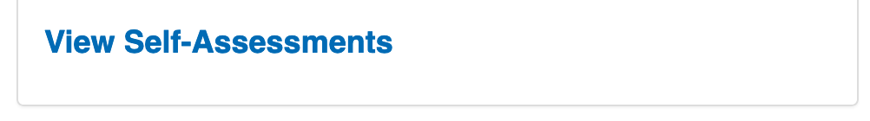
- Choose
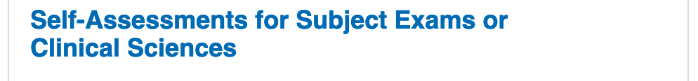
- Select
