To register w/mCE:

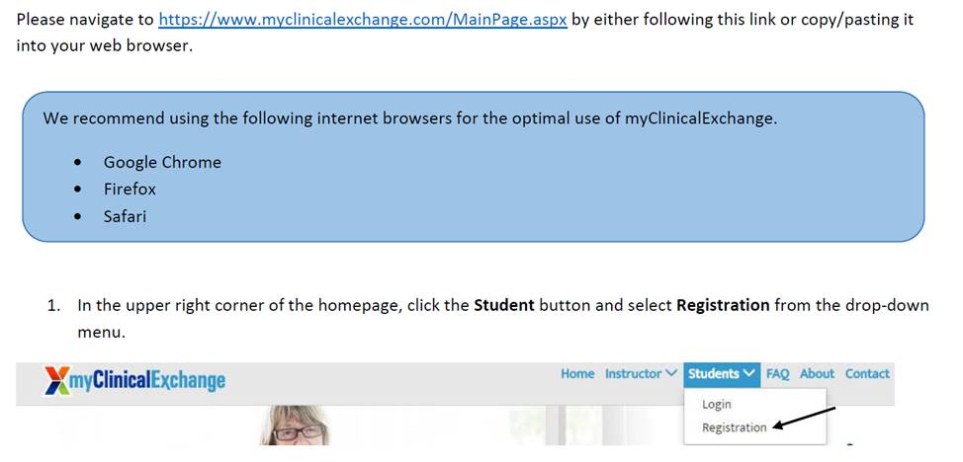

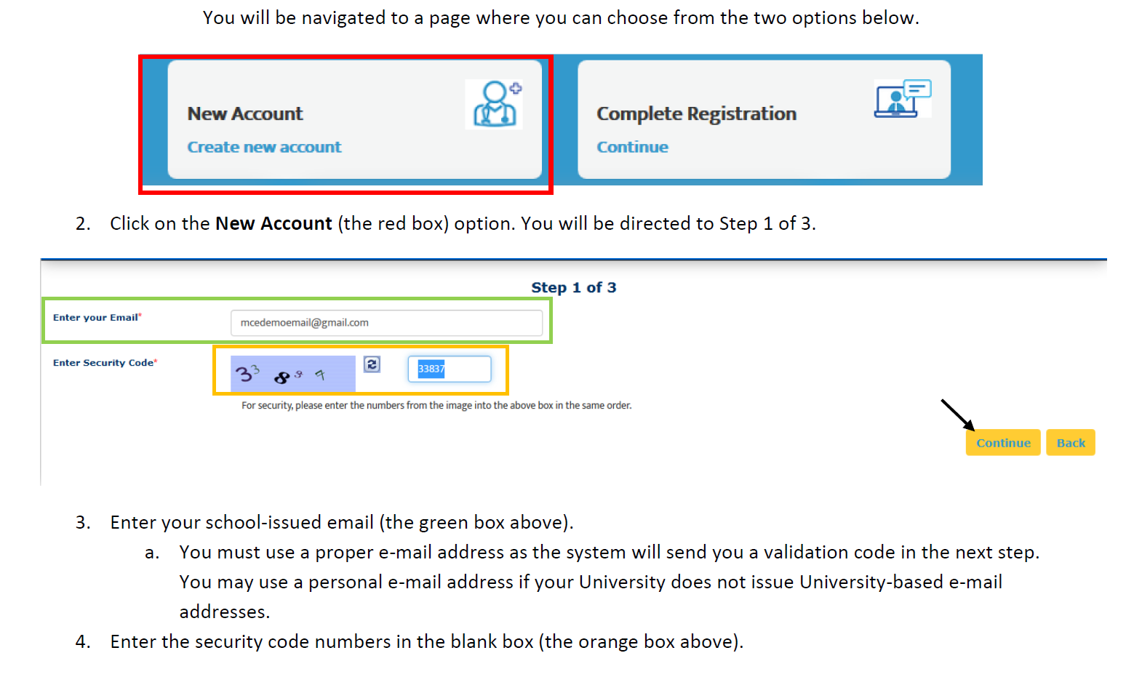

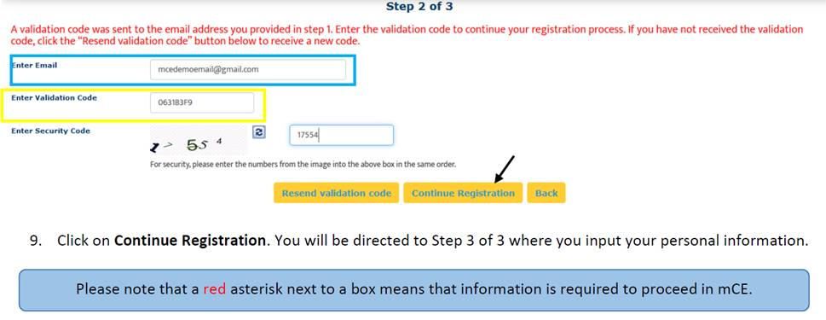

Complete the student registration information:  Personal Information, School Enrollment Details, Emergency Contact Person, and

Once your school has entered your clinical rotation and I have approved it, your school will associate you as the student with the clinical rotation and you will receive an email to login complete any registration needed and pay for your mCE account.  You will now be able to complete your St. Luke’s student credentialing: upload required documents, compliance, safety and EMR trainings

Your clinical rotation will then show in your Clinical Rotation list and you will have a To Do list of documents to upload, compliance, safety and EMR trainings to complete.