Effective Quote Integration

SHOULD I INCLUDE THIS QUOTE?
Ask yourself:
- Will it fit into your argument? Does it fit in where you‟re planning to include it? If so, then using the quote is justified.
- Is it merely descriptive – that is, would it be better to just paraphrase what the writer is saying, rather than directly quoting? If that is the case, consider paraphrasing the author instead.

Once you‟ve decided that the quote should be included, follow the “three-step” rule to integrate it into your paper.

THREE STEP QUOTATION STRATEGY

Step One: Introduce the quotation
College provides a diversity of social, academic and athletic opportunities for students. This can be a powerful positive force, but it can also detract from students‟ abilities to manage their time. As George W. Bush states, “I sometimes overdid it when I was at school, missing out on valuable academic opportunities. Fortunately, I buckled down in my senior year and managed to make a „C‟ average and things have worked out fine since” (227).

Step Two: Explain what the author is arguing in the quotation. (The author should agree with how you sum up the quotation – this will help you establish credibility, by demonstrating that you do know what the author is saying even if you don’t agree.)
College provides a diversity of social, academic and athletic opportunities for students. This can be a powerful positive force, but it can also detract from students‟ abilities to manage their time. As George W. Bush states, “I sometimes overdid it when I was at school, missing out on valuable academic opportunities. Fortunately, I buckled down in my senior year and managed to make a „C‟ average and things have worked out fine since” (227). In this example, George W. Bush is pointing out that the positive extra-curricular activities of college life should be balanced with a responsible approach to studying; also, that the detrimental effects of earlier excesses can be rectified in the senior year of college.

Step Three: State the implications of the quotation for your own argument. (What do you make of the author’s argument?)
College provides a diversity of social, academic and athletic opportunities for students. This can be a powerful positive force, but it can also detract from students‟ abilities to manage their time. As George W. Bush states, “I sometimes overdid it when I was at school, missing out on valuable academic opportunities. Fortunately, I buckled down in my senior year and managed to make a „C‟ average and things have worked out fine since” (227). In this example, George W. Bush is pointing out that the positive extra-curricular activities of college life should be balanced with a responsible approach to studying; also, that the detrimental effects of earlier excesses can be rectified in the senior year of college. While George W. Bush is certainly correct when he implies that it is never too late for a student to try to raise his or her GPA, it is probably better for students to attempt to balance academic and other activities early in their college career. Also, Bush assumes that all students can
achieve what they want with a „C‟ average, but many students need higher GPAs in order to apply to professional school, graduate school and for graduate-entry jobs.

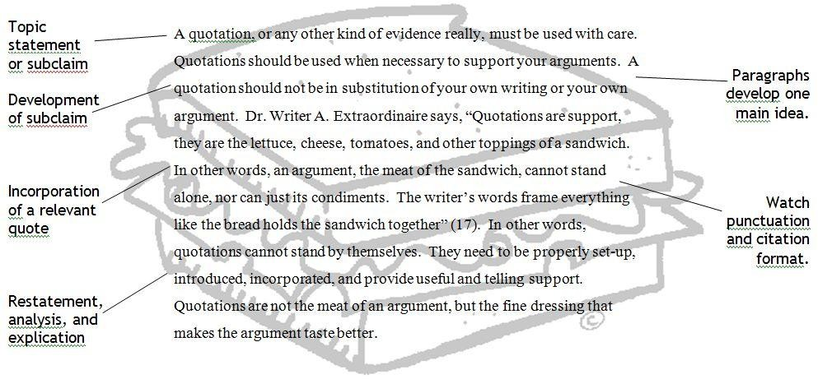
THREE STEP QUOTATION INTEGRATION VISUAL

EVALUATION OF EFFECTIVE QUOTING
Remember that effective quoting:
- Adds Authority
- Adds evidence
- Adds a more sophisticated level of writing

Rate your partner’s use of quoted evidence on a scale of 1-5 according to the following criteria.

In-line (embedded) quotes and blocked quotes:
Does the author establish solid context and introduction for the quote? (i.e. does the author incorporate the quote well enough to make sure it does not seem dropped from nowhere?
Does the paper smoothly transition between the two voices (the voice of the author of the paper and the voice of the quoted author)?

Do you understand why he or she chose the quote? Does the writer take the time to explain the relation between the quote and his or her own argument or does the reader have to figure out how the quote is related?
Do you feel satisfied with the level of analysis AFTER the quote?
Is there as much analysis as there is quoting? Or, is the quote followed up with a mere “like she said” remark? The paper-writer should be doing as much analytic work as the quoted author?

Is each quote connected directly to either the point of the paragraph (check topic sentence) or the thesis of the paper?

