CESU 2025 NCCN Whitebark Pine Mapping Update
Agreement P24AC01311
Institute for Natural Resources, Portland State University
The Institute for Natural Resources (INR) is working to develop maps of whitebark pine, a federally-protected high elevation tree species, across the National Parks in the North Coast and Cascades Inventory and Monitoring Network: Mount Rainier, Olympic, and North Cascades. Field data from the parks and network were reviewed and combined into a single data layer representing tree centerpoint and crown radius for 1,729 trees (937 of those whitepark pine) to train the whitebark pine presence model. Model predictors are being compiled and will include vegetation- relevant texture variables from 2015 airphotos, topographic and climate variables from the NCCN vegetation mapping efforts, as well as 2020 – 2024 growing season satellite imagery (sentinel2) and lidar vegetation height data. Individual tree locations are being pulled from lidar imagery for all trees in the parks. The field tree data will be tied to these locations and they will be used to model the probability that each tree is a white bark pine.
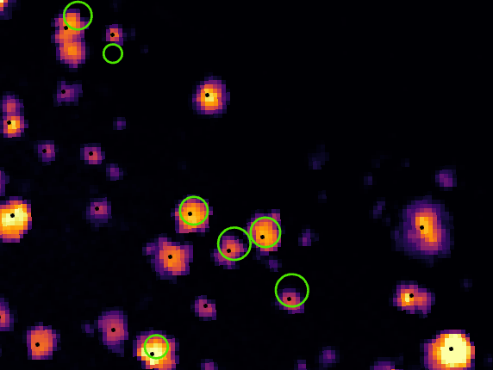
Image shows trees in a small area of Mount Rainier National Park on the south side of the Sunrise Ridge. Lidar-detected vegetation height is shown in shades of black (no vegetation) through purple and red (shorter vegetation) to yellow (tallest vegetation). The black dots represent lidar-derived tree centerpoints and the green circles show field recorded trees that will be ‘snapped’ to the most likely lidar-derived tree centerpoint and used to train the whitebark pine probability model.

