Plant Data Sheet

Species (common name, Latin name):
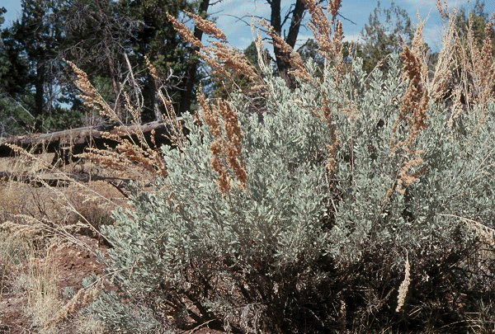
Big Sagebrush, Artemisia tridentata, Nutt.
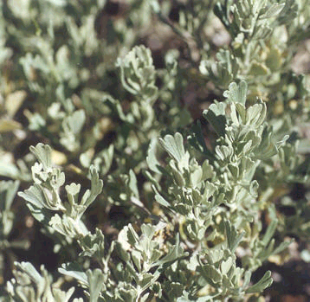

Range
Occurs from British Columbia to Baja California, east to the Dakotas and New Mexico. (Hitchcock and Cronquist 1973)

Climate, elevation
Occurs in semiarid climatic regimes in desert and semi-desert conditions. Basin big sagebrush (A. t. ssp. tridentata) grows on sites with deep, well-drained soils and average precipitation between 10-18 inches per year (occurring mainly in the fall and winter months). The other big sagebrush subspecies (A. t. ssp. spiciformis, A. t. ssp. vaseyana, A. t. ssp. wyomingensis, A. t. ssp. xericensis) tend to occur on more xeric sites.
Elevation ranges are variable: 4,800-5,800 feet (1463-1768 m) in Arizona, 100-7,000 feet (30-2134 m) in Oregon, 2,001-7,019 feet (610-2140 m) in northeastern Utah.
(FEIS database)

Local occurrence (where, how common)
Locally, sagebrush occurs as a dominant shrub in eastern Washington shrub-steppe and dry Ponderosa pine savannas. (Franklin and Dyrness 1973)

Habitat preferences
Prefers deep well-drained soils; locally occurs throughout the dry interior of eastern Washington; dominates the Columbia Basin shrub-steppe zone.
(Franklin and Dyrness 1973)

Plant strategy type/successional stage (stress-tolerator, competitor, weedy/colonizer, seral, late successional)
Prolific colonizer following disturbances; considered a topographic and edaphic climax dominant species over most of its range. (Franklin and Dyrness 1973, FEIS database)

Associated species
Common associates are Pinus ponderosa, Artemisia tripartita, Agropyron spicatum, Festuca idahoensis, Elymus cinereus, Stipa thurberiana, Purshia tridentata, Phlox longifolia, Balsamorhiza careyana, Lithophragma bulbifera, Lomatium spp. and Microseris troximoides. (Franklin and Dyrness 1973)

May be collected as: (seed, layered, divisions, etc.)
May be propagated by seed in the spring and by cuttings taken in late summer through winter.

Collection restrictions or guidelines
Seed production occurs from October to December and most seed is shed in the fall, although some may remain on the plant through the winter. Seeds may germinate in fall and winter in the southern part of big sagebrush’s range; however, most seeds germinate in the spring as early as April. (FEIS database)
Sagebrush seeds are collected by beating or stripping them into shoulder hoppers, baskets, or bags. (Woody Plant Seed Manual)

Seed germination (needs dormancy breaking?)
Dormancy depends on ecotype of collected seeds; individuals from southwestern locations tend to be germinable immediately while northern individuals tend to have a cold stratification or light requirement for germination. Dormancy can be broken by a short (2-week) period of moist, cold stratification and, in many cases, through after-ripening that occurs during storage. (Woody Plant Seed Manual)

Seed life (can be stored, short shelf-life, long shelf-life)
Big sagebrush seeds have been determined to be relatively short-lived, remaining viable less than 5 years in warehouse storage. Storing with a low moisture content (6 to 8% is optimal) and at relatively low temperatures (<10 °C) can extend storage life to 5 years and possibly longer. (Woody Plant Seed Manual) Most sagebrush seeds are not viable in the seedbank for more than 1 year. Fire may reduce emergence of big sagebrush (FEIS database).

Recommended seed storage conditions
Storing with a low moisture content (6 to 8% is optimal) and at relatively low temperatures (<10 °C) can extend storage life to 5 years and possibly longer. (Woody Plant Seed Manual)

Propagation recommendations (plant seeds, vegetative parts, cuttings, etc.)
May be direct seeded, grown as bareroot or containerized material, or propagated by cuttings. Transplants of wild seedlings are also successful. (Woody Plant Seed Manual)
Cuttings should be taken in fall or winter, dipped in rooting hormone and placed in sandy substrate or peat pellets and exposed to bottom heat and top misting. (Alvarez-Cordoza and McKell 1979)

Soil or medium requirements (inoculum necessary?)
Grow best in light, well-drained soils. Prefer not to be in alkaline soils.

Installation form (form, potential for successful outcomes, cost)
Easily established by direct seeding in late fall or onto snow in winter or by transplanting wild seedlings in the spring. May also be installed in the spring as containerized or bareroot nursery grown material. Containerized material requires careful hardening before transplantation. (Woody Plant Seed Manual)

Recommended planting density
3’ centers.
For direct seeding Meyer recommends a seeding “rate of 0.1 to 0.2 kg/ha (1.5 to 3 oz/ac) on a pure live seed (PLS) basis for a lot that averages 4 million seeds/kg (113,400/oz)” (Woody Plant Seed Manual).

Care requirements after installed (water weekly, water once etc.)
Moisture is often the limiting factor in establishing sagebrush from seeds; therefore, watering through the first summer will help ensure the success of direct seeding. (Woody Plant Seed Manual)

Normal rate of growth or spread; lifespan
Sagebrush grows fairly quickly (especially A. t. ssp. tridentata) and is reproductively mature by age 2 years. (FEIS database)

Sources cited
Alvarez-Cordero, E. and C. M. McKell. 1979. Stem cutting propagation of big sagebrush: Artemisia tridentata. Journal of Range Management 32 (2).

FEIS database: Accessed on 4/20/03, http://www.fs.fed.us/database/feis/plants/shrub/arttrit/index.html

Franklin, J. F. and C. T. Dyrness. 1973. Natural Vegetation of Oregon and Washington. Oregon State University Press, Corvallis.

Hitchcock, C. L, and A. Cronquist. 1973. Flora of the Pacific Northwest, An Illustrated Manual. University of Washington Press, Seattle.

Meyer, Susan E. Artemisia, L.: Sagebrush. Accessed on 4/20/03 from USDA Woody Plants Seed Manual: http://wpsm.net

Data compiled by (student name and date): Anne Andreu, 4/21/03

