WEBSITE OUTLINE

General look:

We most like the looks of the American Family Health Survey (AFHS) website. It’s focused most on potential respondents to the survey, looks clean and appealing, easy to navigate, professional, and trustworthy.

We like the UW CSDE website for these things:
- Banner at the top
- Links to each main page arrayed horizontally under the banner
- Wide picture under the links, different for each page- this might look good on ours or it might look to busy.
- Banner at the bottom

We like the Healthy Chicago Survey website, Survey Participants page for how the FAQs are arranged.

- Banners

Banner at the Top of Each Page, something like this:


Includes
- Sound Data logo
- UW logo with W and words
- UW purple and lavender

Banner at the Bottom of Each Page, something like this:
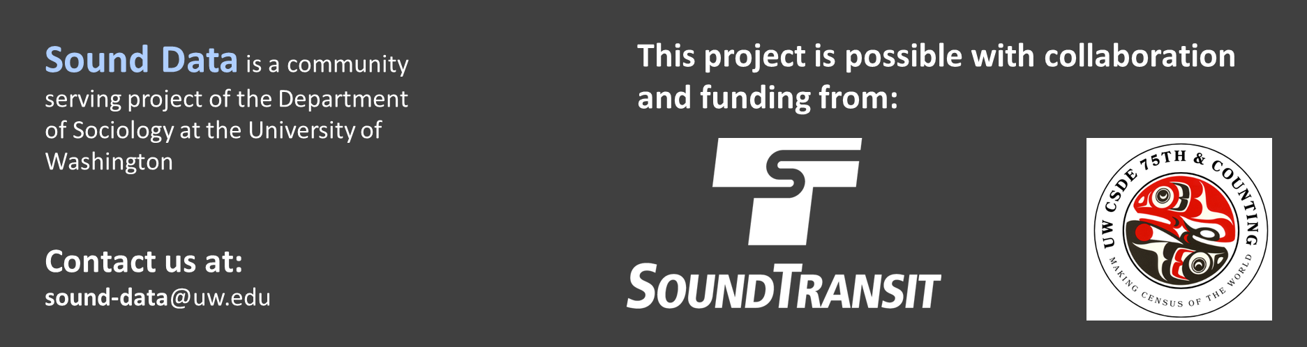

Includes
- blurb about Sound Data being community focused and through the Department of Sociology
- Email address for us
- Sound Transit logo
- CSDE logo
- Probably shouldn’t be purple, because the Sound Transit and CSDE logos would clash. We’re not sure if Sound Transit will want us to use their white logo or a blue one.

Content

Main pages should be:
- Welcome
- For Survey Participants
- Research Team
- Collaborators
- Survey Design, Documentation, Results & Reports
- Contact us

[page] Welcome
[Rotating images of Seattle, King County, and Sound Transit (like on the AFHS website)]

Tagline at the top: Collecting local data to help our local communities thrive

Text on the page:
We are collecting survey data because we want to help make and keep our Puget Sound area a great place to live for ourselves, our families, and our neighbors.
These days, it’s often the loudest voices that get heard, but in our survey, your voice matters and can help shape the future of the Puget Sound region.
We hope you will take the survey and join us in helping our community.
We will share results with policy-makers and community leaders so they can understand the many needs and concerns that residents have:
- Is public transportation working for people?
- Do people feel safe in their neighborhoods?
- What kind of health and social services are needed?
- Are people working in jobs that work for them?

[page] For Survey Participants
Did you receive a mailing or did an interviewer come to your door to ask you to participate?
Here is information about how participation works.

[This page could be organized with questions that users can click on to open up for more information. Like on the “Survey Participants” page of the Healthy Chicago Survey, scroll down a little to see the FAQ pop up boxes]

[We will provide the text content for each of these]

Questions, each in one box:
- What is this survey for?
- Why was I selected to participate?
- How does the survey work?
- What will you ask in this survey?
- How long will it take me?
- Is it safe? Is my information confidential?
- How will my data be used?
- What do I get for taking this survey?
- How can I take the survey?
- Can I see the study results?
- What if I have more questions?

[page] Research Team

We are Professors and students at the University of Washington and employees of Sound Transit. We all live in the Puget Sound region

We are doing the Sound Data surveys to use our expertise to give back to our community, to help the Puget Sound region continue to thrive and to be a place where we and our neighbors, family, and friends are happy, healthy, and proud to live.

[Include small head shots of the people below. We will provide headshots.]

Principal Investigators
- Dr. Nathalie Williams, Professor, Department of Sociology, University of Washington
- Dr. Kyle Crowder, Professor, Department of Sociology, University of Washington

Executive Board
- Dr. Sara Curran, Professor, Department of Sociology and Jackson School of International Studies; Director, Center for Studies in Demography and Ecology, University of Washington
- Dr. Jerry Herting, Professor Emeritus, Department of Sociology, University of Washington
- Dr. Tyler McCormick, Professor, Departments of Sociology and Statistics, University of Washington
- Daniel Thiel, Program Manager in Passenger Experience, Sound Transit
- Dr. Rebeca de Buen Kalman, TITLE, Sound Transit

Sampling, Programming, Survey Management, and Administration
- Dr. Jessica Godwin, Statistical Demographer, Center for Studies in Demography and Ecology, University of Washington
- Dr. Matthew Dunbar, Spatial Research Scientist, Center for Studies in Demography and Ecology, University of Washington
- Caroline Teague, Undergraduate Student, Department of Sociology, University of Washington
- Karthik Ramesh, Graduate Student, Department of Sociology, University of Washington
- Brandon Morande, Graduate Student, Department of Sociology, University of Washington
- Name TBD, Administration, Department of Sociology, University of Washington

[page] Collaborators

This project is made possible with the collaboration and funding from several local organizations.

[Include logos and links to their webpages. We will provide logos and links]

- Sound Transit
- Center for Studies in Demography and Ecology, University of Washington
- Department of Sociology, University of Washington

[page] Survey Design, Documentation, Results & Reports

Survey Design & Documentation
- Sampling- [link to pdf of sampling report]
- Household roster questionnaire [link to pdf]
- Individual interview questionnaire [link to pdf]

Results & Reports from completed Sound Data studies
- A Portrait of the Unhoused Population of Seattle, WA 2023 [link to pdf]

[page] Contact Us
Mailing address:
Sound Data Principal Investigator, Dr. Nathalie Williams
Box 353340, Department of Sociology
University of Washington
Seattle, WA 98195-3340

Email:
sound-data@uw.edu

