Welcome to the Trans Health Allies 365 group/ SharePoint!
This site is for medical providers who wish to learn more about primary and/or specialty care for transgender and gender non-binary patients.
Tools:
Group email:
Click on our group, and you will be on the group email page. An email that you draft from here will go to all members of the group. The calendar, which you can click on from the group email, will have the THA Zoom meetings on them.
The emails you receive can be managed through the group settings widget in the right upper corner of the email page:
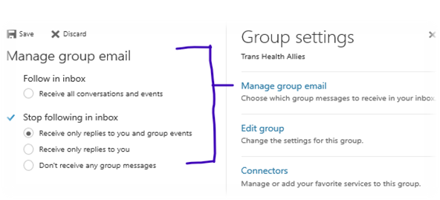
SharePoint site:
To get there, start from the group email screen. In the header you will see:
Click on the … and then on "Site", which looks like this:

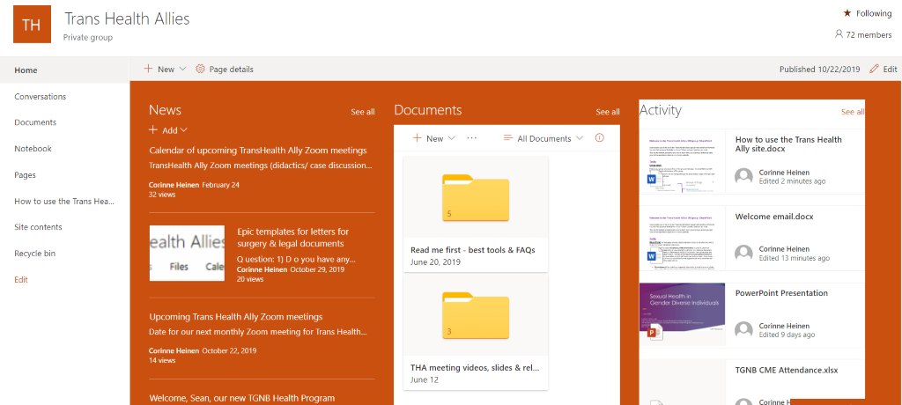

The middle column is "Documents", under which are our folders of resources. This is something we add to regularly. If you click to the right of Documents on "see all" you will see the list of documents on its own page, which is much more functional. You’ll find informed consent, surgical endorsement letter, and other legal/required documentation templates in the pinned “Read me first” folder 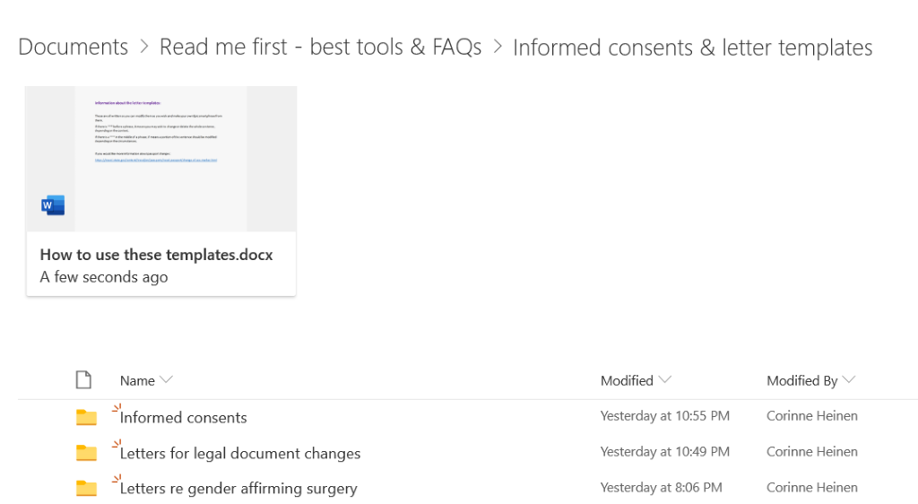📌

Several recordings have been posted from our previous meetings, and can be found in the pinned THA Meeting Videos, slides, & related articles folder.
Other folders (these are not pinned): for managing articles, patient education resources & other documents.
- There will be some redundancy within the folders, to provide a tailored experience depending on your specialty and focus. For instance, the patient education sheet on contraception will be in the primary care, gynecology and patient education folders. Gender affirming hormone management applies to many different specialties, so that will have it’s own first tier folder. If you have suggestions on how you would like the site organized, let us know and we will consider it in the larger picture.
- Procedures will be under their respective specialties, at least for now; at a later date, some of these may involve more than one specialty and require a different approach.
- If you wish to add an article or resource, please ping the health program coordinator or Corinne so we know it is on the site

Here are a couple of other talks about the approach to the patient when providing clinical care to gender diverse patients on YouTube. For context, these were for a QI project CH was doing for Ryan White HIV clinics.
10 minutes: Approach to care
https://www.youtube.com/watch?v=X4nYgAZvE5I&feature=youtu.be
~50 minutes: Trauma Informed Care-1
https://www.youtube.com/watch?v=vhXztF2suYY&feature=youtu.be
~50 minutes: Trauma Informed Care - 2
https://www.youtube.com/watch?v=OPP56HnRCdE&feature=youtu.be

Cheers,
Your UW Medicine Transgender and Gender Non-Binary Health Program team
Sean Johnson, LSWAIC, MSW, MPH – TGNB Health Program Coordinator
Corinne Heinen, MD, FAAFP – TGNB Health Program Physician Lead

