Kind of Report
Agreement _____, Task __
Short (UW) Title

REPORT TITLE

by
Name, Title Name, Title
Department Department

Name, Title Name, Title
Department Department
University of Washington
Seattle, Washington 98195

Washington State Transportation Center (TRAC)
University of Washington, Box 359446
University Tower, 4333 Brooklyn Ave NE
Seattle, Washington 98195-9446

Washington State Department of Transportation Technical Monitor
Name
Title and Department

Prepared for
The State of Washington
Department of Transportation
Roger Millar, Secretary

Month and Year

TECHNICAL REPORT STANDARD TITLE PAGE
1. REPORT NO. |  | 2. GOVERNMENT ACCESSION NO. |  | 3. RECIPIENT'S CATALOG NO.
WA-RD XXX.X
4. TITLE AND SUBTITLE |  |  |  | 5. REPORT DATE
TITLE |  |  |  | Date
 |  |  |  | 6. PERFORMING ORGANIZATION CODE
7. AUTHOR(S) |  |  |  | 8. PERFORMING ORGANIZATION REPORT NO.
Authors

9. PERFORMING ORGANIZATION NAME AND ADDRESS |  |  |  | 10. WORK UNIT NO.
Washington State Transportation Center
University of Washington, Box 359446 |  |  |  | 11. CONTRACT OR GRANT NO.
University Tower, 4333 Brooklyn Ave NE |  |  |  | Agreement XXXX, Task XX
Seattle, Washington 98195-9446
12. SPONSORING AGENCY NAME AND ADDRESS |  |  |  | 13. TYPE OF REPORT AND PERIOD COVERED
 |  |  |  | Research Report
Washington State Department of Transportation  Transportation Building, MS 47372  Olympia, Washington 98504-7372 14  Doug Brodin, Project Manager, 360-705-7972 |  |  |  | 14. SPONSORING AGENCY CODE
15. SUPPLEMENTARY NOTES
This study was conducted in cooperation with the University of Washington.
16. ABSTRACT
Abstract

17. KEY WORDS |  |  | 18. DISTRIBUTION STATEMENT
Key words |  |  | No restrictions. This document is available to the public through the National Technical Information Service, Springfield, VA 22616
19. SECURITY CLASSIF. (of this report) | 20. SECURITY CLASSIF. (of this page) |  |  | 21. NO. OF PAGES | 22. PRICE
None | None

DISCLAIMER

The contents of this report reflect the views of the authors, who are responsible for the facts and the accuracy of the data presented herein. The contents do not necessarily reflect the official views or policies of the Washington State Department of Transportation or Federal Highway Administration. This report does not constitute a standard, specification, or regulation.

CONTENTS

Section Page

Executive Summary vii
CHAPTER 1 Level 1 Heading 1
1.1 Level 2 Heading 1
1.1.1 Level 3 Heading 1
1.2 WSDOT Research Report Organization 1

FIGURES

Figure Page

1.1 Figure title
1.2 Figure title.

TABLES

Table Page

1.1 Table title.
1.2 Table title

Executive Summary

Standard paragraph... researchers developed information tools to increase the speed and efficiency of Washington State Department of Transportation (WSDOT) post-earthquake response and recovery efforts. The researchers upgraded the Pacific...

CHAPTER 1 Level 1 Heading

Standard paragraph... researchers developed information tools to increase the speed and efficiency of Washington State Department of Transportation (WSDOT) post-earthquake response and recovery efforts. The researchers upgraded the Pacific...

Level 2 Heading
Standard paragraph... researchers developed information tools to increase the speed and efficiency of Washington State Department of Transportation (WSDOT) post-earthquake response and recovery efforts. The researchers upgraded the Pacific...

Level 3 Heading
Standard paragraph... researchers developed information tools to increase the speed and efficiency of Washington State Department of Transportation (WSDOT) post-earthquake response and recovery efforts. The researchers upgraded the Pacific...

Level 4 Heading
Standard paragraph... researchers developed information tools to increase the speed and efficiency of Washington State Department of Transportation (WSDOT) post-earthquake response and recovery efforts. The researchers upgraded the Pacific...

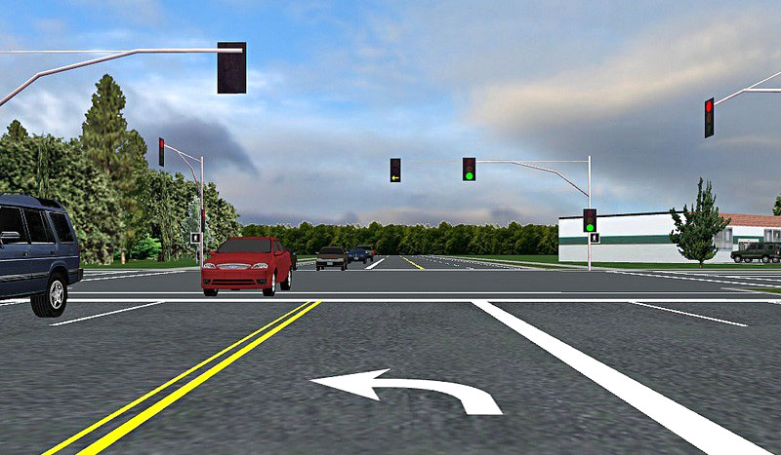
Figure 1-1 Caption
For all figures, make sure to write Alt Text to ensure 508 compliance.

Table 1-1. Caption
Column | Column | Column | Column
Row

For all tables, even if they do not break across a page, make sure to assign “Repeat as header row at the top of each page” to the header row, under Table Properties, to ensure 508 compliance.

University of Washington researchers developed information tools to increase the speed and efficiency of Washington State Department of Transportation (WSDOT) post-earthquake response and recovery efforts. The researchers upgraded the Pacific...

WSDOT Research Report Organization
- Introduction or Background
- Review of Previous Work
- Research Approach/Procedures
- Findings/Discussion
- Conclusions
- Recommendations
- Application/Implementation
- Acknowledgment
- References
- Appendices

