Put the Bottles Down
By Ashley
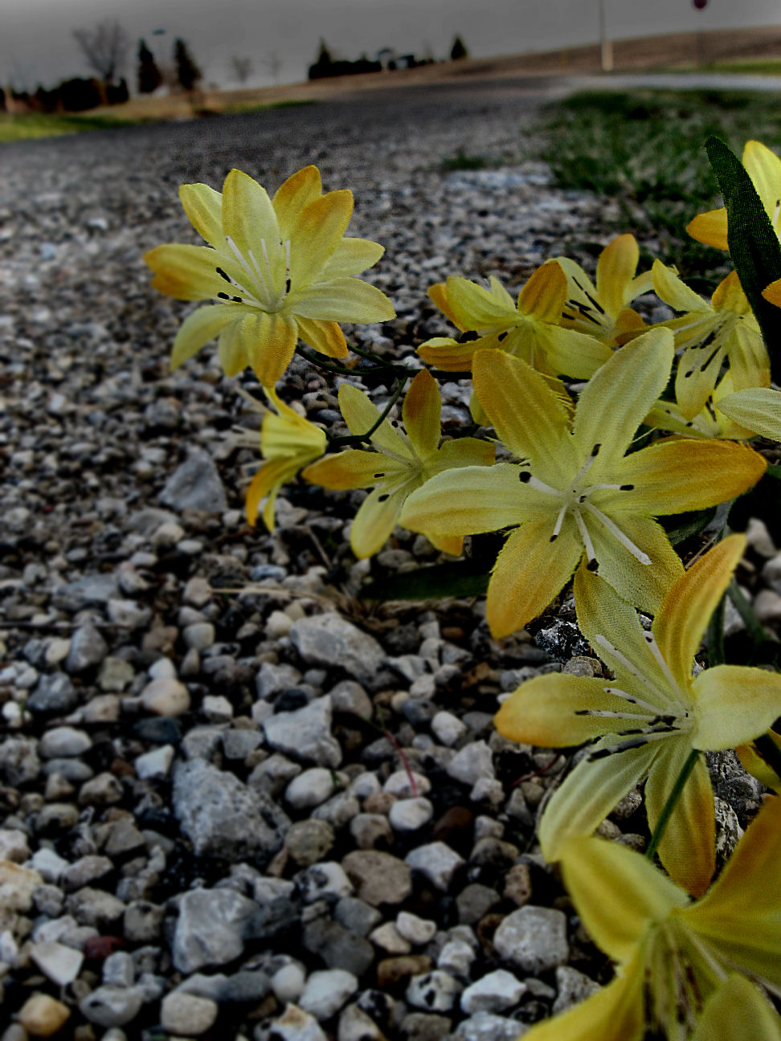
My hands were bound to my face,
slightly parted fingers gave me a glance at my darkest nightmare.
The thing is, I wish it was one.
Pinching me isn't going to change one single thing.
The moon was full, and the stars were bright,
just like the lights flashing in front of me.
As I fell to my knees on the wet pavement,
I realized that I had lost a part of me.

It was April 29th.
I turned on the wipers as the rain fell harder.
My eyes followed as I watched swerving in the distance,
I reached for the volume, I heard more than music.
As I saw what the scene ahead of me included,
thoughts ran wild and untamed in my mind.
A shrill scream escaped from my mouth.
I could recite those license plates forward and backward.
Picture taken & edited by Ashley on 03/30/09

Trembling fingers dialed 911,
my voice explained the horror my eyes had witnessed.
Deep breath in, deep breath out,
I told myself out loud that she was okay,
but I was well aware of my doubt.
I looked up from my daze and there they were,
streams of blue and red flashing rapidly.
This had to be a dream...

But it wasn't.
The car was to my right,
the car was to my left, along with her...
A face full of cuts, blood shot eyes,
a disguise I did not recognize.
I reached out, but my hand was stopped.
"Stay back miss,
do you know who this is?"

"Madison. My twin, my other half,
and my sister, not just by heredity, but by choice.
A girl I thought I knew,
but I guess I didn't know her as well as I thought."
Uneven breaths and sniffles muffled my words,
in between them I heard a man's voice.
"I don't really know how to say this,
but I think this is my first D.O.A."

...as I fell to my knees on the wet pavement,
I realized that I had lost a part of me.

It's April 29th.
In one split second, in the blink of an eye,
your entire world can change in this small amount of time.
Yellow flowers in one hand, a prom picture in the other.
I set both on this cold stone she would have to call home.
It's been one year to the day that Madison's been away.
The sad reality is that this could have been avoided
if she would have just put the bottles down.

