The Challenge of Nature

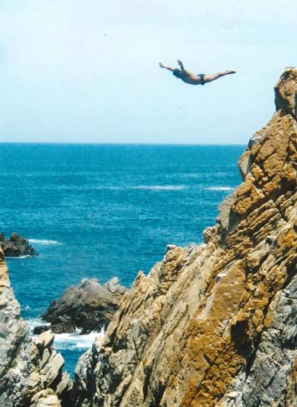
Acapulco owns a part of the Pacific Ocean. Immense and unfathomable, its powerful waves smash into the rocks with a force that you can see, but this man is fearless. He challenges the waves daily to support his family, but it is also his calling. Performing this dive from the highest peak is an enormous accomplishment; an act of devotion, bravery, skill, and precision. This diver is not a professional athlete. He has inherited his skill from all who came before him and he carries on a tradition that is unique to this place. Even though he and his fellow divers know the dangers, they are there every single day, seeking the shiny coins of approval from the crowds.
He stands in silence, waiting for the restless waves to settle down; while his heart beats against his chest. His muscles get harder and harder, like the rough, brown rocks where he stands. Each time there is the possibility that he could smash himself on the huge, jagged rocks and die. He plunges from the uppermost peak and the spectators freak out. When he cuts into the blue ocean, the splash is loud, deep and exuberant. Suddenly, he comes up from the deep waves; without any injuries and proud to receive the joyful applause and gleeful shouts of “Great job!” from the gaping tourists.
I love the ocean, but it’s so profound and powerful that I could never challenge it. The waves and rocks extend into each other, crashing everything in their path. That’s why I so admire this brave man and wonder about his love of this life-threatening profession that challenges danger and death with his skill every day of his life.
Photo was taken by Sara.

