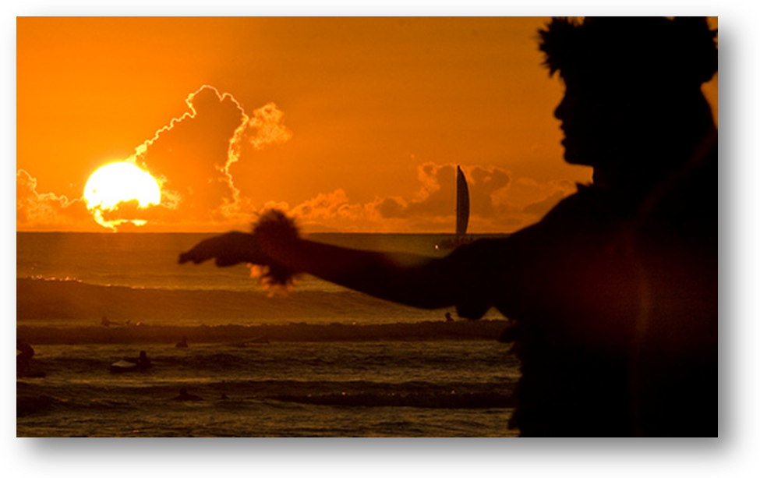

My Hawai'i

As it stretches beneath the waves,
The islands emerge from utter nowhere,
As the rays stretch out from behind the clouds,
Dear Hawai'i, she grins.

From the grasps of so many Chiefs,
All so loyal and proud,
To the monarchy of long ago,
Dear Hawai'i, she smirks.

Our Queen, she was pulled through hell,
Forced to give up Hawai'i,
To the greedy plantations,
Dear Hawai’i, she frowns.

Annexed as a state,
The 50Th for our wealthy country,
A place of “paradise”,
Dear Hawai’i, she grins.

Now a place of many cultures,
The Filipino, Portuguese, Asian, Polynesian & nations of the world,
All living in peace and harmony,
Dear Hawai’i, she smirks.

The Hawai'i culture it shines,
From the White house to the plantation homes,
Our Hawai’i still offers aloha,
Dear Hawai’i, she smiles.

The children, the future of Hawai’i,
Practice the culture, that will continue to live,
From dancing hula to the waves we hit,
Dear Hawai’i, she beams.

No longer does Dear Hawai'i frown, grin or smirk,
Dear Hawai’i she beams, the world in awe,
So here’s to you, our love and aloha,
A dance in your honor, and a start of a new day.

Poem by: Pearl
Picture credit: http://farm3.static.flickr.com/2202/2203524592_47e74f9994.jpg?v=0

