The Hoover Dam Trip

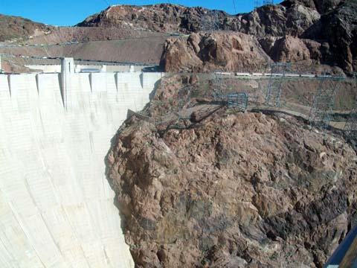

For someone who has never left the state of Texas, visiting Hoover Dam was like bungee jumping off the Eiffel Tower. Having the privilege of visiting one of man’s greatest and historic landmarks was truly an honor - one of the greatest experiences of my eighteen years of life.

This past March, the Upward Bound Program from the University of Texas at El Paso took a group of over fifty juniors and seniors on the annual College Visits Tour during spring break. I was elated to be one of the seniors chosen to go on the adventurous journey across Arizona and Nevada. On the last day of our exhilarating trip, we visited Hoover Dam, on the border of Arizona and Nevada. I could feel my heart pounding out of control as we made it to the entrance in mid-afternoon and were greeted kindly by a hard working tour guide who had already put in many hours.

My eyes widened at the sight of the tunnels and the structures where thousands of men had worked night and day for four years in order to create what we were seeing almost 74 years later. I kept asking myself how these guys were able to work in such darkness. Did they ever get nervous? Touching the hard and rocky surface that they were able to penetrate made me wonder about the enormous amount of strength, power and persistence these workers must have had in order to make this landmark what it is today.

I was stunned when we walked into a room housing the hydroelectric generators. Being so high up, sent a trail of goose bumps throughout my entire body. I was astonished to learn how much energy these generators create and send throughout several states. Did Americans really make this? How on earth did they come up with such a breath taking machine? I started to wonder about the possibilities we, as people, have yet to discover. Knowing that man created something this amazing, made me realize how intelligent humans are and how great it is to be American.
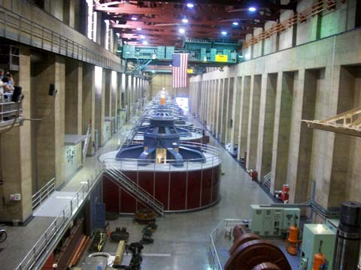
As we finally made our way to the very top of the dam, I could feel my jaw drop as my eyes wandered around in a full circle. Never had I seen such beauty up close. My body grew very weak when I looked down over the rail and saw the bottom of the dam and the beautiful teal water flow smoothly. I dared myself not to stare down at the terrifying and mysterious bottom, but my heart couldn’t resist the gentle waves that hypnotized me, making me forget the people and everything else around me. The sun shimmered beautifully on the mountains, giving everything in sight a glow that not only caught my eye, but my heart as well.

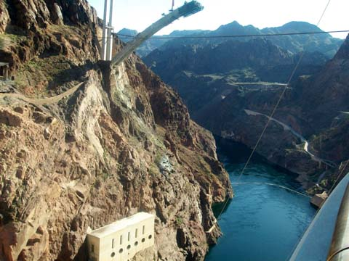
Being on top of the Hoover Dam made me feel like being on top of the world; although I wasn’t crazy enough to get on top of the rail and yell it out loud. When I reached out into the distance, I realized that the possibilities for human kind are endless. All we have to do is reach out, grasp them, and never let go.

Photos were taken by Veronica.

