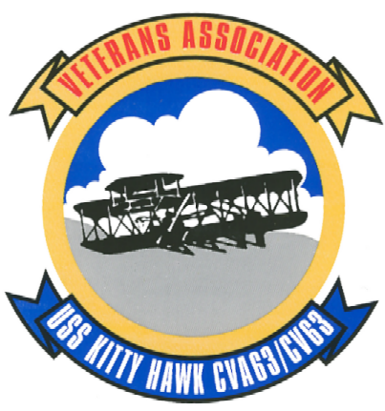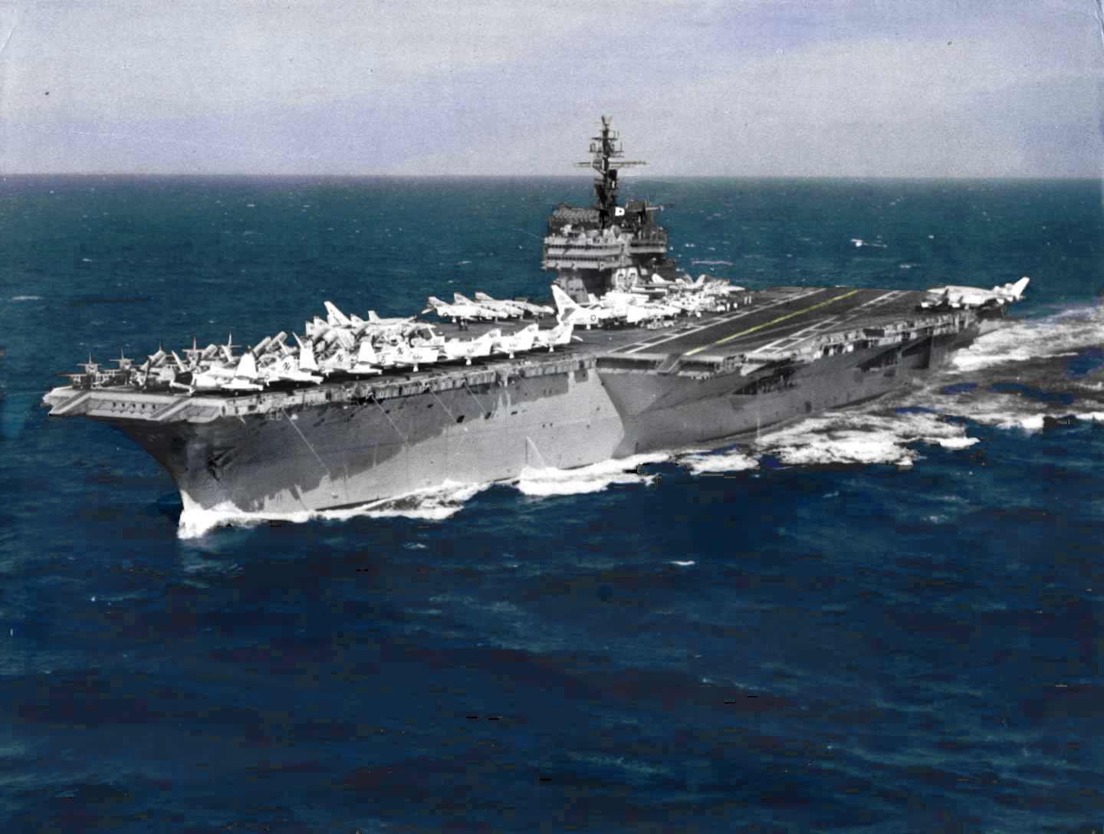
1965
United States Navy

Charles Magee MM1 U.S.N.R. Retired

[tragedy on the high seas: A carrier fights for life.]
It was the morning of six December, 1965. Because of certain events, this would become a day that would haunt me off and on for the rest of my life. I was topside, had just been paid, and was standing in line to see the corpsman. There was a boil on my backside that I wanted to get removed. Not that it was really necessary, but it meant I could stay topside for a while longer. The engine room was very hot and stuffy while underway and I enjoyed the air and cooler temperature of the upper decks.
Suddenly a voice came over the 1MC: “Fire! Fire! fire! There is a fire in three main machinery room! All hands, General Quarters. This is not a drill.”
The ship’s bell sounded frantically to inform all hands of the emergency! This was the most dreaded call that could sound on board a U.S. Naval ship. The entire crew had been required to attend fire-fighting training on a semi-annual basis just because of this type of emergency. Now was the time to put that training into action.
Hastily, I tossed my medical records on the desk and started to my battle station in main machinery room number four. I remember thinking that the guys in three would have the fire out before I got to my station. But as I turned the corner, not ten feet from the door, the blackest smoke I had ever seen met me head on. The smoke must have traveled at least a hundred yards to get that point which told me in an instant this was a very serious fire.
Quickly I grabbed the handrails of the ladder and slid down into the engine room. I started thinking about the fire’s location. My thoughts turned to the friends that worked down there. This had to be a serious fire to send black smoke this far forward. But just how bad could it be? There was an ammo magazine just aft of number three and if the fire got hot enough it could present a very dangerous situation back there. Five hundred pound bombs were stored there. Even if one of them was set off it would cause a chain reaction that would blow the entire aft third of the ship.
We held our battle stations for three and a half hours while the fire party entered into the space below decks. The engineers who occupied the space as a workstation initiated their jobs to get control over the fire until the fire party made it down into this fiery hell. My thoughts about it were that they were charging into Hades with a water gun. Flames were shooting up the aft bulkhead from the bilges to the overhead above the boiler. The boilers were about the size of a two-story house. The boiler watches would have to secure the burners and the boiler check valves. The fire continued to burn out of control with all the fury it could muster, eating up everything it could find. Its lust for life gave it such a head start that it took the fire party two hours to gain control and start beating the flames back.
Still at General Quarters two hours later: our messenger of the watch was taking the readings on all machinery for the top watch and informed us that he had heard that two people had been killed, but word as to who it was had not come down the line yet. Another hour past by and the messenger returned. I asked him if he had found out anything. He said one was a fireman apprentice named Charles Philhower; even though I had never met him I still remember his name. I suppose because there was a rumor going around that his father had been in the Navy and was killed in similar fashion, a fire on board ship. Charles had been aboard the Kitty Hawk less than six months. I asked who the other one was. He said he wasn’t sure but thought it was Billy Hooper. Billy was a very good friend of mine.
After three hours had lapsed and since my general quarters station was more minor in that one man could include it under his responsibility, I was sent back to three main to help over haul the fire and set the watch for re-flashes.
I later found out that Billy actually made it out of the engine room but died later at sickbay of smoke inhalation. We all know the sacrifices that have to be made in times of this type of tragedy. These two men gave their lives for the ship, its aircraft, and in all probability at least fifty per-cent of the crew. Charles Philhower secured the burners on the boilers; Billy Hooper secured the boiler check valves. This eliminated the chance of the boilers exploding.
Billy had been a friend of mine. We went to the movies and spent time at the U.S.O. clubs in San Diego. Our conversations carried us into how short he was. Not in stature but in time left on his enlistment. He only had six months left and he would go home to Montana. I didn’t think he would go with us overseas, but he had three months more than the required to stay behind. These are the facts that have haunted me ever since. Every time I see a picture or hear her name (Kitty Hawk) on the news, I think about the time she burned and killed my shipmates.
The cause was later discovered to be a jet fuel line ran through the main engine room instead of the magazine. As it turns out it was not the fault of the ship, but the fault in the construction. When building the Kitty Hawk a mistake was made in reading the blueprints. The jet fuel line was placed in the engine room just about a foot and a half from the boiler. JP5 is a highly volatile fuel and mixed with the fuel oil that invariably finds it way into the bilges cost two very good sailors and shipmates their lives. But if they hadn’t done what they did the cost would have been, in my opinion, the entire multi-million dollar aircraft carrier. At the time, the Kitty Hawk had only been a commissioned vessel about six years.
Not everyone is privileged to serve with the type of individuals that I have been. I have always been proud to have served with these two young men; they paid the ultimate sacrifice to save the ship and the entire crew. But of course not everyone has been in the situation that they were put in. Navy pride runs deep in the souls of the crew members who have had the honor and privilege to serve on board and walk her decks.
The people of the United States should be proud of their servicemen and women. These young people put their lives on the line every day to see that this nation lives free. This pride of service runs into serving the greatest nation and in the greatest navy in the world today, tomorrow, and forever. Kitty Hawk (CVA 63) will always have a place in my heart.
Overcoming adversity of such a nature as this fire was not commonplace in her illustrious career, but show the indelible spirit of the crewmen who served on board her with pride. A proud ship sailing in harm’s way for the cause of freedom, she continued to set the standards for other ships following in her wake. The Kitty Hawk served the Untied States for an unprecedented forty-eight years of continuous service.

