Young Tribe

Carefully listen to the drum beat.  When they are picking wheat, it is in their heartbeat.  For those who draw together,  their ancestors are in their hearts forever.  When you see the youngsters gracefully dancing,  In their mind, there is chanting.  As everybody gathers, they can see their small spirits soar,  As if they were the great American eagle rising.  The scarlet paint on our face symbolizes “We are ready to grow,  Therefore we show.  We are the past, present, and future.” |  | 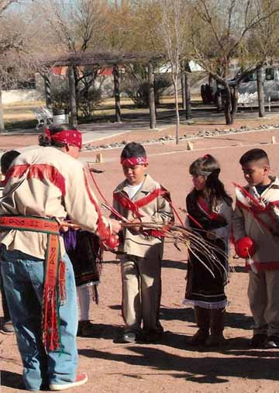

Picture was taken by Diamond.

