Some Handy Socratic Questioning Tips

1) Identify their cognition and try to really understand their basis for it.
E.g., if it's self-blame ("it was my fault"), you might ask, "Why was it your fault?" and "What exactly do you think you should have done differently?"
E.g., if they think their child is "ruined" you might ask, "What do you mean when you say that?" and "What is your evidence for that?"

It's much easier to challenge specific cognitions like "I should have known he would rape me that night" or "I should have done X in situation Y" than it is to challenge the less specific overall statements "I'm a bad parent" or "It's my fault." Dig down and find the specifics.

One idea is to visualize a stool, where there are specific thoughts propping up a belief. You can only eliminate the belief when you've taken out the legs (or faulty "evidence") it stands on. You can even draw a stool and have them fill in all the legs they can come up with. Then you can challenge their validity together.

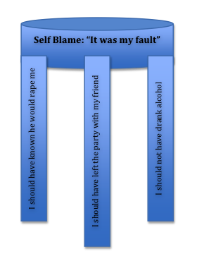

2) Ask questions to identify all the reasons their behavior made sense at the time. A core assumption here is that all behavior makes sense, given what was known and going on for them at the time. Set the stage for their behavior to seem reasonable with questions along these lines:
"What did you know at the time?"
"What were you thinking at the time?"
"Help me understand, why did you do [their behavior]?"
"Did you know [the trauma] would happen?" ("Why didn't you know?")
"What evidence did you have that [the trauma] wouldn't happen?" (Usually they have a lifetime of evidence!)
"At the time, what did you think would happen?"
"What did you want to happen?" (Intention underlies responsibility)
"Had [the trauma] ever happened before?"
"Had [the same behavior] ever resulted in [the trauma] before?" (Flesh this out--they may have been in the same situation hundreds of times without consequence.)
"At the time, what evidence was there that [the behavior] was safe or unlikely to result in [the trauma]?"

Basically, try to elicit all the internal and external conditions that made the behavior feel or seem reasonable at the time.
I usually brainstorm a long list of questions and angles I'll take before the session--it can be very hard to come up with good questions on the spot.

3) Expand their view of other causes and responsible parties. Responsibility pie helps expand the window on all the people and events that led to the trauma.

4) Psychoeducation can help, but whenever possible be Socratic.
E.g., a parent thinks, "She should have told me about the sexual abuse."
You might ask, "When kids are abused, guess how many of them speak out?" before telling them.
Ask, "What are some reasons you can think of why a kid might not talk about sexual abuse?" so they have to make sense of their child's behavior.

