Preventing Sexual Violence in the Intellectual and Developmentally Disabled Community
Handout

Power and Control Wheels

Partner Relationships –

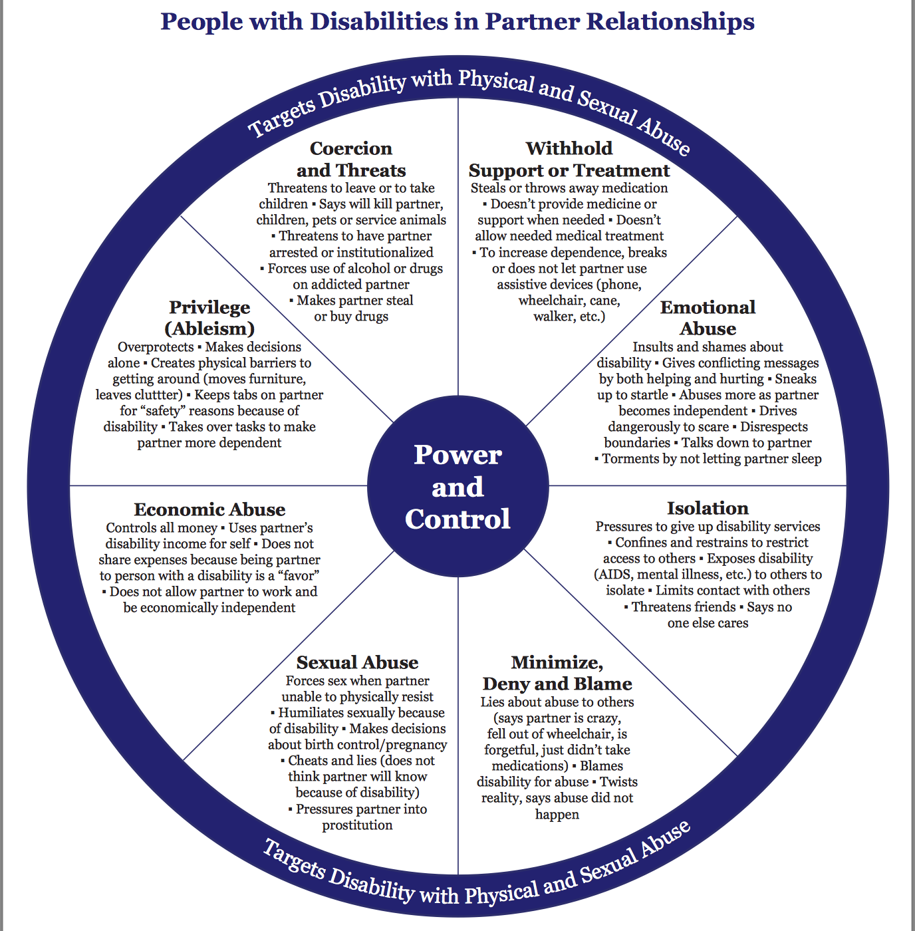
Caregiver Relationships -
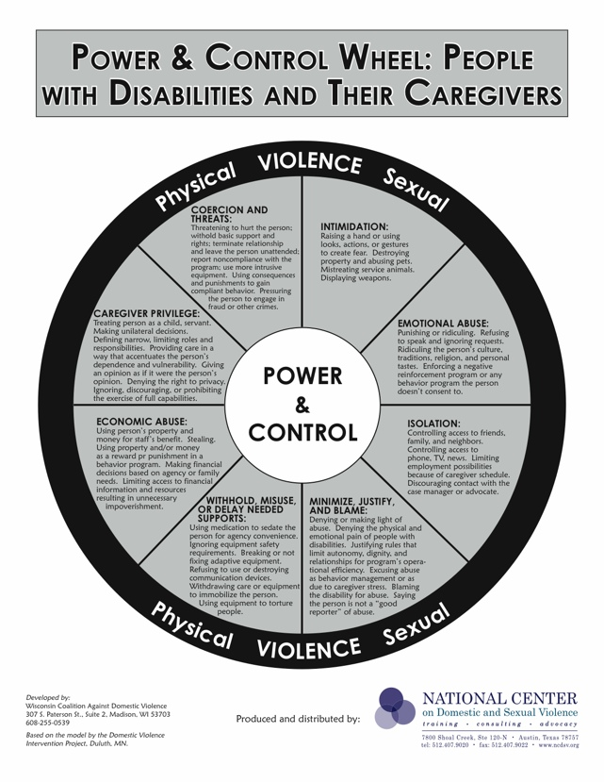
Links

10 Principles of Disability – Sins Invalid:
https://www.sinsinvalid.org/blog/10-principles-of-disability-justice

Comprehensive sex health education implementation:
https://www.k12.wa.us/student-success/resources-subject-area/sexual-health-education/comprehensive-sexual-health-education-implementation

NPR Abused and Betrayed podcast:
https://www.npr.org/series/575502633/abused-and-betrayed

Mandatory Reporting is Not Neutral:
https://www.mandatoryreportingisnotneutral.com/

