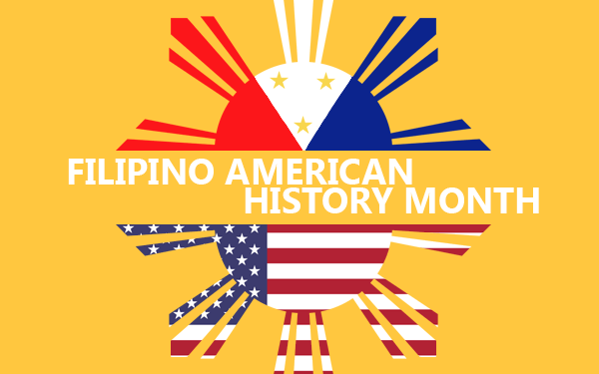

Please join HATC in celebrating the rich history of Filipino Americans during the month of October. Filipino American History Month is celebrated in October because the first Filipino immigrants arrived in the United States on October 18, 1587. October is also the birth month of Filipino American labor leader Larry Itliong. Now every October, we celebrate the many historical and cultural contributions that Filipino Americans have made in this country.
See Notable Filipino and Filipino American Pioneers!
NASW Social Work Pioneer – Mila Ruiz Tecala
How Filipino Nurses Supported America’s Medical System
Filipino Americans: Significant Contributions to US Healthcare System

Relevant Educational Materials!
The Perpetual Foreigner: What it’s Like to be Filipino American in a Time of Hate
Filipino American Boys and Young Men: Culturally Responsive Recommendations for Policy and Practice
Filipino Americans in Seattle

