How to quickly pull your Clinic’s Quality Metrics by PCP

HBI Tool – PCP Quality Metrics

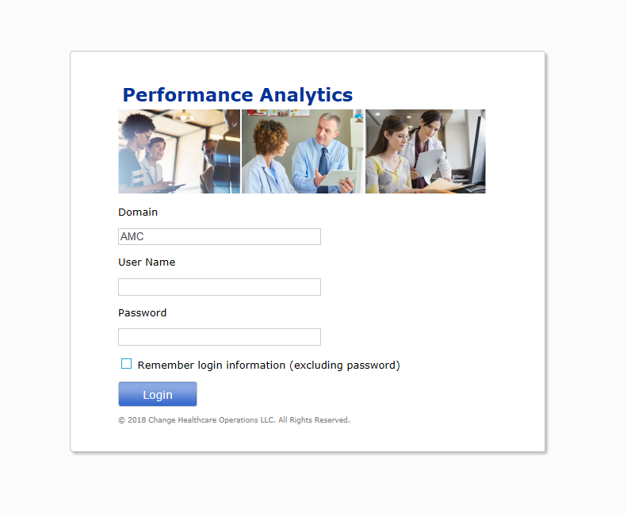

Access HBI Tool

Choose “Analyses”

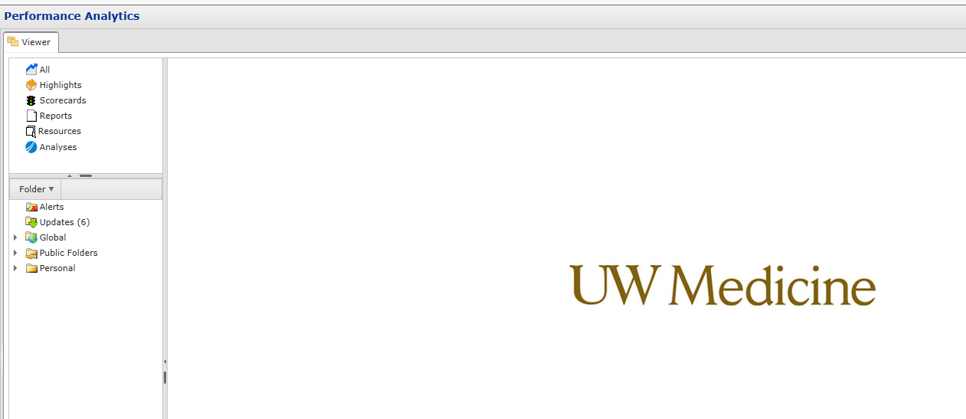

Choose “UWM Population Management Dashboard”

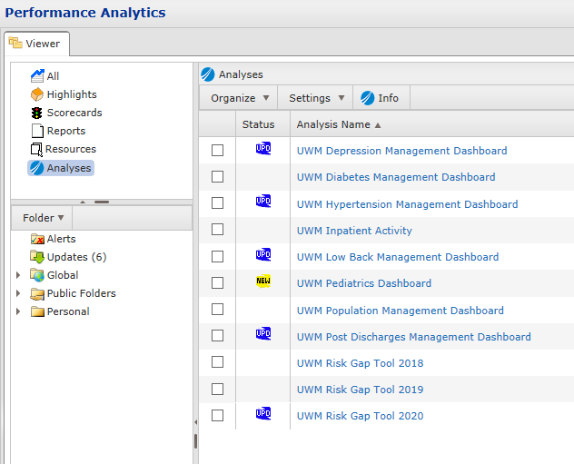

Choose the “PCP” Tab

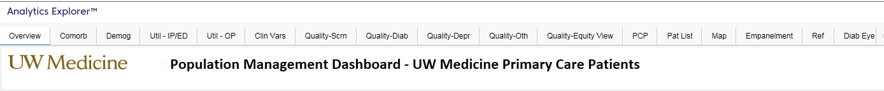

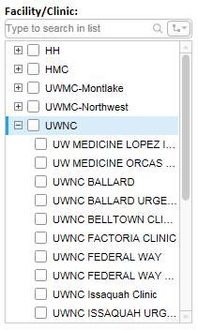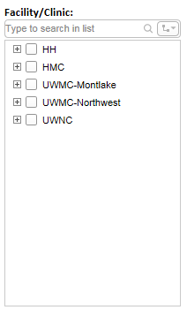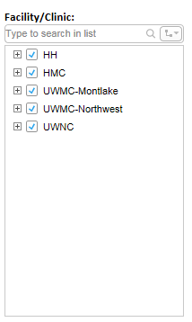

Deselect ALL Facilities – then expand on your Facility (click on the “+” sign)

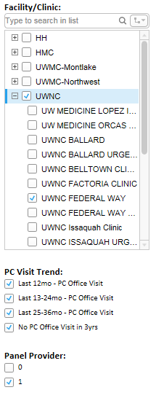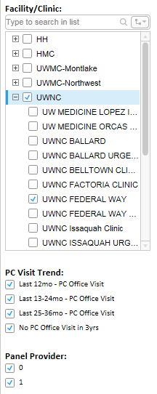

Choose your Clinic – then deselect “Panel Provider = 0” so that it is un-checked

Your Clinic’s Quality Metrics are now displayed by PCP

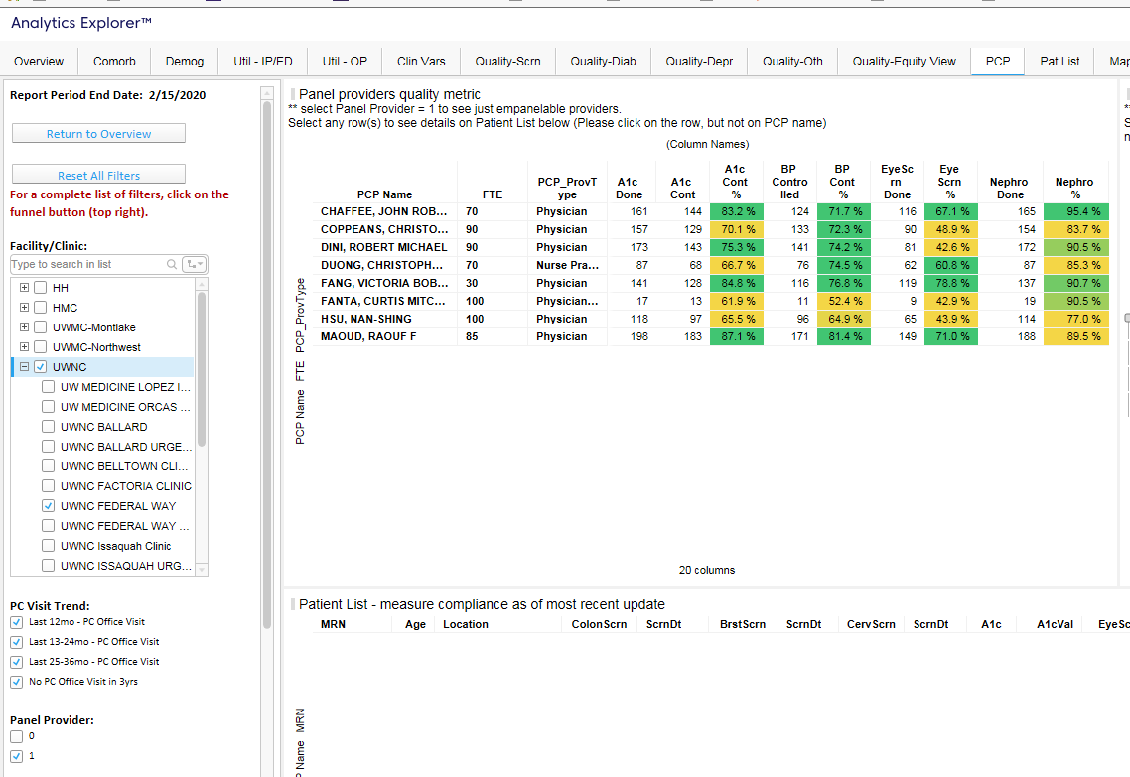

Windows and column widths can then be manipulated to display all of these metrics simultaneously (by “clicking and dragging”)

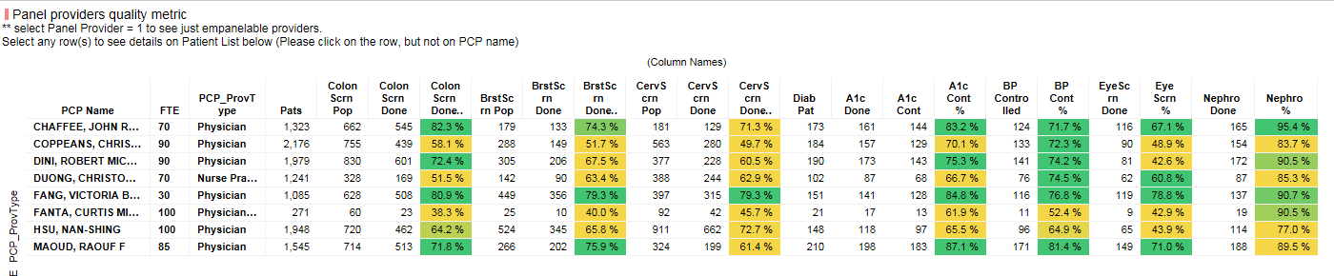

The results can be “Snipped” and pasted onto legal sized paper to “Publish” them

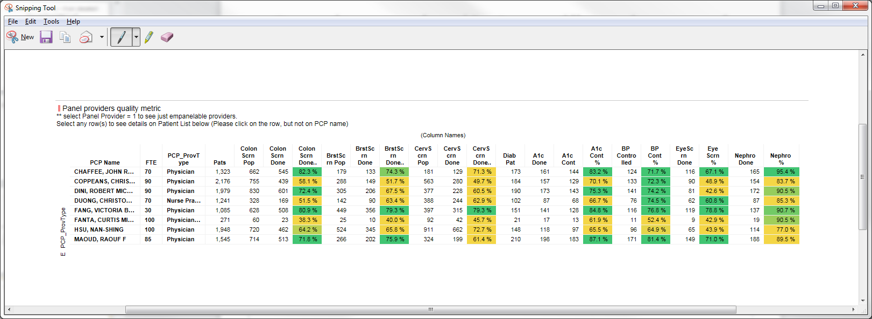

To save your Report – choose “Bookmarks” then name and save

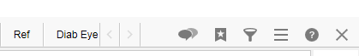

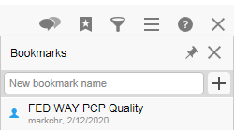

* Feedback?
* Additional Information?
* Other Data Repositories?

Questions?