“PREPARE TO ADAPT” FEEDBACK FRAMEWORK¹

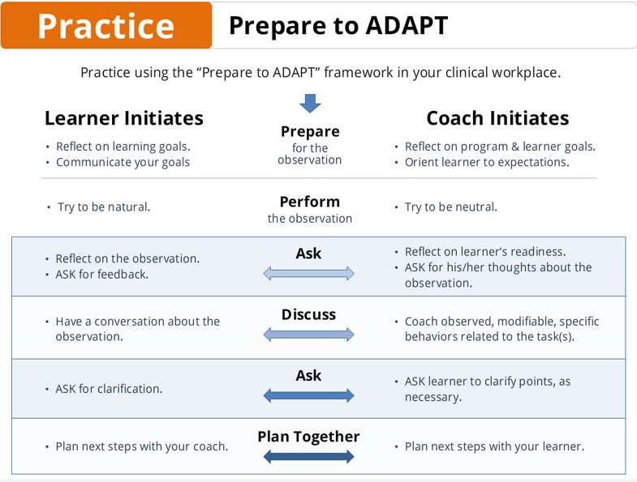

Please review the PREPARE to ADAPT feedback framework @ https://www.uwmedicine.org/education/Pages/ADAPT-Feedback.aspx

CONSENT HANDOUT FOR RESIDENTS BEING OBSERVED

As a senior resident currently enrolled in an inpatient or elective rotation, you are eligible to participate in a Seattle Children’s research study to assess the impact of completing direct peer observations on residents’ confidence in acting as teachers and team leaders. You can choose not to participate or to opt out of the study at any time.

You have been asked to participate in this study by a resident enrolled in the Team 7 rotation. The residents in the team 7 rotation have been educated about the ADAPT framework for providing feedback and have been asked to complete 2 direct peer observations using standardized teaching evaluations to facilitate giving feedback. As a subject, you will be observed by a peer resident either during rounds or during a scheduled teaching time such as morning report or afternoon team didactic sessions. You will also be expected to participate in a feedback session after completion of the direct observation. Participating residents involved in the Team 7 rotation will be asked to complete pre- and post-rotation surveys to assess their own confidence in teaching and team leading. You will not be asked to complete a survey as a part of this study.

Results from this study will inform future intervention and curriculum development. By participating in this study, you will have the opportunity to receive feedback from a peer about your teaching and team leadership styles. There are no known risks to participating in this study. Standardized evaluation forms completed by observing residents will be de-identified and collected only for tracking purposes. These evaluations will have no connection to your evaluation or credit for completion of the inpatient rotation.

Completion of the peer direct observation after receiving this information will be interpreted as consent to participate in this research study. You may choose to withdraw consent at any time.

If there are any questions or concerns please contact:
Dia Hazra, MD; Paul Morales, MD
Pediatric Resident Principal Investigator
dia.hazra@seattlechildrens.org; paul.morales@seattlechildrens.org

We appreciate you participating in our study! Thank you for your time!

OSTE TOOL TO BE USED FOR ROUNDS²
 | Patient 1 | Patient 2 | Patient 3
Rounding Atmosphere (promoting autonomy of learners, safe learning environment, etc.) | [] Position of Team - good  [] Allows presenter to finish his/her  presentation before interrupting  [] Allows intern to speak post-med  student  [] Appropriate # of interruptions  [] Appropriate timing of  interruptions  [] Redirects parents’ questions to  presenter  [] Reaffirming language  [] Positive nonverbal cues  (nodding, others)  [] Ensures nurses and other  ancillary staff are involved, as  appropriate | [] Position of Team - good  [] Allows presenter to finish his/her  presentation before interrupting  [] Allows intern to speak post-med  student  [] Appropriate # of interruptions  [] Appropriate timing of  interruptions  [] Redirects parents’ questions to  presenter  [] Reaffirming language  [] Positive nonverbal cues  (nodding, others)  [] Ensures nurses and other  ancillary staff are involved, as  appropriate | [] Position of Team - good  [] Allows presenter to finish his/her  presentation before interrupting  [] Allows intern to speak post-med  student  [] Appropriate # of interruptions  [] Appropriate timing of  interruptions  [] Redirects parents’ questions to  presenter  [] Reaffirming language  [] Positive nonverbal cues  (nodding, others)  [] Ensures nurses and other  ancillary staff are involved, as  appropriate
Communication with Patient/Family | [] Asks team to clarify medical  jargon (or N/A [])  [] Asks team to clarify complex  concepts (or N/A [])  [] Appropriate use of interpreters  (or N/A []) | [] Asks team to clarify medical  jargon (or N/A [])  [] Asks team to clarify complex  concepts (or N/A [])  [] Appropriate use of interpreters  (or N/A []) | [] Asks team to clarify medical  jargon (or N/A [])  [] Asks team to clarify complex  concepts (or N/A [])  [] Appropriate use of interpreters  (or N/A [])
Clinical Care | [] Clarifies (if necessary)  ☐ assessment  ☐ prioritized differential diagnosis  ☐ plan  [] Clarifies/Identifies  ☐ big picture of hospitalization  ☐ discharge goals  ☐ discharge needs  [] Assesses advice from consultants | [] Clarifies (if necessary)  ☐ assessment  ☐ prioritized differential diagnosis  ☐ plan  [] Clarifies/Identifies  ☐ big picture of hospitalization  ☐ discharge goals  ☐ discharge needs  [] Assesses advice from consultants | [] Clarifies (if necessary)  ☐ assessment  ☐ prioritized differential diagnosis  ☐ plan  [] Clarifies/Identifies  ☐ big picture of hospitalization  ☐ discharge goals  ☐ discharge needs  [] Assesses advice from consultants
Teaching Points | [] Provides a fact/teaching pearl  about the patient  [] Uses questions to teach (variety  of types of questions is good)  ☐ probes for facts  ☐ probes for understanding  ☐ probes for contingency planning  [] Identifies own learning needs –  asks questions of attending/others | [] Provides a fact/teaching pearl  about the patient  [] Uses questions to teach (variety  of types of questions is good)  ☐ probes for facts  ☐ probes for understanding  ☐ probes for contingency planning  [] Identifies own learning needs –  asks questions of attending/others | [] Provides a fact/teaching pearl  about the patient  [] Uses questions to teach (variety  of types of questions is good)  ☐ probes for facts  ☐ probes for understanding  ☐ probes for contingency planning  [] Identifies own learning needs –  asks questions of attending/others
Providing Feedback (if applicable) | [] If provides feedback on rounds,  gives specific feedback  [] If provides feedback on rounds,  does so in a safe manner | [] If provides feedback on rounds,  gives specific feedback  [] If provides feedback on rounds,  does so in a safe manner | [] If provides feedback on rounds,  gives specific feedback  [] If provides feedback on rounds,  does so in a safe manner
Workflow | [] Ensures efficient workflow  [] If indicated, tells family that  team will return later to finish  answering questions  [] Efficient with teaching points | [] Ensures efficient workflow  [] If indicated, tells family that  team will return later to finish  answering questions  [] Efficient with teaching points | [] Ensures efficient workflow  [] If indicated, tells family that  team will return later to finish  answering questions  [] Efficient with teaching points

PREPARATION SKILL |  | Level of achievement (Circle below where the majority of boxes are marked on the right) | Observed Behaviors  (Check a box after viewing these behaviors during the OSTE)
SKILL 1 | Establishing learning objectives for the educational encounter | 1 | - No stated topic  - No discussion of objectives for the session
 |  | 2 | - States the topic of the session  - Discusses goals of the session in general terms (i.e. “we’re going to talk about how to work up …”)
 |  | 3 | - States the topic of the session  - Outlines specific goals and objectives for the session (i.e. “at the end of this talk you should be able to work through the differential diagnosis, know the key history and physical exam components, and understand basic treatment of …”)
SKILL 2 | Assessing the level of the learner | 1 | - Does not assess the learner’s prior exposure to the topic  - Does not assess the learner’s perceived knowledge of the topic
 |  | 2 | - Assesses the learner’s exposure to BUT does NOT assess the learner’s knowledge of the topic (i.e. patients seen with condition, prior lectures on the topic, etc.)  - Assesses the learner’s knowledge of BUT does NOT assess the learner’s prior exposure to the topic (i.e. does the learner already feel comfortable with the content of the topic)
 |  | 3 | - Assess the learner’s exposure to AND knowledge of the topic
SKILL 3 | Creating a comfortable and safe learning environment | 1 | - The interaction between the teacher and learner appears uncomfortable  - Does not discuss expectations of the learner’s knowledge prior to starting the session (If checked also check level 2 box 2)
 |  | 2 | - The interaction between the teacher and learner appears comfortable (i.e. relaxed posture, appropriately spaced apart, etc.) BUT DOES NOT discuss expectations of the learner’s knowledge prior to starting the session  - Does discuss expectations of the learner’s knowledge prior to starting the session BUT interaction between the teacher and learner DOES NOT appear comfortable
 |  | 3 | - The interaction between the teacher and learner appears comfortable AND the teacher does discuss expectations of the learner’s knowledge prior to starting the session (i.e. “I realize you probably haven’t had any exposure to this yet and that is totally O.K….”)
OSTE TOOL TO BE USED FOR STRUCTURED TEACHING SESSIONS³
___ / 9
TEACHING SKILL |  | Level of achievement (Circle below where the majority of boxes are marked on the right) | Observed Behaviors  (Check a box after viewing these behaviors during the OSTE)
SKILL 1 | Setting the tone and providing context | 1 | - Does not appear interested in teaching OR enthusiastic about the topic being presented  - Immediately begins conveying information without first priming the session with a case example or shared patient experience
 |  | 2 | - Appears interested in teaching OR enthusiastic about the topic  - Prime the session with a case example or shared patient experience without learner involvement
 |  | 3 | - Appears interested in teaching AND enthusiastic about the topic  - Primes the session with either brief case or reference to a shared patient experience with learner involvement and discussion
SKILL 2 | Covering key content areas of a topic in an effective and efficient manner | 1 | - Appears rushed  - Difficulty navigating the topic so content appears disorganized  - Unable to cover prior stated goals or topic of the session
 |  | 2 | - At times appears rushed  - At times has difficulty navigating the topic but overall content is presented in an organized manner (i.e. no use of transitions, takes more than one attempt to convey a point in a clear manner)  - Able to superficially cover stated goals or relevant topics of the session
 |  | 3 | - Content is conveyed in a calm manner at a manageable pace  - Smooth navigation of the topic with content presented in an organized manner  - Able to thoroughly cover stated goals or relevant topics of the session
SKILL 3 | Reviewing and adapting to the needs of a learner | 1 | - Exhibits a teacher-centered approach by not assessing learner engagement or comprehension throughout the session  - Does not address learner difficulty with a term or component of a topic
 |  | 2 | - Minimally exhibits a learner-centered approach to assess learner engagement or comprehension throughout the session (1-2 actions)  - Superficially assesses learner engagement or comprehension (i.e. “make sense, sound good, etc.”, use of only pointed questions)  - Acknowledges cues of learner difficulty with a term or component of the topic, BUT does NOT adjust terminology or teaching style
 |  | 3 | - Continually exhibits a learner-centered approach by assessing learner engagement and comprehension throughout the session (3+ actions)  - Thoroughly assesses learner engagement or comprehension (i.e. use of back and forth discussion, learner provides considerable content)  - Acknowledges AND effectively addresses learners who struggle, and adapts accordingly
___ / 9

___ / 9
REFLECTION SKILL |  | Level of achievement (Circle below where the majority of boxes are marked on the right) | Observed Behaviors  (Check a box after viewing these behaviors during the OSTE)
SKILL 1 | Eliciting learner feedback | 1 | - Does not elicit learner feedback
 |  | 2 | - Elicits learner’s enjoyment of the session  - Does not discuss the effectiveness of the various components of the session OR how to improve teaching
 |  | 3 | - At the conclusion of the session inquires as to the effectiveness of the session, asking for specific examples of what did and did not work well  - Asks for recommendations as to how to improve as a teacher
SKILL 2 | Assisting the learner in reflection | 1 | - Does not assess retention OR encourage the learner to reflect on the session and how they will apply this information to future patients
 |  | 2 | - Asks the learner questions regarding the content that was covered to assess retention (i.e. teach-back) (If checked also check level 3 box 1)  - Does not have the learner reflect on what they will take away from the session and how they will apply this information to future patients
 |  | 3 | - Asks the learner questions regarding the content that was covered to assess retention  - Encourages the learner to reflect on the session, discussing how the learner will utilize this information in the future or ensure retention beyond the session (i.e. “How would you apply this to the next patient you see with cough?”)
SKILL 3 | Providing steps for improvement | 1 | - Does not outline steps for improving in content competency
 |  | 2 | - Encourages general steps at improvement BUT does NOT discuss specific steps tailored to the learner (i.e. reading, paying attention on rounds, discusses topics to be covered in future teaching sessions)
 |  | 3 | - Assists the learner in developing specific steps for improving competency at the topic tailored to the learner’s educational needs and preferred learning style (i.e. “Next time we have an admission with [complaint] try and come up with a full differential based on their history so that we can develop a plan together to address that differential.”)
___ / 9
DURATION OF EDUCATIONAL EXPERIENCE: _________

References:
- Fainstad T, Mcclintock AA, Ridder MJVD, Johnston SS, Patton KK. Feedback Can Be Less Stressful: Medical Trainee Perceptions of Using the Prepare to ADAPT (Ask-Discuss-Ask-Plan Together) Framework. Cureus. 2018. doi:10.7759/cureus.3718.
- Rassbach C, Rooholamini S, Bogetz A, Batra M, Grow M, Lee L, Loutit C, Quitiquit C, Sakai D, Srinivas N, McPhillips H, Blankenburg R. Coaching Strategies to Help Trainees’ Clinical Skill Development. Association of Pediatric Program Directors 2017.
- Zackoff M, Jerardi K, Unaka N, Sucharew H, Klein M. An Observed Structured Teaching Evaluation Demonstrates the Impact of a Resident-as-Teacher Curriculum on Teaching Competency. Hospital Pediatrics. 2015;5(6):342-347. doi:10.1542/hpeds.2014-0134.

